

Rochester Youth Hockey Association

GRAHAM IV GROUNDBREAKING

Graham IV Arena became a reality for the Rochester Youth Hockey Association as it celebrated the groundbreaking on
August 15, 2006. RYHA participated in the ceremony with the Olmsted County Board and Rochester City Council.

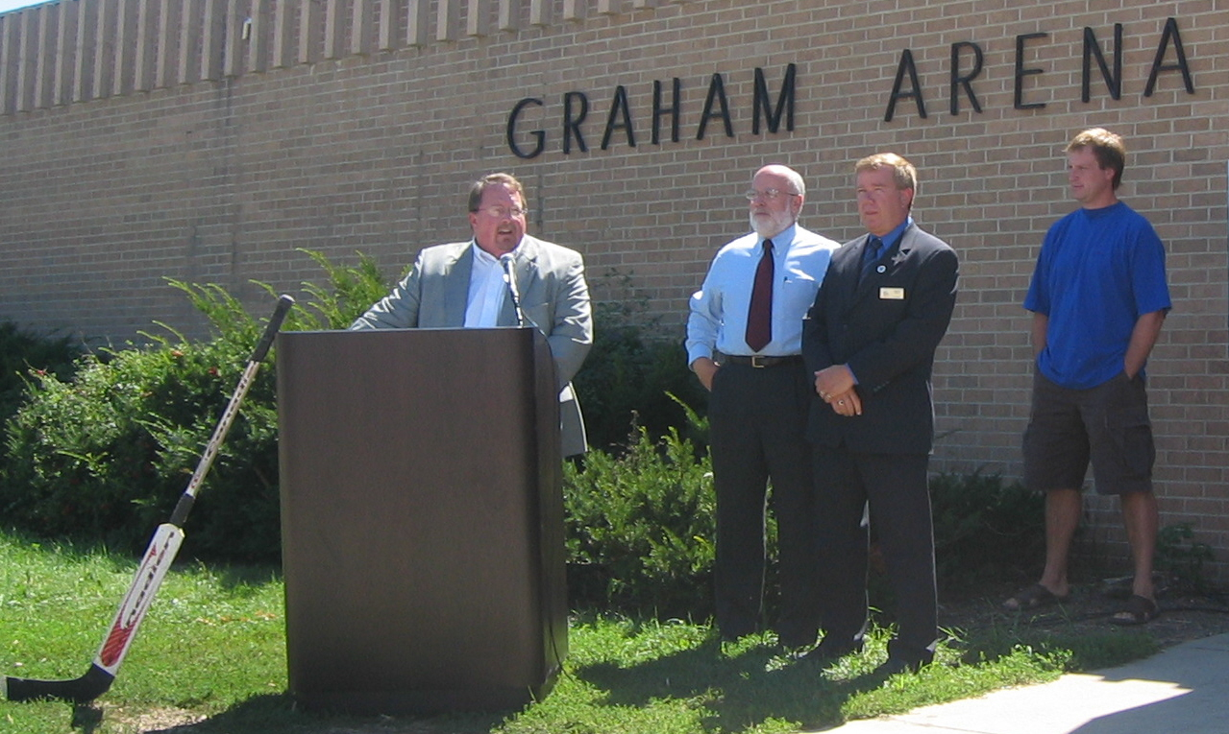

Paul Grinde - RYHA, Ken Brown - Chair of the Olmsted County Board, Dennis Hanson - President of the Rochester City Council and Doug Zmolek - RYHA spoke at the ceremony. All were proud of the partnership of the private and public sector to create the complex at the Olmsted County Fairgrounds for families and children.

RYHA kids celebrated by breaking ground with the Gold contractor shovels.

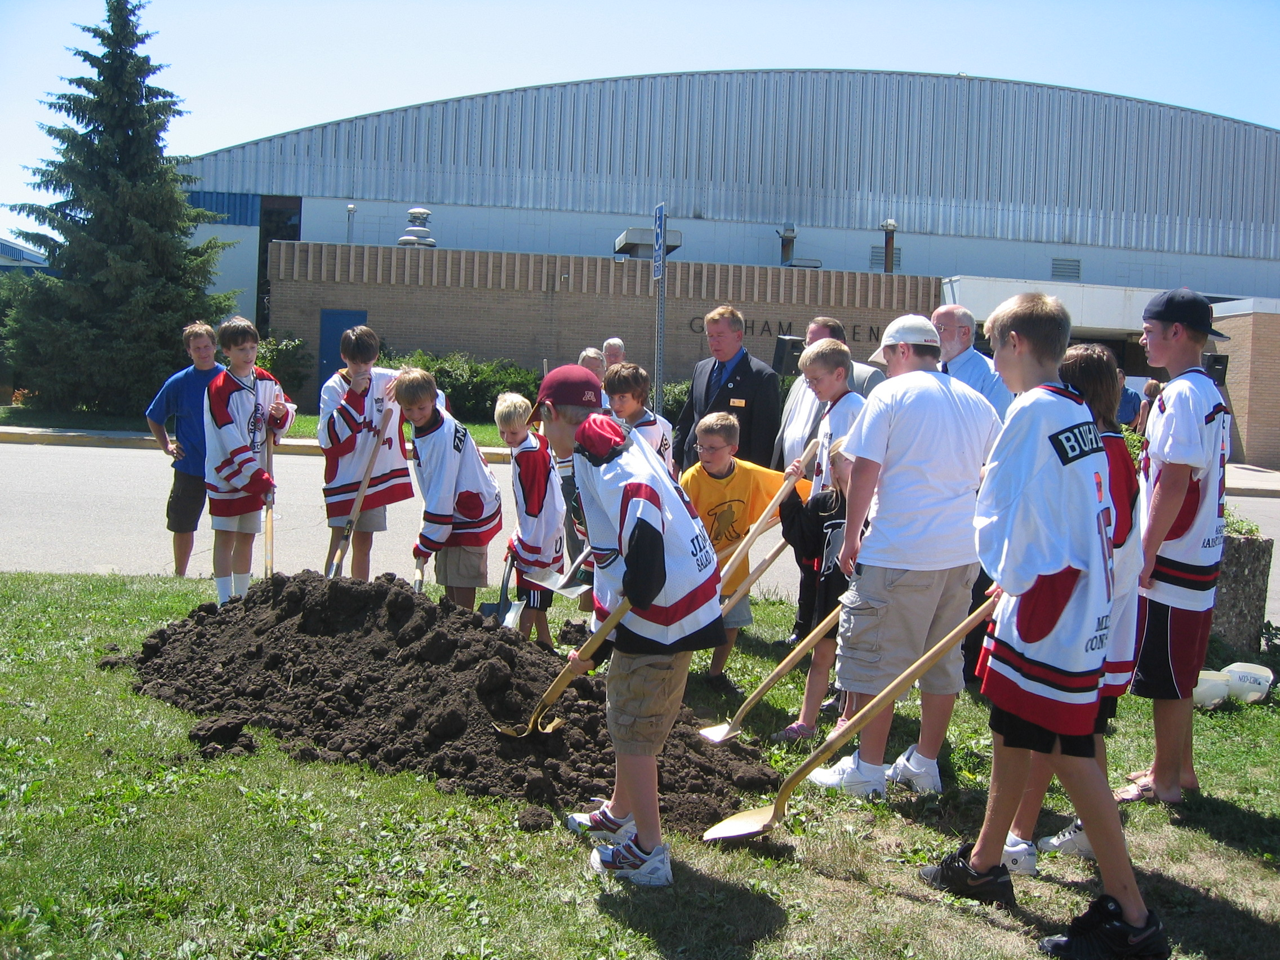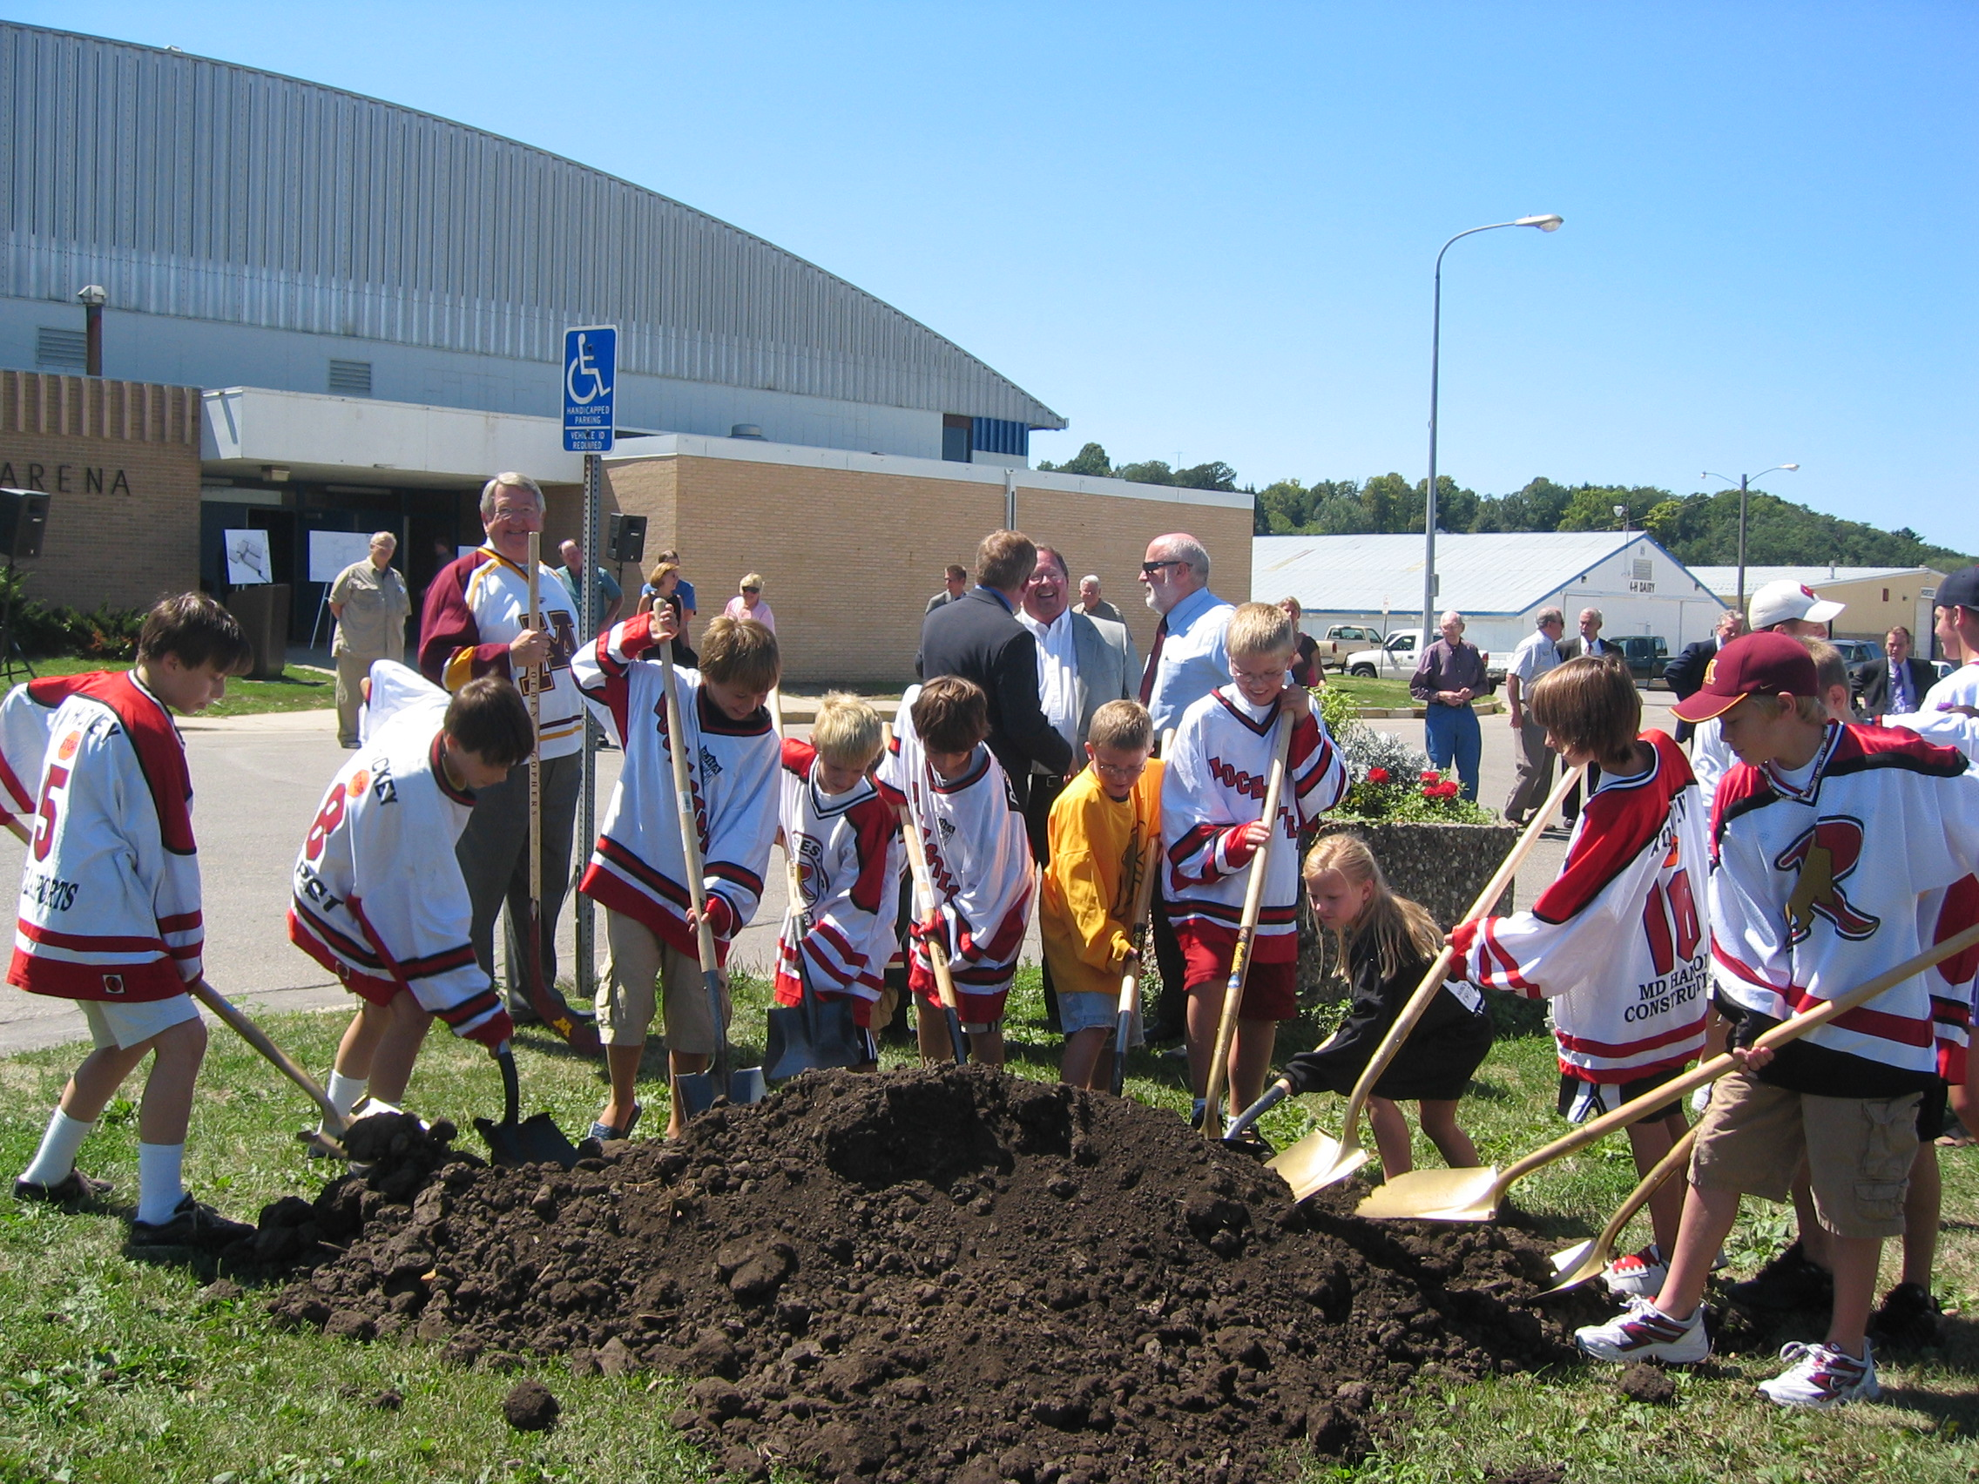

Rochester Youth Hockey Association

HISTORIC GRAHAM IV GROUNDBREAKING

The groundbreaking for the Graham IV Arena on August 15, 2006 at the Olmsted County Fairgrounds was a historic moment for the Rochester Youth Hockey Association and the community. The newest arena continues the legacy of Dr. Christopher Graham. The comments made at the groundbreaking event by Paul Grinde, Chair of the RYHA Building Committee are printed below:

In the early 1900s, Dr. Christopher Graham became interested in the Olmsted County Fair and particularly the exhibits made by the children that were shown at the fair.

The original fair ground area was to the south of 12th Street and to the east of 3rd Avenue, not too far from this site. That area was rented for the fair from a Mr. Ireland. Dr. Graham was unable to negotiate a deal to purchase that parcel of land. He then purchased a 160 acre parcel that today includes Libby’s, Friedell, Crossroads Shopping Center, and of course, the Graham Fairgrounds.

In October of 1919, a 60 acre parcel of property, which is now the Fairgrounds, was gifted to Olmsted County by Dr. Graham. The Olmsted County Fair Board was given a perpetual lease of the grounds.

In 1967, the Olmsted County Board recognized the need for a large arena for skating and hockey that could also be used for a judging arena at the time of the Olmsted County Fair. The board resolved to build Graham West and named the building after Dr. Graham. A resolution by the County Board at that time stated in part as follows:

“It was in appreciation of his interest, generosity and dedication as well as his farsighted interest in youth education, recreation and
agriculture that this building be named Graham Arena.”

In August of 1969, the new Graham Arena was dedicated having been built with the assistance of the Rochester Juvenile Hockey Association now known as the Rochester Youth Hockey Association.

I believe Dr. Graham would be proud of the continued partnership between the County, City and Youth hockey for the benefit not only of youth hockey but also now, as a future gathering place for those attending the Fair and other events here. Minnesota is known as the “State of Hockey” and today is the beginning of the creation of the Jewel at the Graham Arena Complex. We have many people to thank for this and I hope not to miss anyone.

There is one individual whose drive, dedication and generosity of time I believe probably equaled Dr. Graham in this process. He put together spreadsheets, power point presentations and attended meeting after meeting. His will would not be crushed. If he was knocked down he got back up again and again. Mark Hickey is not able to join us today because he is serving his country in Iraq and Afghanistan. I assure you that through emails I have received from him, he is a very happy man that this arena groundbreaking is taking place. Please keep his safety in mind for him and his family.

Tom Konokaowitz has been a driving force for the funding not only of this arena but also for Graham North. Tom was also instrumental in putting together a foundation to help disadvantaged youth enjoy the great game of hockey through the establishment of scholarships.

Mike Cousino from Olmsted County has worked tirelessly on this project. Without his perseverance I doubt we would be standing here today.

Rochester Youth Hockey would also like to thank the County Board, the City Council, County Administration and Rochester Park and Rec., the Rochester Convention and Visitors Bureau, and the Rochester Area Chamber of Commerce and the Hospitality First initiative. I truly believe the type of partnership that has been shown here at the Graham Arena Complex, evidences the best of a public/private partnership and what can be accomplished through cooperation and leadership.

It’s a great day for hockey!!

Rochester Youth Hockey Association

RYHA Registration
2006-2007 Season

Fall registration for 2006-2007 is scheduled for September 12th and 13th at Graham West from 6:00-8:00 p.m. The electronic registration format will be used again this year. It should make things go quickly and smoothly. For late registration, please come to Graham North on September 20th from 6:30-7:30 p.m.

Registration forms are available inside the newsletter. If you need additional forms please go to www.ryha.net. Please complete the registration form prior to coming to registration at Graham West on September 12th or 13th.

If you have questions, please contact Kathy Heightland at ktheight@msn.com or Mary Foley at sfastuds@msn.com

Rochester Youth Hockey Swap
At

Play It Again Sports

Bring in Your GOOD Used Gear
Starting August 21, 2006

RYHA Swap
August 28 – November 15, 2006

PLAY IT AGAIN SPORTS
102 Elton Hills Dr NW
Across from the Recreation Center
281-1943

Used Equipment
By Steve Nelson

RYHA is trying to build up an inventory of used equipment to be used primarily for new kids who want to try hockey in “Intro to Hockey” clinics, “New Skater” Fall clinic sessions, or similar programs. If you have equipment you would like to donate, please bring it to the Coaching or Girls tables at registration, or contact Steve Nelson (senroch@yahoo.com) or Mike McCormack (mac15hockey@hotmail.com). RYHA will provide a written record of donations.

Sponsors Wanted
By Mary Foley

Have you been thinking that your company logo
would fit perfectly on a hockey jersey?
Maybe on a dasher board or banner too?
We are always looking for sponsors
to help us fund RYHA.
Please give it some thought.
Contact
Paul Miller at paulm@useminc.com
or
Mary Foley at sfastuds@msm.com
with any questions you might have.

RYHA Considering
Closed Tryouts in 2006-07
By Doug Zmolek

RYHA is considering closing tryouts this season. In considering this, we hope to eliminate a lot of nervous energy a parent-filled-rink brings to the tryout process. While so many of you come with good intentions, the fact that the rink has hundreds of eyeballs on these players does not help the already tense situation.

Our (RYHA) goal is to try and create an environment where as many players as possible can play to their best. The more tension we create, the harder it becomes for these players to do so. Without parents in the stands, a good portion of tension on the players would be eliminated.

Even if we (RYHA) decide not to close tryouts, I ask you to consider finding something else to do (instead of watching) while your child skates their tryout.

Coaches Corner
By Mary Foley

Minnesota Hockey is requiring ALL on-ice coaches to wear helmets this season. There will be no exceptions. RYHA has received generous discount pricing for all coaches volunteering this season. Please take advantage of this offer and comply with this new rule.

Mission/Itech has the following helmets available at these prices:

Mission Intake - $65.00
Itech HC 100 - $39.00
Itech HC 95 - $33.00

These helmets can be ordered from Mission/Itech through RYHA. We will place an order after registration, and the helmets will be delivered through Shoot-n-Save (the local Mission dealer). This is a group discount offer, so please do not go to Shoot-n-Save on your own and request this discount pricing. Come to registration with the style and size you need, and a check made out to Mission Hockey for the correct amount. If we need to place an additional order later in the season, Mission will happily accomodate us.

Hockey Giant has also offered coaches discounts. They have the following Bauer helmets available. Please check out sizing on the following styles, and come to registration with a check made out to Hockey Giant Anaheim.

Bauer 3500 - $40.00
Bauer 1500 - $23.00

Sizing: Small 6 1/8-6 5/8,
Medium 6 5/8- 7 1/8,
Large 7 1/8- 7 5/8

Termite/Super-Mites
By Charles Paulson

The 2006-2007 hockey season is approaching and it is time to unpack the hockey equipment to see if anything fits after the spring and summer growth spurts. The importance of proper fitting equipment cannot be stressed enough. The skates are probably not going to fit, at least they won’t if they fit properly last March at the end of the hockey season. The name of the game is skating. It is hard enough to skate with proper fitting skates, but it is virtually impossible to skate with poor quality skates that don’t fit. The only way to ensure proper fit is to have the foot measured by a knowledgeable person that understands the sizing and proper fit of hockey skates. Skates are not sized the same as street shoes and can vary significantly from brand to brand. Rochester has several local sporting-good stores that sponsor our great sport. Hockey equipment can be purchased at Shoot-n-Save, Gillespie’s Sports, Play it Again Sports, and Gorilla Sports. The people at these stores are experts in the proper fit and carry a wide selection of new and used equipment. Please take advantage of their expertise and try to purchase the best equipment that fits your budget. While skates are very important, all of the equipment should be checked for size and condition. Replace anything that appears damaged or broken.

The used equipment sale will be held this year at Play it Again Sports. The first day of drop off is August 21st and the sale will run through November 15th. There will be no used equipment for sale during registration this year.

Registration will take place September 12th and 13th at Graham Arena West. The format for the Termite and Super-Mite programs will remain much the same as last season. The first day of the season is Saturday, October 28th. All players will receive group assignments approximately one week prior to the start of the season. There will be no sessions on the weekends following the Thanksgiving, Christmas, and New Year holidays. The Jamborees are tentatively scheduled for the second weekend in March, however, ice scheduling conflicts could change the date.

Termites will get their jerseys at the parent meeting on November 11, 2006. Plan on attending this meeting as we will explain the Termite program, expectations, important dates, and also provide the schedule for the year. The meeting will be held during the regular Saturday session times. Super-Mites will be given jerseys and schedules by their coaches or team parents shortly after the start of the season. A letter summarizing the Super-Mite program will be distributed.

The youth hockey program constantly seeks additional volunteers. The Rochester Mite Board is searching for a Secretary. If you are interested in this position or another position within the organization, please contact Kathy Heightland at 288-8213 for more information. Please consider volunteering your time and talents to help the program succeed. The season will be upon us shortly and hopefully it will be a great year with fun for all.

Key dates for Termites and Super-Mites

Start of the season (Termite and Super-Mite)
October 28, 2006

Termite parent meetings
November 11, 2006

Termite pictures
November 18, 2006

Super-Mite pictures
November 14/16, 2006

Pizza sales (required for all skaters)
January 2007

Termite Jamboree (tentative)
March 10, 2007

Super-Mite Jamboree (tentative)
March 11, 2007

Commissioners Needed
By Nick Ibarra, RYHA City Unit Director

The City Unit needs your help as a Commissioner for the following levels:

- Squirt House Skaters, 4 Teams
- Peewee House Skaters, 4 Teams

If you have the drive to help coordinate and guide team operations, you qualify. There will be a great deal of support, including coordination with the Traveling Commissioners and the RYHA Board. The initial ‘rush’ is early in the season from hockey signup through team assignments. The actual season tasks mostly involve coordinating with team managers. As you can imagine, this is an over simplified description, however, the role is crucial to a fun season for our skaters!

This is a great way for you to help and learn more about your organization. It does not matter what level your skater is at, you can help! To volunteer or to discuss the role of a Commissioner, please contact me at 285-3328 (home) or email me at nibarra@charter.net

Your efforts will make hockey more FUN for our skaters!!

Calling All Non-Coaches!!!!
By Lee Ann Furness

Coaches are the most visible volunteers in hockey associations. But did you know we have many other volunteer opportunities? For instance, this newsletter is typed and created by a volunteer. The information submitted to the newsletter was written by volunteers. The whole organization is run by volunteers! But, as with any organization, new volunteers are always needed. Can you help with any of the areas listed below? Please call Lee Ann at 280-9798 or email her at lfurness@charter.net.

NEWSLETTER…Our dedicated volunteer, Karen Hanson, is nearly done with her years as a parent in RYHA. She is ready to hand the newsletter task over to the next volunteer. The newsletter goes out three to four times each year. Karen is willing to help her successor learn the ropes.

PIZZA SALES…although I have a few years left in RYHA, I am hoping someone will step up and work side-by-side with me for the next few years so they can take over the pizza sales. The job is big but organized! And fun!

PIZZA PARENTS…please consider volunteering for this 6-week commitment. Our pizza committee continues to work towards making the process smooth for all of us. Have ideas from the past? Call Lee Ann and let her know those ideas!

TEAM PARENT OR MANAGER…help your team and coach by being the information source! Each levels’ responsibilities are different. Ask at registration about specific duties of a team parent or manager!

Goalie Corner
By Mike Bromberg

All goalies who are using RYHA equipment need to fill out the Goalie Equipment Sign-out form and turn it in during registration at the Goalie Table. The Goalie Equipment Sign-out Form is enclosed with the newsletter.

Goalie’s who need equipment, or need to bring back equipment and exchange it for a different size, should bring any excess equipment to registration. Receipt of larger or new equipment will be distributed at a later date so a thorough inventory of sizes can be done.

Rochester 2006-2007 Hockey Tournaments
By Brenda Mackey – Tournament Director

Bantam C December 1-3
PeeWee B December 8-10
Jr. Gold December 16-17
PeeWee A January 5-7
Squirt A January 12-14
Girls U10A/B U12A/B January 19-21
Bantam A January 26-28
Bantam B February 9-11
Squirt B2 February 16-18

This year Rochester will be hosting the 41st Annual Invitational Hockey Tournaments. With each tournament there are many volunteer opportunities. In the past youth hockey parents have done a tremendous job volunteering and I offer them my gratitude. This year we will be hosting nine tournaments and I would like to remind parents that volunteers are always needed at these tournaments as well as on the tournament committee to plan for upcoming tournaments. If you would like to volunteer for tournaments or to help on the tournament committee, my phone number and e-mail address can be found on the RYHA web page. Have a great season!

Pizza Samples
Food Samples
Cinnamon Rolls!
By Lee Ann Furness

This year our fundraiser will again be from Club’s Choice. We have added a few new items such as chicken strips, egg rolls and jalapeno poppers! There will be samples of our new items the first night of registration.

This year we hope to raise over $130,000 with the fundraiser!!! All of the dollars raised helps to lower your registration fees and off-set expenses for ice time !

HOW DO I BECOME A REFEREE?
By Al Faupel

Simple! You must register to attend a seminar, and then, take and pass a test. There will be 2 seminars held in Rochester this Fall, one for Level 1 and 2 referees, and one for Level 3 referees. The Rochester seminars are currently scheduled for:

Date Time Location Level
9-10-06 9:00a Rochester Rec. Ctr 1 & 2 (New Referees)
9-24-06 9:00a Holiday Inn South 3

Registrations for officials runs from early August to around the middle of May. The Minnkota Seminar season runs from early September until early December. Even though you may be able to register as an official, you may have difficulty meeting the seminar requirement if you register too late in the season. You can view a list of all Minnkota seminars at the web site: http://www.minnesotahockey.org/officials/new_referee.asp and clicking on the appropriate icon. To be completely registered as an official, you will need to complete the following steps.
1. Apply to USA Hockey at www.usahockey.com. After completing the process, you will receive an official’s number. This number will be needed when you attend a seminar to record your attendance. If you do not have internet access, a paper application will be available from a local supervisor. A listing of local supervisors can be found at the above web site by clicking on “officials”, then “directory, and scroll down and click on “minnkota”. You may also call your state Referee-in-Chief to find a local supervisor.
Minnesota: Eric Olson 763-767-7342
2. Complete the open book exam you receive from USA Hockey. This can also be done on-line!
3. Attend a seminar. A current listing of seminars is available at www.mhoa.us If you are a Minnesota Official, you will need to register on-line at this same web site for a seminar to prevent the issue of overcrowding. If you don’t have internet access, you may contact a local supervisor to register you for the seminar you wish to attend. At the seminar you will need to complete a closed book exam for your appropriate level. The level 1 exam is mainly for informational purposes. All of the closed book exams are also utilized as record of your seminar attendance.
4. Minnesota official state dues can either be turned in at the seminar or sent in via mail. A current dues form for Minnesota can be found at www.mhoa.us
You can check on each portion of your registration status by calling (719) 576-8724 and follow the voice activated menu prompts for officials’ registration. If you additional information, please contact your nearest local supervisor. Welcome aboard!

He or She Shoots and Scores!
By Aynsley M. Smith, RN, PhD., Michael J Stuart, MD, Matthew Sorenson,
Mayo Clinic Sports Medicine Center

Or perhaps your skating speed, agility, strength and stamina will improve after you, your child, or someone you coach participates in the Hockey and Skating Program at the Mayo Clinic Sports Medicine Center.

This individualized program for hockey players and figure skaters was created by Mayo Sports Medicine professionals including Dr. Michael Stuart (orthopedic surgeon and USA Hockey Chief Medical Officer), Joe Eischen, Tim McLean, Dave Krause (physical therapists) and Candee Mills (athletic trainer). These specialists are not ice hockey or skating coaches, but have extensive experience in the areas of injury prevention and performance enhancement. Joe Eischen recently completed a mentorship program with Peter Twist, a former NHL strength coach and a recognized world leader in hockey conditioning.

This program is designed specifically for the skating sports and emphasizes individualized functional movement analysis. After identification of deficits in body mechanics, flexibility, strength and balance, the player is given a tailor-made program with the tools to achieve their goals. If you believe you will benefit from becoming more mentally tough by learning sport psychology skills, you can ask to see Dr. Aynsley Smith (sport psychology consultant and co-chair of the Minnesota Hockey Education Program). Similarly, if you have concerns with weight loss, weight gain, or eating for top performance, you can also request an appointment with a Sports Medicine Center nutritionist. Together, this team of experts can construct the ideal fitness program to help you reach the next level and beyond.

Call the Mayo Clinic Sports Medicine Center at 507-286-9384 for an appointment. A Hockey and Skating Program evaluation would make a great gift for any hockey player who

truly loves the game!
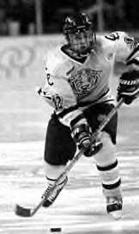

RYHA ACADEMIC HONOR ROLL
By Paul Grinde and Deb Jacobson

The Rochester Youth Hockey Association is very proud of the 305 players that qualified for the Academic Honor Roll for the 2005-2006 hockey season. The players worked hard in school and on the ice.

RYHA has supported an academic achievement program for the Squirts through Jr. Gold players for four years. This year players that earned good grades for the first two quarters of the school year were given a Certificate of Recognition and a zippered CD/DVD case with the RYHA logo on the front cover. And, again this year our local Culvers generously donated basket meal coupons for all 305 players.

During the 2002-2003 hockey season RYHA began to honor student athletes through the SKATE (Skaters Keep Achieving Through Education) program. The original local SKATE committee included Barb Hexum, Jill Wylam, Kristy Thorsen, Debbie Worden, Paul Grinde and Deb Jacobson. RYHA set up the local program and purchased its own prizes for all participants. Prizes have included movie passes, knit hats, duffle bags, pins, mini hockey sticks, gift cards for sporting goods and certificates of recognition. The committee during subsequent years included Jill Wylam (treasurer), Marci Nagle, Paul Grinde and Deb Jacobson.

In the Fall of 2005, the SKATE program notified RYHA that it required a fee. RYHA decided to continue to honor good students through its own program. The SKATE program was very worthwhile, but the benefits were outweighed by the additional cost to our organization.

The RYHA ACADEMIC HONOR ROLL has expanded from 96 students the first year to 305 students for the 2005-2006 season. It is thrilling to recognize so many players for excellence in the classroom while they participate in a sport that takes time and commitment. Kids deserve credit for all their efforts. The growth of the program has been made possible by the volunteer Honor Roll parent for each team. The Honor Roll parent distributed information about the program to team members and collected applications and grades. They also distributed prizes and sent information to the schools to congratulate the players in school newsletters.

RYHA thanks all the volunteers, sponsors, coaches, managers and parents for making this academic program possible.

The 2006-2007 Hockey Season will be the fifth year for an academic recognition program for our players. Serena Powers has agreed to lead the program. Please notify her with any suggestions and your willingness to help. spowers@cbburnet.com

2006 RYHA Honor Roll

BANTAM

BANTAM A RED–
VFW POST 1215

Tyler Anderson (Century)
Cory Birkestrand (Century)
Max Foley (John Marshall)
Bill Grinde (Century)
Derek Hovick (John Marshall)
Bryan King (Holy Spirit)
Alex Paulsen (Century)
Jared Samuelson (Century)
Kent Worden (Kellogg)

BANTAM A WHITE
VFW POST 1215

Andrew Block (Mayo)
Brad Fisher (Mayo)
Ethan Hoppenworth (Century)
Alex Kurth (Willow Creek)
Jeff Nagel (Century)
Kevin Oetliker (Mayo)
Colby Palmersheim (Century)
Rick Weber (Mayo)
Mike Warzala (Rochester Central Lutheran)
Jordan Yaggy (Mayo)

BANTAM B RED
KNUTSON CONSTRUCTION

Brandyn Chezick (Willow Creek)
Alex DeWitz (Holy Spirit)
Brett Dennis (Willow Creek)
Michael Hanson (Kellogg)
Travis Higgins (Kellogg)
Jordan Martini (Kellogg)
Justin Powers (Rochester Central Lutheran)
Matt Roth (Holy Spirit)
Rory Vesel (Kellogg)
Alex Heroff (Rochester Central Lutheran)
Nick Schoeberl (St. Pius)

BANTAM B WHITE

YAGGY

Nick Edwards (Home School)
Kaine Kaase (Kingsland Middle School)
Brendan Mosier (St. Francis)
Alex Peterson (John Marshall)
Rudi Schiebel (Mayo)
Phillip Schotte (Plainview)

BANTAM C1
OLYMPIC FIRE PROTECTION

Thomas Carr (St. Francis)
Kenny Cloft (Lourdes)
Jayce Semmen (Kellogg)
Ryne Sheppard (Century)
Ian Turner (John Adams)
John Tuseth (John Adams)

BANTAM C3
6 NEWS FIRST KAAL

Jake Acker (Kellogg)
Alexander Antolak (John Adams)
Kevin Grothe (Kellogg)
Andrew Klugherz (Century)
Dalton Sycks (Century)
Adam Zumbrunnen (Century)

PEE WEE

PEE WEE A RED
VIRGIL’S

Andrew Benner (John Adams)
Alec Brandrup (Holy Spirit)
Garrett Brossart (Bamber Valley)
Robby Campbell (Stewartville Middle)
Brock Kautz (Kellogg)
Luke Klugherz (Kellogg)
Reed Miller (Rochester Central Lutheran)
Nick Raeshler (Kellogg)
Sam Slightam (Stewartville Middle)
Tyler Vesel (Holy Spirit)
Brian Wasz (Holy Spirit)

PEE WEE A WHITE

HAWK & SONS

Bryce Berletic(Lincoln)
Reed Bjork (Holy Spirit)
Joseph Canakes (Rochester Central Lutheran)
Jack Dingle (Willow Creek)
Landon Farrell (John Adams)
Anthony Johnson (John Adams)
Ryan Lakin (John Adams)
Eric Mackey (John Adams)
Nate Musta (Kellogg)
Alex Rush (Kellogg)
Ryan Yetzer (John Adams)

PEE WEE B RED
MD HANSON CONSTRUCTION

Calvin Bjerke (Kellogg)
John Borkenhagen (Willow Creek)
Marcus Buehler (John Adams)
Tom Foley (John Adams)
Matthew Hickey (Home School)
Dominick Jacobs (Kellogg)
Brandon Kautz (Kellogg)
Jared Kristo (John Adams)
Jim Pearson (Kellogg)
Daniel Rossman (St. Francis)
Preston Sycks (Kellogg)
Wyatt Travis (Rochester Central Lutheran)
Erik Wennberg (Kellogg)

PEE WEE B WHITE
INSTY PRINTS

Matthew Broman (John Adams)
Matthew Cyr (John Adams)
Andy Guibert (Holy Spirit)
Blake Heroff (Rochester Central Lutheran)
Alexander Herold (Willow Creek)
Henry Ishitani (Schaeffer)
Mitchell King (Holy Spirit)
Jason Macken (John Adams)
Brady Moran (Friedell)
Isaac St. Marie (Kellogg)
Blake Waters (Rochester Central Lutheran)
Brian Williamson (St. Pius)

PEE WEE C TRAVELING
PLAY IT AGAIN SPORTS

Kyle Andrews (John Adams)
Nikolas Brozovich (Willow Creek)
Chris Creedon (Kellogg)
Kyle Hildebrandt (Stewartville)
Tyler Iverson (Kellogg)
Chase Laures (Willow Creek)
Nishant Nyar (John Adams)
Channing Tipton (St. John)

PEE WEE C 2
CITY AUTO GLASS

Jacob Barth (Kellogg)
Nolan Bowron (John Adams)
Nolan Doyle (Kellogg)
William Hempy (John Adams)
Ryan Hill (John Adams)
Jon St. Peter (Rochester Central Lutheran)
Nolan VanNurden (Kellogg)

PEE WEE C 3
POST BULLETIN

Jake Andrist (Willow Creek)
John Andrist (Willow Creek)
Jeffrey Baier (Willow Creek)
Evan Borkenhagen (Willow Creek)
Adam Gibson (Willow Creek)
Taylor Kosis (Willow Creek)
Chip Locke (Willow Creek)
Jesse Neumann (John Adams)
Shiv Pruthi (St. John)
Alex Utley (Willow Creek)
Alex VanGelder (Willow Creek)

PEE WEE C 4
WELLS FARGO

James Armstead (St. Francis)
Michael DeBusman (Rochester Central Lutheran)
Sam Imhoff (Friedell)
Steven Janzow (Kellogg)
Benjamin Kleist (Willow Creek)
Reed Klopenhower (John Adams)
Brandon Koster (John Adams)
Kyle McGrane (St. Francis)
Josh Newman (Friedell)
Gavin Polansky (John Adams)
Tanner Tschann (Willow Creek)

PEE WEE C
TRYGSTAD AUTOBODY

Ryan Iverson (Kellogg)
Jeremy Jacobson (John Adams)
Zenny Kuzyk (Kellogg)
Alex Nordland (Kellogg)
Eric Bonapace-Potvin (St. Francis)
Nathan Salsman (Friedell)
Jayden Schuster (John Adams)
Sam Wick (Dover-Eyota)

SQUIRT

SQUIRT A RED
PEPSI

Justin Aldrich (Willow Creek)
Brady Bridges (Jefferson)
Sammy Broman (Sunset Terrace)
Nolan Edwards (Home School)
Andrew Ellingson (St. Francis)
Kyle Lawler (St. Francis)
Karl Krecke (Holy Spirit)
Ryan Martin (Ben Franklin)
Nick Paulson (Jefferson)
Jason Samuelson (Jefferson)
Gavin Sandwick (Sunset Terrace)
Dalton Travis (Rochester Central Lutheran)
Lydia Wagner (Holy Spirit)

SQUIRT A WHITE
GOLDEN CORRAL

Drew Applegath (Gage)
Andrew Bugliosi (Washington)
Jimmy Casazza (Sunset Terrace)
Thomas Fjelsted (Bamber Valley)
Dallas Hager (Hoover)
Tommy Hanson (Ben Franklin)
William Holtan (Home School)
Isaac Jones (Bamber Valley)
Alec McGinn (Sunset Terrace)
Nathan Roth (Holy Spirit)
Adam Sherden (Kellogg)
Griffin Slightam (Stewartville Bonner)
Matt Sturchio (Riverside)
Luke Utley (Bamber Valley)
Jackson Wilson (Sunset Terrace)
Riese Zmolek (Jefferson)

SQUIRT B 1
TOP SHELF

William Adamson (St. John)
Lars Anderson (Rochester Central Lutheran)
Jake Billings (Bamber Valley)
Mitchel Gade (Rochester Central Lutheran)
Logan Haskins (St. John)
Bailey Kazeck (Bamber Valley)
Matthew Moore (Bamber Valley)
Ryan Olney (St. John)
Matthew Rogers (Bamber Valley)
Nick Roth (Holy Spirit)

SQUIRT B 2
FITZPATRICK REAL ESTATE

Sam Batterson (Sunset Terrace)
Lee Brandrup (Holy Spirit)
Jace Berndt (Gage)
Connor Fitzpatrick (Holy Spirit)
Chris Klingsporn (Harriet Bishop)
David McCarthy (Holy Spirit)
Nick Musta (Riverside)
Alex Ney (Kasson-Mantorville Elementary)
Brandon Raehsler (Sunset Terrace)
Carter Scrimshaw (Washington)
Garrett Strom (Harriet Bishop)
Nick Waara (St. Francis)

SQUIRT B 3
JIMMY’S SALAD DRESSING

Kane Carstens (St. Francis)
McKay Carstens (St. Francis)
Cody Cossette (St. John)
Colin Eakins (Hoover)
Liam Eakins (Hoover)
Matthew Jorgensen (Hoover)
Ryan Just (Sunset Terrace)
Jacob Roth (Elgin-Millville Elementary)
Jordon Roth (Elgin-Millville Elementary)
Patric Sadecki (Sunset Terrace)
Jacob Titus (Sunset Terrace)
Chris Wasz (Holy Spirit)

SQUIRT B 4
SUPERIOR SCREENERS

Hayden Ashworth (Plainview Elementary)
Logan Berge (Lincoln)
Brian Murray (St. Francis)
Sean O’Donnell (St. Francis)
Jack Sackett (Home School)
Liam Sullivan (St. John)

SQUIRT B 5
HILLER STORES

Patrick Bower (Hoover)
Andre Boysen (Hoover)
Cole Donahue (Sunset Terrace)
Michael Farrell (Sunset Terrace)
Brett Helling (Sunset Terrace)
Mitchell Hoover (Hoover)
David Keith (Sunset Terrace)
Mike Klampe (Hoover)
Thomas Miksch (Hoover)
Noah Nordeen (Bamber Valley)
Jacob Oliver (Schaeffer Academy)
Dakota Streit (Holy Spirit)

SQUIRT B 6
PEPSI

Ben Bierman (Hoover)
Griffen Buck (Stewartville Central Intermediate)
Brady Dahl (Washington)
Bryton Dahl (Sunset Terrace)
Dillon Grengs (Riverside)
Henry Heins (Folwell)
Noah Hickey (Home School)
Rebecca Lorsung (Hoover)
Bradley Mathiowetz (St. Pius)

SQUIRT C 1
DEPUTY SHERIFFS

William Thor Anderson (Elton Hills)
Peter Beiswanger (St. Francis)
Nils Boyum (Jefferson)
Drew Derouin (St. Francis)
Mark Herbeck (St. Francis)
Nathan Jacobson (Kellogg)
Eric Joyce (Hoover)
Ryan Saltness (St. Francis)
Ryan Sherden (Riverside)
Henry Wittren (St. Pius)

SQUIRT C3
GORILLA SPORTS

William Aksamit (St. John)
Jacob Anderson (Bamber Valley)
Sawyer Bock (Folwell School)
Shane Guidinger (Harriet Bishop)
Ben Harens (Gage)
Keith Kallmes (Rochester Montessori)
Simon Ouellette (Bamber Valley)
Neel Pruthi (St. John)
Brad Thomas (Folwell School)
Ian Torchia (St. Francis)

GIRLS

GIRLS 14UA
VFW

Michaela Antolak (John Marshall)
Sonia Bakke (Kellogg)
Michelle Bonapace-Potvin (St. Francis)
Megan Dekutoski (St. John)
Nicole Fleming (Kellogg)
Mary Grace Flesher (Willow Creek)
Jennifer Krahn (Dover-Eyota)
Emma Leof (Willow Creek)
Dana Olofson (Kellogg)
Keri Pickel (Willow Creek)
Allison Young (St. Francis)

GIRLS 12UA
URBAN STUDIO

Kelli Anderson (Willow Creek)
Marissa Bruesewitz (John Adams)
Samantha Carlson (Willow Creek)
Rebecca Graham (Dover-Eyota)
Makinzee Kazeck (Willow Creek)
Mackenzie McCormack (Willow Creek)
Ann McNaughton (John Adams)
Olivia Mewhorter (Willow Creek)
Hannah Nelson (Holy Spirit)
Nicole Nelson (Holy Spirit)
Courtney Palmer (Willow Creek)
Courtney Schubauer (Willow Creek)

GIRLS 12UB
RYAN & GRINDE

Claire Anderson (Kellogg)
Madeline Baartman (Kellogg)
Chole Billings (Friedell)
Jamie Clay (Willow Creek)
Jessica Faunce (Kellogg)
Kayla Fjelsted (Willow Creek)
Shelby Greer (Gage)
Katrina Heim (Willow Creek)
Elizabeth Rime (John Adams)
Allison Schulte (Kellogg)
Kaitlyn Schotte (Plainview)
Savanna Seeger (Harriett Bishop)

GIRLS 10UA
CLEMENTS CHEVROLET

Kali Aldrich (Bamber Valley)
Kelly Bier (Holy Spirit)
Makenzie Birkestrand (Hoover)
Mia Bruesewitz (Elton Hills)
Gabrielle Laures (WillowCreek)
Sam Macken (Holy Spirit)
Markayle Schears (Longfellow)
Tessa Rud (Bamber Valley)
Tori Thompson (Resurrection Lutheran)

GIRLS 10UB

FAMILY FUN CENTER

Sara Brakke (Bamber Valley)
Lexa Brossart (Bamber Valley)
Jiana Chezick (Bamber Valley)
Allie Durigan (Pinewood)
Delany Edwards (Ben Franklin)
Bethany Gibson (Bamber Valley)
Lucy Hanson (Holy Spirit)
Sheridan Hawkins (Hoover)
Blair Lebeck (Elton Hills)
Kaitlyn Maidl (Elton Hills)
Hannah Poppen (Bamber Valley)

From The Rink …
By Bob Montrose, Graham Arena Manager

Graham Arena was once again a busy place over the summer months. There were 36 different events that took place with a wide variety of themes. Events such as bull riding, pool and dart tournaments, home shows, ultimate combat sports, weddings, and of course, the County Fair filled the three arenas with attendance well over 200,000 people.

But now we start to transition back to hockey arenas! Ice will be in Graham North on October 2nd. East will have ice on October 9th, and West will be running on October 15th. We plan to have the arenas open for both adult and youth open hockey as we open to provide some extra skating time for everyone to prepare for the upcoming try-outs. Please call the arena hotline (281-6189) for specific skating schedules. These schedules will be available in mid-September.

Graham Arena West will have a new electronic message center which will scroll the daily schedule including all locker room assignments and events. The message center will also show video clips, promote upcoming RYHA and high school events, and run a sports center ticker. This should make finding your place at Graham Arena much easier for both the local players and out of town guests. It won’t be long before the pucks are flying again … See you this Fall at Graham Arena!
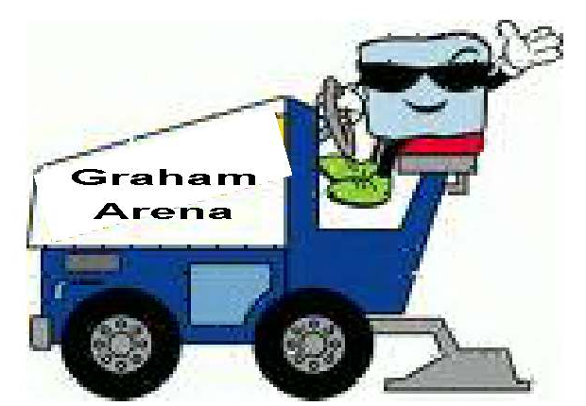

ACHA Hockey Showcase
By Ben Boldt & Shelley Boettcher
Rochester Amateur Sports Commission

The Rochester Amateur Sports Commission (RASC) will be hosting the American Collegiate Hockey Association (ACHA) National Showcase on November 17-19, 2006. Eight Men’s Division III teams including University of Colorado, St. Olaf College, South Dakota State University, University of Richmond and eight Women’s teams including North Dakota State University, St. Cloud State University, University of Minnesota and University of Wisconsin will travel to Rochester to compete in this three-day event. Games will begin on Friday, November 17th and will conclude with Championship games on Sunday afternoon, November 19th. Games will be played at the Rochester-Olmsted Recreation Center and Graham Arena. Full schedule and tournament information can be found on the website, www.rochsports.com.

ACHA is the national organization for non-varsity collegiate hockey teams. Over 300 college and universities belong to the ACHA in 4 divisions. The ACHA hosts several events each year including National Championships for each division. More information on ACHA can be found on their web site, www.achahockey.org.

The Rochester Amateur Sports Commission would like to offer discounted tickets to players, coaches and fans of Rochester Youth Hockey. Please contact the Sports Commission for more details at 507-280-4701.
Copy of News Release
Graham Arena IV
Ground Breaking Ceremony

A groundbreaking ceremony for the Graham Arena IV will be held on August 15, 2006 at 12:30 p.m. at the project site on the County Fairgrounds.

Representatives from the Olmsted County Board, Rochester City Council, Board of Education, and Rochester Youth Hockey Association will offer comments on the project.

The Olmsted County Board approved the funding and awarded the contract to Met-Con Companies in the amount of $5,764,300 on July 25, 2006. Architectural design fees, construction permits, inspections, testing, surveying, legal, bid fees, demolition work, and 5% construction contingency brings the total project cost to $6,463,725.

The Rochester Youth Hockey Association will make an initial down payment of $1,225,000. Additional donations, grants and other funding sources, plus bond issuance costs, will reduce the bond issue amount to $5,022,000.

Olmsted County will finance the project with an 18 year term bond issue.

Olmsted County and the City of Rochester will fund the project at $100,000 per year for 15 years for a total of $1.5 million each. Independent School District 535 and Lourdes High School will finance their share, $930,000, through the capital portion of ice rental fees. Youth Hockey will contribute $5.55 million toward the project.

The Graham Arena project will include 140 x 240 foot multi-purpose arena with an 8,000 square foot lobby connecting the four arenas at the Graham Complex.

The original Graham Arena, Graham Arena West, was constructed in 1968 at a cost of $349,000. Olmsted County contributed $229,000, City of Rochester $30,000, and Youth Hockey $90,000 to construct Rochester’s first ice/multi-purpose arena.

Graham Arena East was built in 1993 at a cost of $1,025,000. Olmsted County contributed $153,000, City of Rochester $100,000, and Rochester Youth Hockey $772,000.

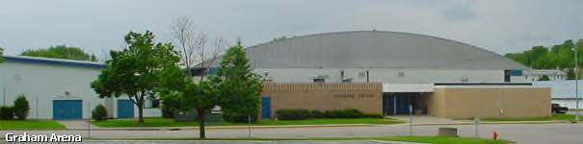
In 1997, Graham Arena North was built at a cost of $1.6 million. The public/private partners in the project included $225,000 each from Olmsted County and the City of Rochester, $250,000 from a State of Minnesota Grant, $325,000 from the high schools through ice rental fees and $575,000 from Youth Hockey.

Construction will start right away and is expected to be completed in the summer of 2007.

Rochester Youth Hockey Newsletter
Non-Profit Org.
US Postage
PAID
Rochester MN
Permit No. 386
Karen Hanson
2011 Century Hills Drive NE
Rochester, MN 55906
khanson@att.net

Direct other correspondence to:
Rochester Youth Hockey Association
PO Box 237
Rochester, MN 55903

Minnesota Wild Tickets
2006-2007 Season
By Brent Koster

RYHA is once again selling a limited number of tickets to five Minnesota Wild home games for $16 per seat. Payment for purchased seats should be by check made payable to RYHA.

Games for sale are:

Pheonix Coyotes Friday, November 24th, 1pm Carolina Huricanes, Saturday February 10th, 7pm
Chicago Blackhawks, Saturday December 9th, 7pm Colorado Avalanch, Sunday March 11th, 2pm
Dallas Stars, Saturday January 20th, 7pm

If you would like to purchase tickets for any of these games or have questions regarding seats,
contact Brent Koster at: b2d2koster@charter.net or call 288-3020 and leave a message.

ROCHESTER YOUTH HOCKEY ASSOCIATION
2006-2007 REGISTRATION
(additional information and forms available on www.ryha.net)
Play hockey with your friends – Everyone welcome, new and returning players.

Sign up at Graham WEST Arena September 12 & 13, 2006 – 6:00-8:00 p.m.
Late Registration at Graham North September 20, 6:30-7:30 p.m.

Check here if first year in Rochester Hockey or if address is different from last registration.

Player’s name: __________________________________________________ Date of Birth: ____________________
L a s t N a m e, F i r s t N a m e

Address: ______________________________________ City: ________________________ Zip Code: ___________

Phone Number: _______________________ Name of School: ___________________________ Grade: ___________

Parents’ Names: Father:________________________________ Mother:________________________________

E-Mail Address: _____________________________________ Sex: M F

Bring a copy of player’s birth certificate. A copier will be available.

GIRLS REGISTRATION: AGE on 6-30-06: _________

Girls U10  (under 10) | Girls U12  (under 12) | Girls U14  (under 14)
$225.00 | $275.00 | $375.00

BOYS REGISTRATION: AGE on 6-30-06: _________

Supermites  trying out for  Traveling Squirts | Squirts  (Ages 9, 10) | PeeWees  (Ages 11,12) | Bantams  (Ages 13,14) | Jr. Gold  (Ages 15-18)
$225.00 | $225.00 | $275.00 | $375.00 | $375.00

How many years of ice hockey experience? __________ Are you a goalie? Yes No

We hereby agree to assume all responsibility for any injury sustained by our child _____________________ by playing or practicing in hockey under the jurisdiction of the Rochester Youth Hockey Association during the 2006-2007 season. We also agree to hold the City of Rochester, Rochester Youth Hockey Association, their employees, officers and coaches harmless against any and all damages, losses, liabilities, or claims arising out of or relating to any injury or loss. I also agree to participate in the Youth Hockey fundraiser through the sale of pizza or cash buyout. Refund Policy: RYHA will refund a player’s registration fee less a $25.00 handling fee for requests submitted in writing prior to late registration 9/20/06. Make checks payable to RYHA.

_______________ _________________________________ _____________________________________
(Date) (Signature of Parent/Guardian) (Parent Email Address)

Will you help the team with? Team Parent Pizza Parent Head Coach Asst Coach Other

The following traveling fees will be due once tryouts are over and players are assigned to teams. Individual team fund fees may also be requested by team managers as agreed to by team.
Squirt A = $325.00, Squirt B2= $200.00, PWA = $350.00, PWB = $325.00, BA = $400.00, BB = $275.00, BC = $100.00,
Jr. Gold = $125.00, GU14A = $375.00, GU12A = $325.00, GU12B = $175.00, GU10A = $300.00, GU10B = $175.00.

Registration use only: Birth Certificate Paid—Check #__________ Payment Plan Tryout # _____________

Rochester Mite Hockey Association
2006-2007 Registration
 | Additional information and forms available at www.ryha.net and click on Mites.
Sign up at Graham West Arena on September 12th & 13th 2006 from 6:00-8:00 pm
Late Registration: September 20, 2006, 6:30-7:30 p.m. at Graham North
 | □ Check here if first year in hockey or if address is different from last registration
 | Player’s Name: |  |  |  |  |  |  |  |  |  |  |  |  |  |  |  |  |  |  | Date of Birth:
 | Player’s Address: |  |  |  |  |  |  |  |  |  |  |  | City: |  |  |  |  |  |  |  |  |  |  |  |  | Zip Code
 | Player’s Home Phone Number: |  |  |  |  |  |  |  |  |  |  |  |  |  |  | Sex: □ Male □ Female
 | Name of School: |  |  |  |  |  |  |  |  |  |  |  |  |  |  |  |  |  | Grade Level:
 | # of years at Termite Level: |  |  |  |  |  |  |  |  |  |  |  | # of years at Supermite Level:
 | Age on 6-30-06: ____________
Termite Level  (Ages 3, 4,5,6)  No birth certificate needed to register |  |  |  |  |  |  |  |  |  |  |  | Supermite Level  (Ages 7,8)  No birth certificate needed to register |  |  |  |  |  |  |  |  |  | Squirt Level Tryout  (Ages 7,8,9)  Copy of Birth certificate needed to register
 | □ $50.00  (ages 3 and 4) |  |  |  |  |  | ⁯$80.00  (age 5 and 6) |  |  |  |  | □ $170.00 |  |  |  |  |  |  |  |  |  | □ $225.00

Parent/Guardian Information
(parent/guardian information required)
 | Name: |  |  |  |  |  |  |  |  |  |  |  | Home Phone Number:
 | Address: |  |  |  |  |  |  |  |  |  |  |  | City: |  |  |  |  |  |  |  |  |  |  | Zip Code:
 | Email Address: |  |  |  |  |  |  |  |  |  |  |  | Relationship to player:
 | Will you help? |  |  |  | □ Team Parent |  |  |  |  |  | □ Head Coach |  |  | □ Asst Coach |  |  |  |  |  |  | □ One Time Volunteer
 | Name: |  |  |  |  |  |  |  |  |  |  |  | Home Phone Number:
 | Address: |  |  |  |  |  |  |  |  |  |  |  | City: |  |  |  |  |  |  |  |  |  |  | Zip Code:
 | Email Address: |  |  |  |  |  |  |  |  |  |  |  | Relationship to player:
 | Will you help? |  |  |  | □ Team Parent |  |  |  |  |  | □ Head Coach |  |  | □ Asst Coach |  |  |  |  |  |  | □ One Time Volunteer
 | We hereby agree to assume all responsibility for any injury sustained by our child _____________________ by playing or practicing in hockey under the jurisdiction of the Rochester Mite Hockey Association during the 2006-2007 season. We also agree to hold the City of Rochester, Rochester Youth Hockey Association, Rochester Mite Hockey, their employees, officers and coaches harmless against any and all damages, losses, liabilities, or claims arising out of or relating to any injury or loss. I also agree to participate in the Youth Hockey fundraiser through the sale of pizza or cash buyout. Refund Policy: RMHA will refund a player’s registration fee less a $25.00 handling fee for requests submitted in writing prior to November 15th. Make checks payable to RMHA.
 | Date |  |  |  |  |  |  |  | Signature of Parent/Guardian


Rochester Youth Hockey
Goalie Equipment Sign-out

Player Name:
Parent Name:
Address:
Telephone:
E-mail Address:
Level: | Jr. Gold Bantam Pee Wee Squirt Supermite

Leg Pads: Size: |  | Make: |  | Serial Number:
Blocker: |  | Make: |  | Serial Number:
Catcher: Size: |  | Make: |  | Serial Number:
Body Armor: Size: |  | Make: |  | Serial Number:

Policy

All goalie equipment is the property of RYHA
- All goalie equipment must be returned or inventoried by May 1st 2007
- You will be responsible to replace all lost equipment
- Summer rental fee’s for 2007 are $150 payable by May 1st 2007
- If you have any problems with the equipment contact the goalie equipment manager listed on the RYHA website

I have read the RYHA Goalie Equipment policy and agree to its terms.

Signature |  | Date

