Steps to create an account and/or become a member
If already have an account with a NGIN and need to become a member, want to verify email addresses, add additional emails skip to step 5.

- Can click on this link to create account
  - http://andoverhuskies.pucksystems2.com/users/new
- Click on “create an account”
  - 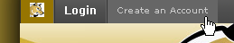
- Fill in your information on the next screen. Make sure both boxes are checked and click on “Sign up for…..”
  - 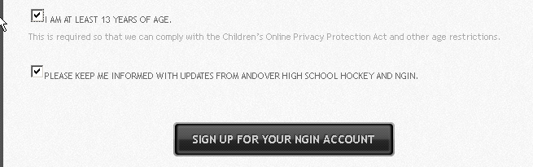
- You will be sent an email to verify your account setup.
- If you already have a NGIN account or if you just created an account and you see this by your login name
  - 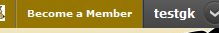
  - Click on “Become a Member” and update your profile/s you want to belong to the site
  - If you want to add additional email address to your account you can click on “account settings”
  - 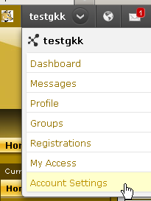
- Click “add email address”
  - 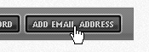
- Enter address and click “add email address”
- A confirmation email will also be sent to this address and the link in the email will need to be click on to verify before that email address will be able to receive messages from the site
To receive emails you have to make sure the “Andover High School Hockey” is checked
