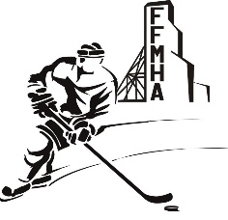
FLIN FLON MINOR HOCKEY ASSOCIATION

NOTICE OF MOTION

AMENDMENT TO:
 | CONSTITUTION ARTICLE NO. |  | PARAGRAPH NO. |  | PAGES
 | BY-LAW NO. |  | PARAGRAPH NO. |  | PAGES

SUBMITTED BY:

DATE:

CURRENT WORDING:

PROPOSED WORDING:

RATIONALE FOR CHANGE:

For Office Use Only
Withdrawn | Tabled | Carried | Carried as Amended | Defeated

