Summary:

The following instructions summarize the process and settings for creating a template that uses Avery Mailing Labels 5163/8163. These labels can be used for

In Microsoft Word 2007 and 2010:

- Select “Labels” under “Mailings” tab
- Select “Options” on the “Envelopes and Labels” pop-up

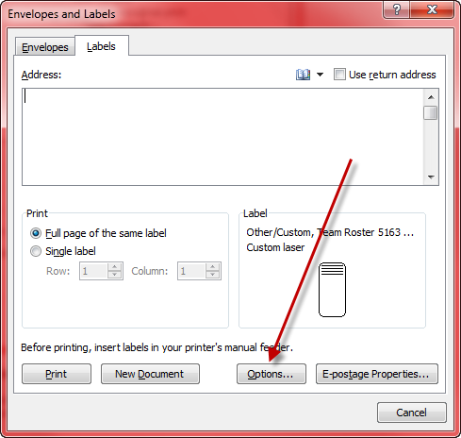

- Select “Other/Custom” in the drop down for ”Label Vendor”
- “New Label” on the “Label Options” pop-up

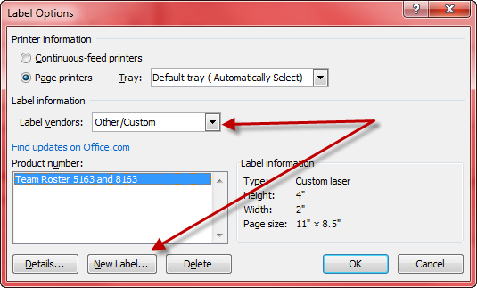

- In the pop-up, adjust the measurements to match the ones below and click “Ok” when finished (You may name it anything you want)

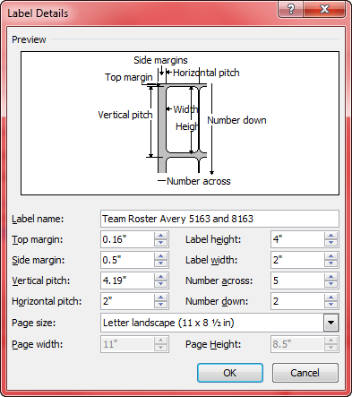

- You have just created a template that will print on Avery 5163/8163 Mailing Labels
- Populate the cells with Player and Coach information

