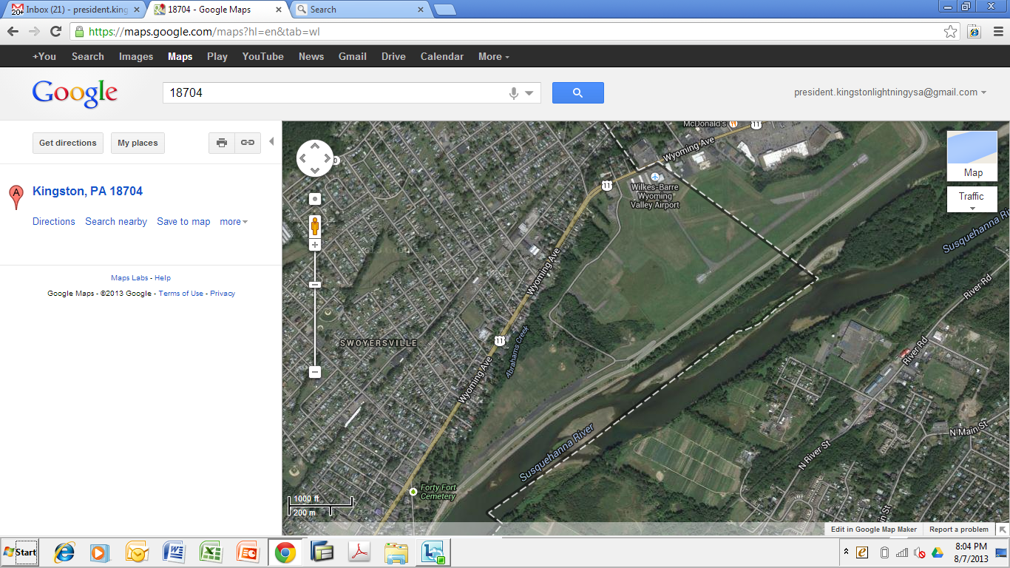

LUZERNE C. FIELD

FF FIELDS