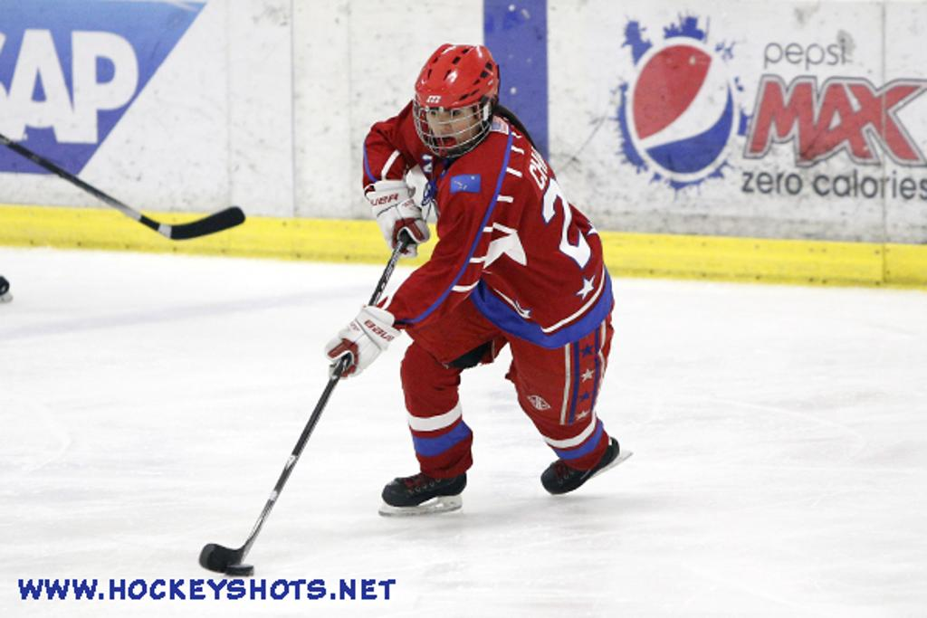  - April 2, 2014  USA Hockey Girls Tier II National Championships  Welcome Party  Players and families come join us at the Girls Nationals Welcome Party hosted by Amherst Hockey. There will be food, music/DJ, dancing, contests/prizes and lots of fun. Players are free, adults are $10.00, seniors and children under 12 are $7.00. The Party will be located under the tent in the back of the facility. Please see your scheduled times located on the side panel for each age group. Team Contests to include: Team T-Shirt and Overall Team Theme contests for each level (see attached contest rules for additional info).  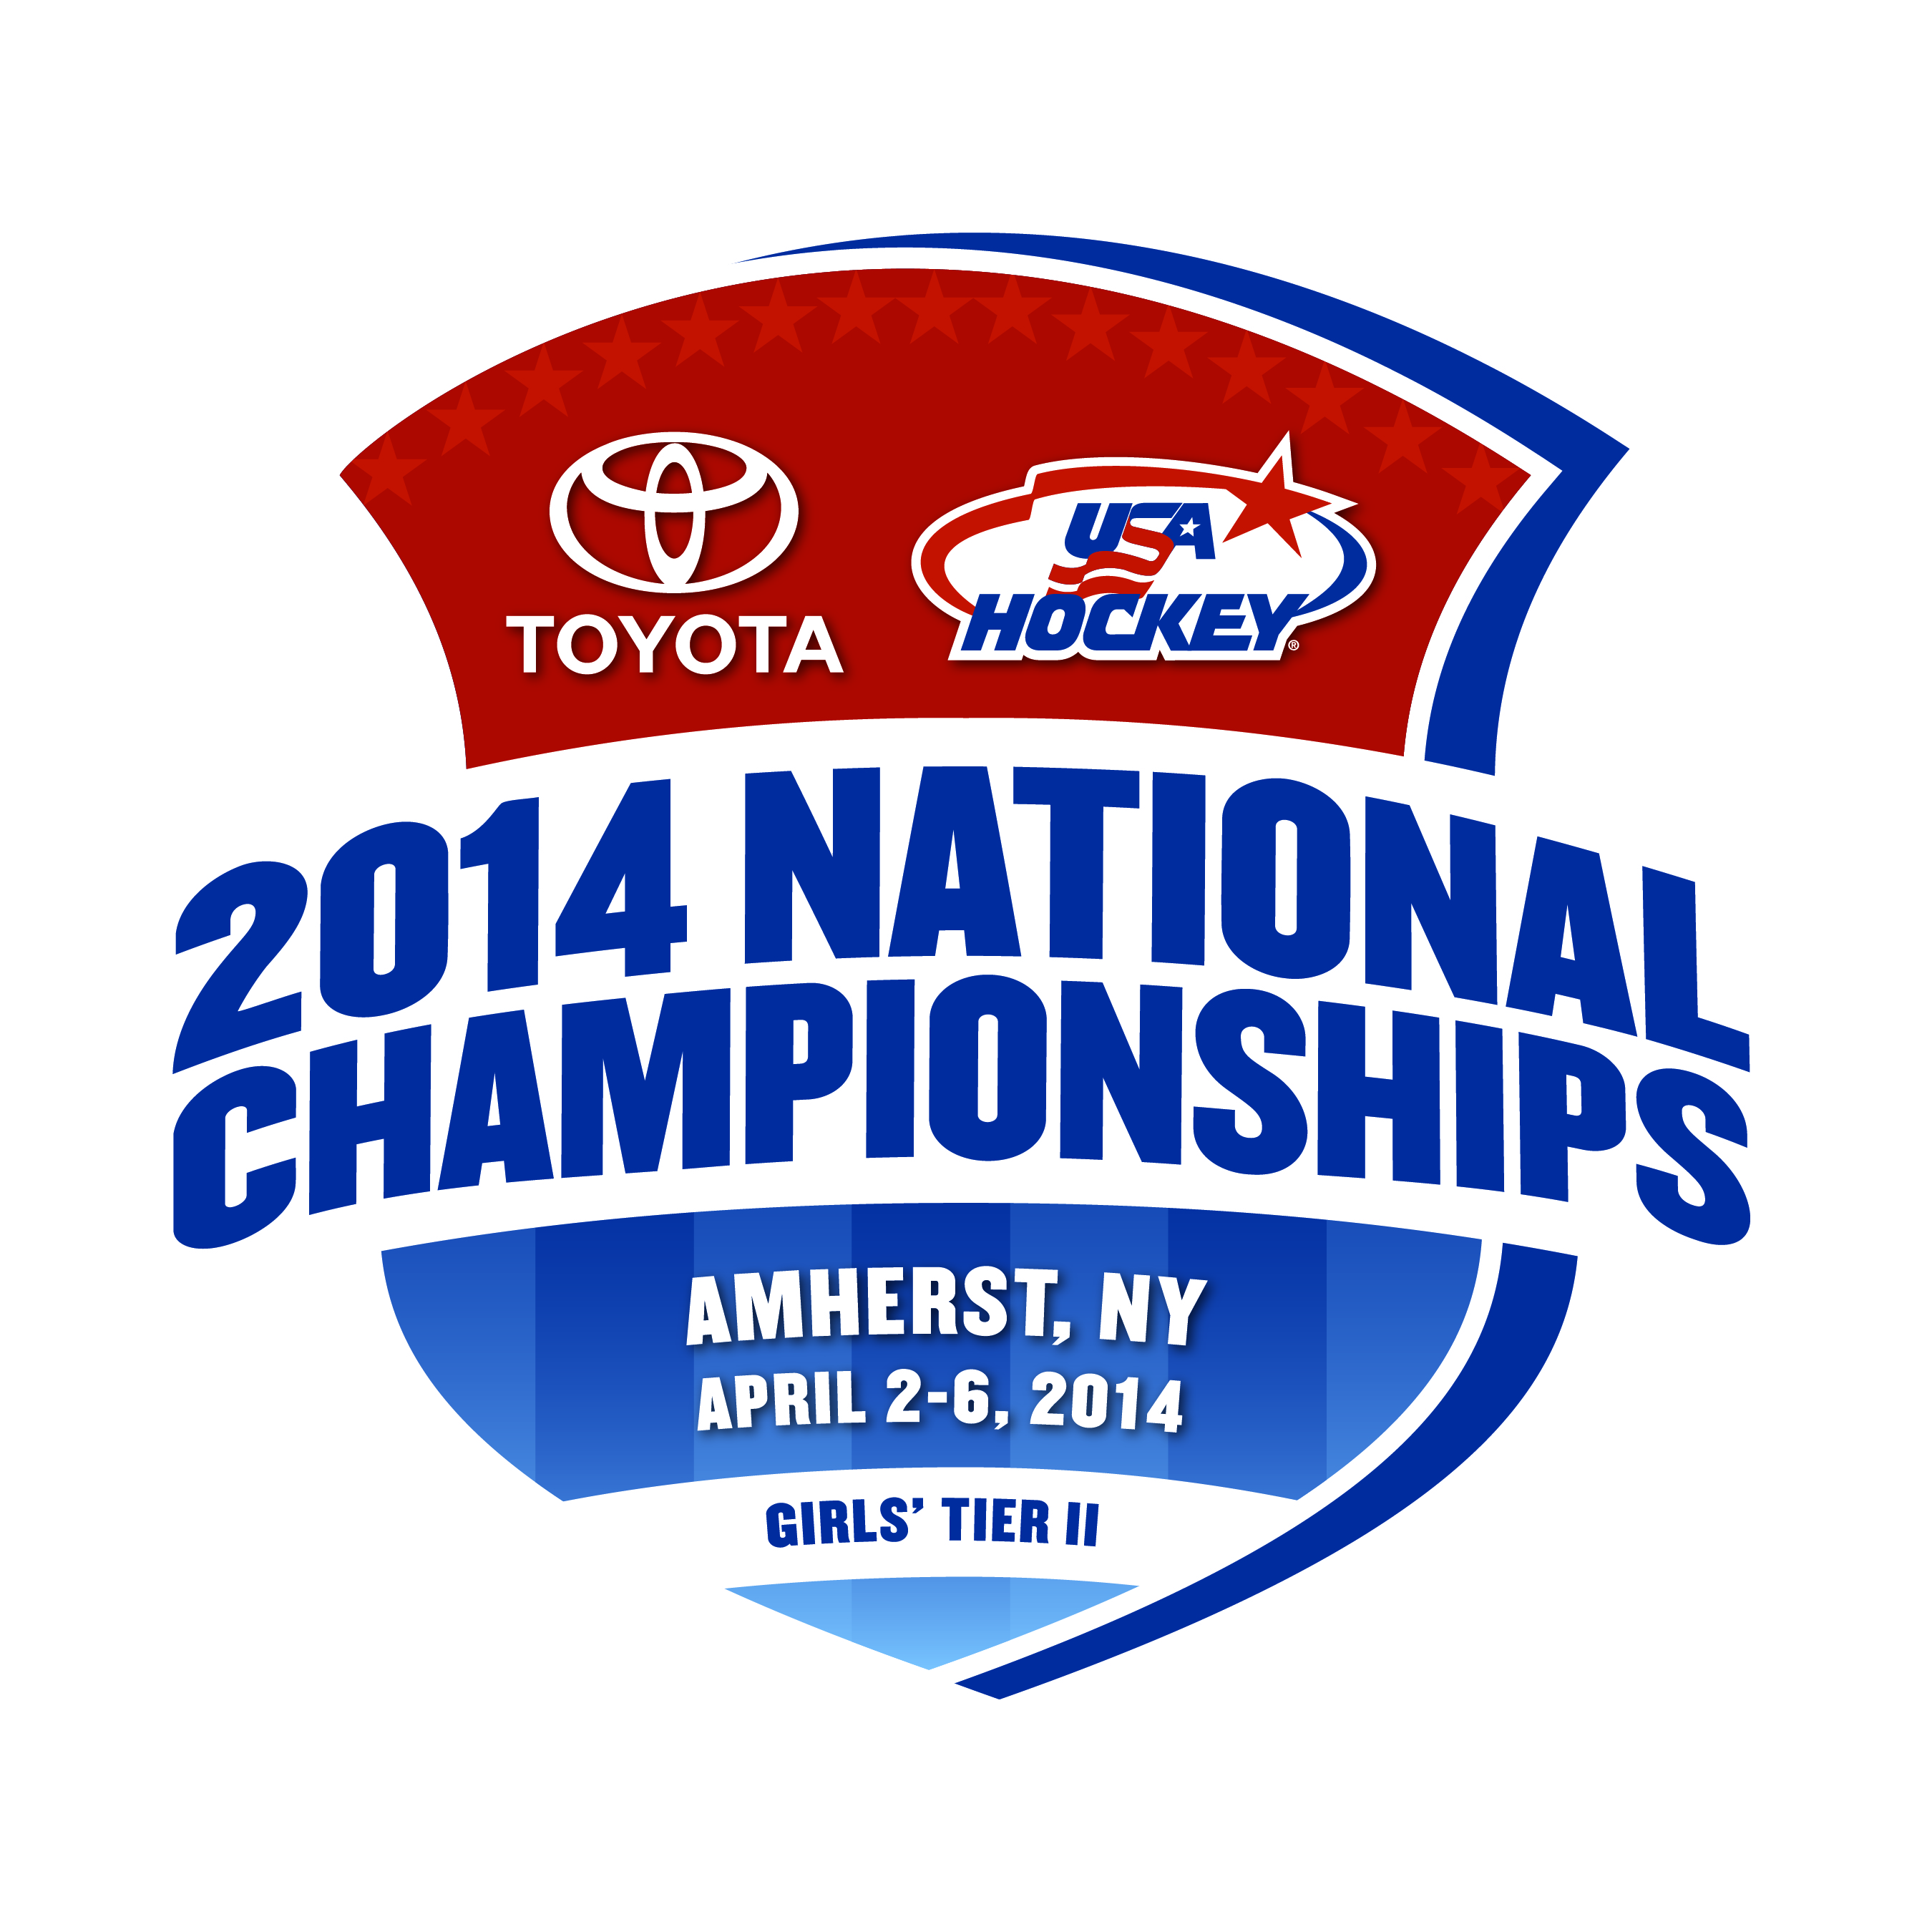 |  | USA Hockey’s Girls Tier II National Championship Welcome Party  April 2, 2014 @ Northtown Center of Amherst, in the back lot under the tent  There will be food, music/DJ, dancing, contests and lots of fun!!!  Designated Welcome Party times: 14U-4:00 PM-6:00 PM, 16U 5:00 PM -7:00PM & 19U- 6:00 PM-8:00PM  Players free, Adults-$10.00, Seniors and Kids under 12-$7.00  Northtown Center of Amherst  1615 Amherst Manor Drive Williamsville, NY 14221 716-631-7555  April 2, 2014 4:00 PM – 8:00 PM

2014 Tier II Girls Nationals Team Tee Shirt Contest Rules
Each Girls team will produce t-shirts representing your team organization, city or state. The teams at each level (14U, 16U and 19U) with the top designs will receive a prize. Winners will be chosen by our distinguished panel of judges.
To participate, each team member should wear their team t-shirt at the Welcome party. When your team is called upon, each team will come forward and the designated team representative will explain their t-shirt design.
Winners will be announced before the end of the Welcome Party and all participants are expected to attend the Welcome Party.

Contest Rules
- Designs must include either your team logo or organizational logo to be eligible for awards.
- T-Shirt Contest winners will be selected prior to the end of the Welcome party by popular vote.

Contest Checklist
- Design a team t-shirt
- Wear your t-shirt at the Welcome Party.
2014 Tier II Girls Nationals Team Theme Contest Rules
- Each Girls team will determine a team theme incorporating the Tier II Nationals logo and your team organization, city or state. The teams at each level (14U, 16U and 19U) with the top designs will receive a prize. Winners will be chosen by our distinguished panel of judges.
- To participate, each team will be called up at your designated time during the Welcome party to present their theme.
- Winners will be announced before the end of the Welcome Party and all participants are expected to attend.
- Be creative and have fun.

