CAMEL KIDS PUSH UPS FOR OUR TROOPS
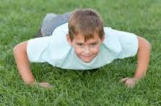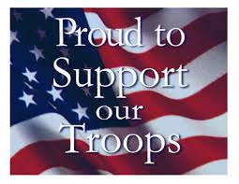

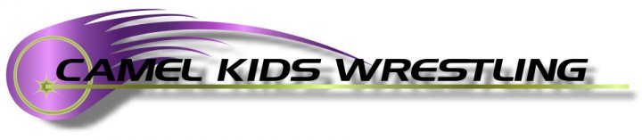
June 21st, 2014
Dalbey Park (Fishing Lake)
1:00 p.m
JOIN US IN SUPPORTING OUR TROOPS
Nationwide Americans throughout the U.S. will join together to show our support of the 1.4 million service men and women that are currently serving our country by completing as many push-ups as they can in 90 seconds.
Each pushup completed raises much needed funds for Boot Campaign®, a national nonprofit that promotes patriotism, raises awareness and provides vital assistance for our nation’s heroes.
The Boot Campaign® provides assistance to our military and their family members through six key initiatives: Jobs, Housing, Wellness, Education, Urgent Assistance and Family Support.
https://www.crowdrise.com/CamelKidsPUC/fundraiser
or contact Scott Sorensen at (307) 696-3986 or Mike Johnson at (307)660-4969

