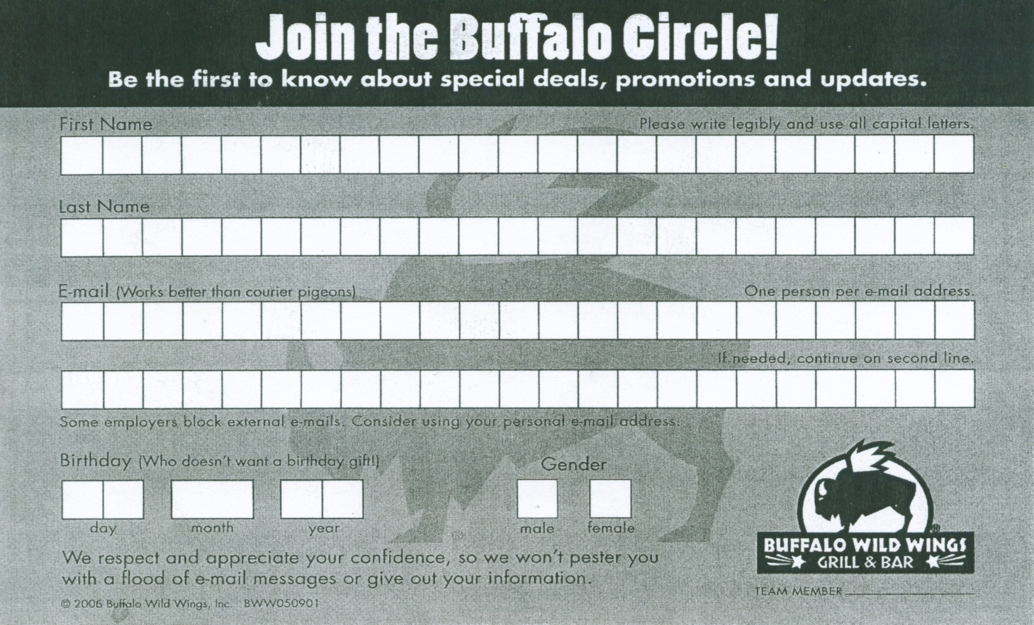

All Players, students, families and fans are invited to
participate in a fundraising event for
Fort Wayne Travel Hockey PeeWee A1
Everyone is invited to gather at
Buffalo Wild Wings® (10524 Maysville Rd.)
Please join us for dinner or a snack, from 6-8pm.
10% of all food purchases* accompanied by the certificate
below will be donated to Fort Wayne Travel Hockey PeeWee A1.

Please join us on:
Wednesday, January 28, 2015, 6-8pm
Present this flyer to your Cashier or Server at the time of your purchase
and know that 10% of your purchase* will go to support Name of Fundraiser.
Only valid at 10524 Maysville Rd., Fort Wayne IN (260) 486-9464.
*Alcohol purchases not included.

