








4
^{th}
Annual North Paulding Touchdown Club
Golf Tournament
Tuesday, June 16
^{th}
, 2015
Raffle Tickets & Other Great Prizes
Win a pair of FREE NPTC Den Memberships!!

Mulligan Package $20- Includes 1 raffle ticket & 2 Mulligans

see reverse side for registration and payment information)
(
4545
Champions Walk Dr.
Acworth, GA 30101
$100 per golfer

Includes Breakfast & Lunch
Driving Range & Cart
9:00
am Start

Driving Range opens at 7:30am
Individual Registration Foursome Registration

Name: __________________________ Name: __________________________

Email: __________________________ Email: __________________________

Payment Information Name: __________________________

Cash ___ Total Amount $_________ Email: __________________________

Check ___ Check #_______________ Name: __________________________

PayPal ___ Receipt# _____________ Email: __________________________

Credit Card ☐Visa ☐MC ☐AMEX Name: __________________________

Credit Card # _____________________ Email: __________________________

Exp: __________ Security Code: _____ Company Name: _________________

Hole Sponsorships are available! Contact Kbentley2995@gmail.com for details.

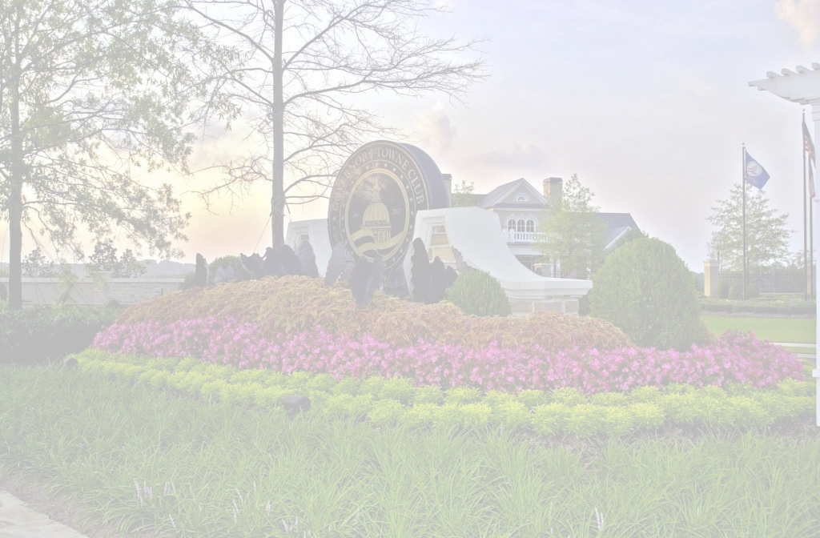
You can pay online at www.northpauldingfootball.com or make checks payable to NPTC.
Thank you for your support!!

NPTC is a registered 501c3, a portion of your registration may be tax deductible. Please consult your tax advisor.
Each participant assumes full liability for any and all damages caused to the facility during the course of the tournament.



