Bat Speed Agility Workout

- Modified Dynamic Warm Up

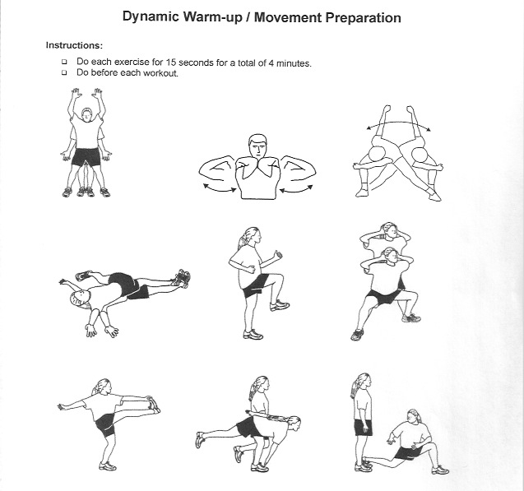

- Strength Circuit

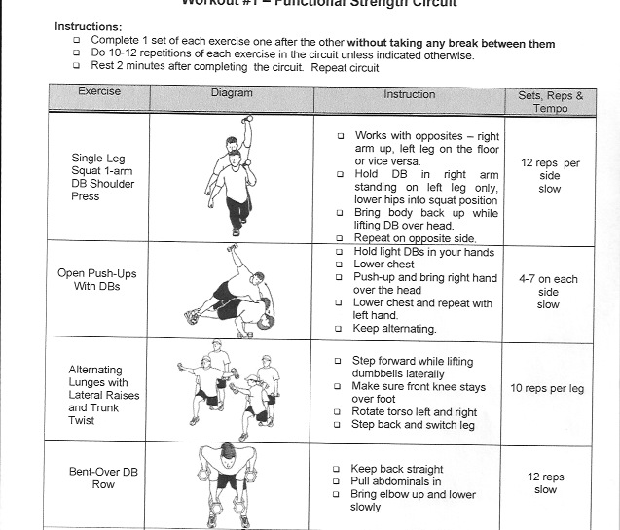

- Hitting Circuit

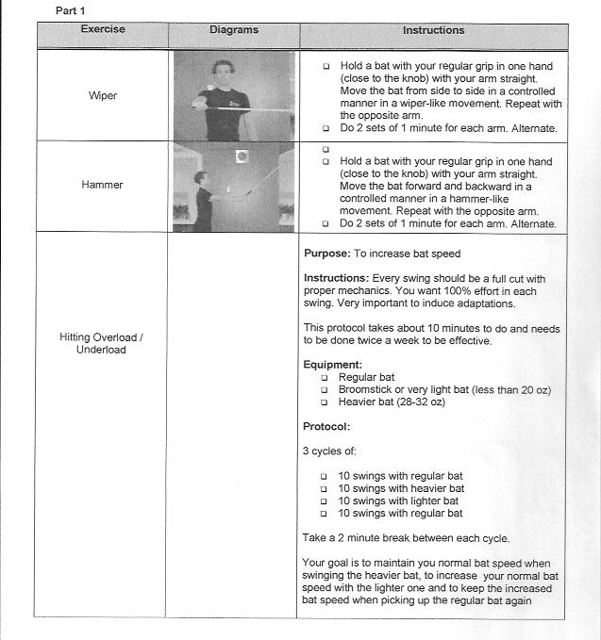

- Hitting Drills
  - Long Tee Drill
    - Hit off T with target 30-50 feet away.
  - Drop Toss
    - Partner drops ball from shoulder height.
  - Heavy Ball Side Toss
    - Side toss with heavy ball
  - 60 Second Drill
    - Take as many swings as you can (correctly) in 60 seconds. Do twice

