We are
THE OMAHA "AIR STRIKE"
QUARTERBACK ACADEMY
We are a local program, for local athletes, by local coaches with championship experience.
We provide affordable, off-season instruction for athletes attending any school.

We are experienced coaches with a proven track record of developing All-State, All-District, and All-Conference quarterbacks.
We employ positive coaching methods aimed at building confidence and success.
We are career coaches who are
state-certified-educators.
We are "safe environment" and "concussion awareness" certified.
We are fathers who strive to coach our athletes the way we would want our own children to be treated.
We are the first, local program in Omaha to offer annual camps designed specifically for youth QB's.
We are committed to developing our quarterbacks in fundamentals critical for success: Drops, Reads, Execution, Accuracy, Mechanics
The D.R.E.A.M.

For complete BIO’s of our
CHAMPIONSHIP COACHES,
please visit
www.omahaqbacademy.com

8TH annual

youth

QUARTERBACK Camp
QB'S WILL LEARN
Proper grip
Proper stance
Drop techniques
Foot speed drills
QB keys for success
Moving in the pocket
Throwing with accuracy
Proper throwing mechanics
Huddle & cadence procedures

Quick release & efficiency drills
Read-recognition and "chalk-talk"

WHAT IS INCLUDED

- INSTRUCTION BY VARSITY COACHES
- FILM STUDY & TECHNOLOGY EQUIPMENT
- RECEIVERS & TARGETS
- AGE SPECIFIC FOOTBALLS

WHAT TO BRING

- EXTRA T-SHIRT & SHORTS
- WATER BOTTLE/JUG
- CLEATS (NO BASEBALL SPIKES PLEASE)
- HAND TOWEL (OPTIONAL)
- A GREAT ATTITUDE! (MANDATORY)

Presented by
OMAHA “AIR STRIKE”
QUARTERBACK ACADEMY
www.omahaqbacademy.com

Ages 12-14
Friday
July 17
8:00 – Noon
$45

Ages 6-8
Wednesday
July 15
10:00 – Noon
$25
Register at: www.omahaqbacademy.com

Ages 9-11
Thursday
July 16
9:00 – Noon
$35

Target your D.R.E.A.M.
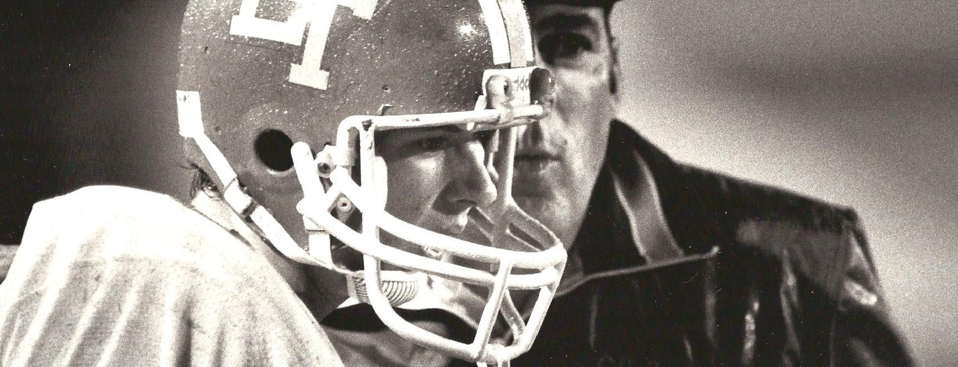
AGES 12-14
FRIDAY
JULY 17, 2015
8:00 a.m. - Noon
$45
Register at: www.omahaqbacademy.com
SCHEDULE*
7:30 - 8:00 Registration
8:00 – 8:50 Proper warm-up techniques, grip, stance, throwing mechanics, throwing for accuracy.
8:50 - 8:55 Break
8:55 - 9:20 3 & 5-step drop techniques, footwork and balance drills, movement in the pocket drills.
9:20 - 9:25 Break
9:25 - 9:50 Roll-out techniques, throwing on the run, basic routes & reads.
9:50 - 9:55 Break
9:55 - 10:50 NFL style QB competition
11:00 – 11:55 Chalk-talk, understanding coverages, reads & recognition
11:55 - 12:00 Break-it-down
*Subject to modification
AGES 9-11
THURSDAY
July 16, 2015
9:00 a.m. - Noon
$35
Register at: www.omahaqbacademy.com
SCHEDULE*
8:30 - 9:00 Registration
9:00 – 9:30 Proper warm-up techniques, grip, stance, throwing mechanics, throwing for accuracy.
9:30 - 9:35 Break
9:35 - 9:50 QB Competition
(Emphasis on FUNdamentals)
9:50 – 10:20 3 & 5 step drop techniques, footwork and balance drills, movement in the pocket drills.
10:20 - 10:25 Break
10:25 - 10:40 QB Competition
(Emphasis on FUNdamentals)
10:40 - 11:10 Roll-out techniques, throwing on the run, basic routes & reads.
11:10 - 11:15 Break
11:15 - 11:40 Hand-off techniques
11:40 - 11:55 QB Competition
(Emphasis on FUNdamentals)
11:55 - 12:00 Break-it-down
*Subject to modification
AGES 6-8
WEDNESDAY
July 15, 2015
10:00 a.m. - Noon
$25
Register at: www.omahaqbacademy.com
SCHEDULE*
9:30 - 10:00 Registration
10:00 – 10:15 Proper warm-up techniques, grip, stance,
throwing mechanics
10:15 Break
10:20 - 10:35 QB Competition
(Emphasis on FUN!)
10:35 Break
10:40 - 10:55 Reinforce throwing mechanics. Progress to throwing for accuracy.
10:55 Break
11:00 - 11:15 QB Competition
(Emphasis on FUN!)
11:15 Break
11:20 - 11:35 Intro to receiving the snap and 3-step-drop mechanics
11:35 Break
11:40 - 11:55 Reinforce receiving snaps & 3-step-drop mechanics.
11:55 - 12:00 Break-it-down
*Subject to modification

