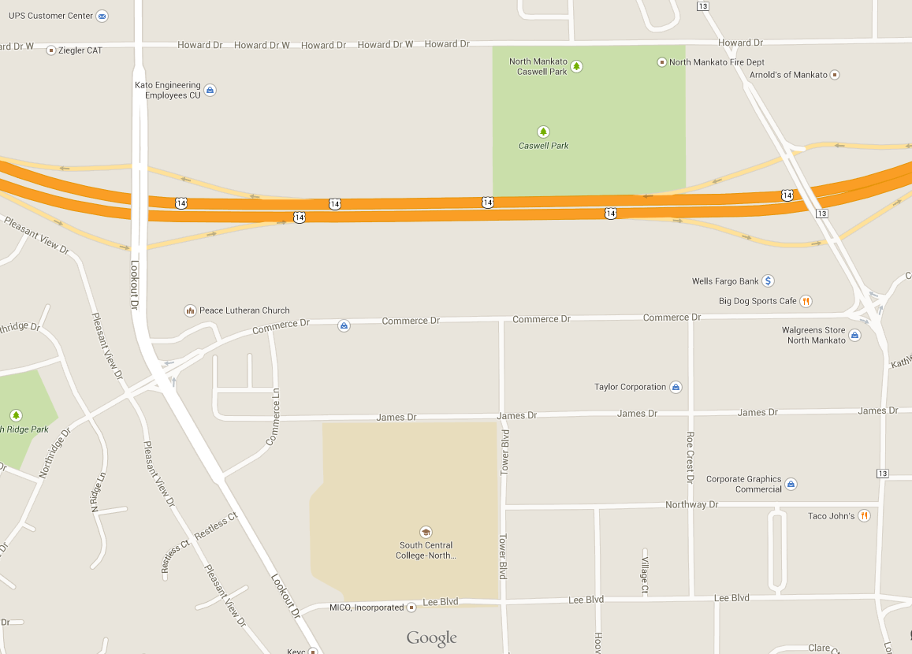
Note – there will not be concessions at the South Central Field locations. There is one parking lot and on-street parking. There will be two port-a-potties on site.
Parking
1
5
4
2
3

