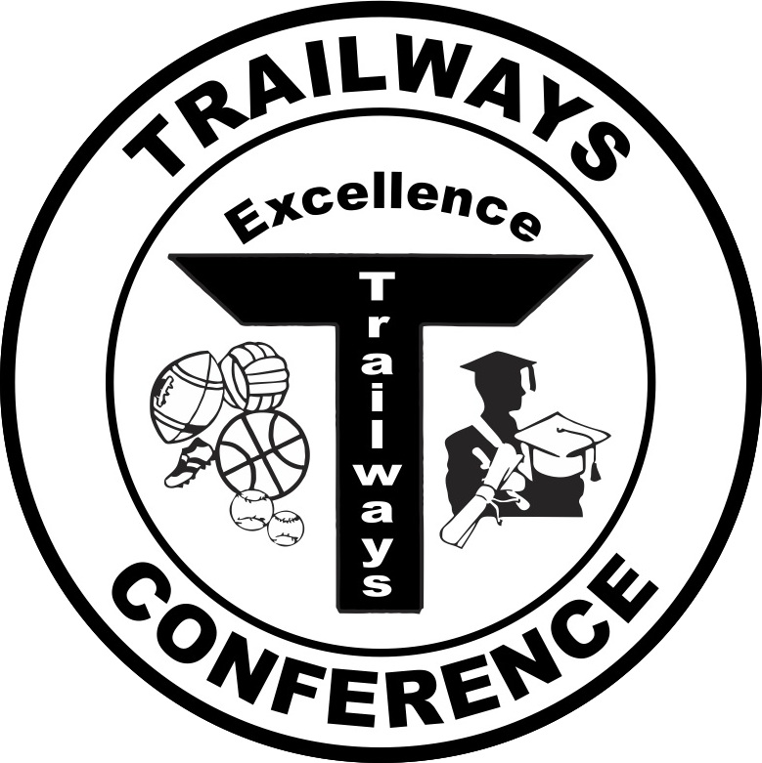

Rich Fronheiser, Commissioner
550 Vista Cir
Columbus, WI 53925
trailwayscommish@gmail.com
(920) 623-9660 - office
(608) 469-5722 - mobile

2015 Trailways South Softball All-Conference Teams

First Team
Player of the Year – Taylor Emrath, Johnson Creek

Player | Class | School
Quinn Kruel | Senior | Horicon
Angie Laabs | Freshman | Horicon
Madison Mantai | Sophomore | Horicon
Sarah Schliewe | Sophomore | Horicon
Megan Tillema | Senior | Horicon
Elysa Doherty | Sophomore | Johnson Creek
Taylor Emrath | Senior | Johnson Creek
Gwen Uselman | Senior | Johnson Creek
Alex Eilenfeldt | Junior | Deerfield
MacKenzie Kapral | Junior | Deerfield
Gracie Wilson | Sophomore | Deerfield
Hannah Spern | Senior | Dodgeland
Taylor Scott | Junior | Williams Bay

Second Team

Player | Class | School
Peyton Litterick | Sophomore | Horicon
Mady Heald | Freshman | Johnson Creek
Alyssa Layton | Senior | Johnson Creek
Calista Schindler | Freshman | Deerfield
Elizabeth Calvo | Senior | Dodgeland
Bella DeNotto | Freshman | Williams Bay
Sabryn DeNotto | Junior | Williams Bay
Kiara Kuehl | Senior | Hustisford
Kelly Schiller | Sophomore | Hustisford
Kelly Tramburg | Junior | Fall River
Megan Waterworth | Senior | Fall River

