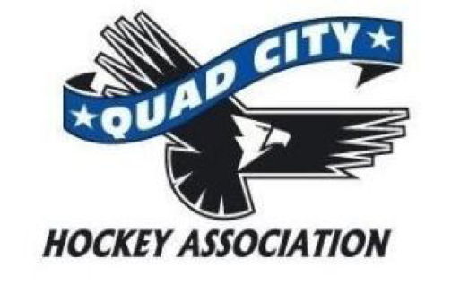

Meeting Minutes
Monday, March 3
6:00 pm The River’s Edge

Call to Order. Meeting was called to order at 6:04

Present: Mel Muskopf, Mark Fitzpatrick, Marv Wise, Bill Shink, Allen Arendt, Mike Hurd, Anne Gannon, Todd Larsen, Lori Sturtzer, Cory Nelson

Excused absence: Jay Freiburger; Todd Watkins. Allen made motion to approve. Mike second. All approved.

Approval of Minutes – February minutes - change from "meeting agenda” to "meeting minutes". Allen made motion to approve, Cory second the motion. All approved.

New Business:

Player banquet - last year cost less than 1500. Lori Larsen, Anne Gannon were integral in the planning of this event. This year the cost for the YMCA is slightly higher.
The event is planned for March 29
Motion to approve $2000 budget. Todd made motion. Allen second. All approved.

Try hockey for free - 38 kids participated. 21 showed up without registration. Handed out info about upcoming programs. The age of participants were under 8 and a few approx. 10/11. Announced at mallards games, handed out jerseys

- Marv shared that is encouraging Blues players to work with youth hockey players. Have to be 13 years old to help.
- Are older players available to tutor hockey skills during the summer months? Todd shared that stick and puck is available from the city of davenport. Patrik Levesque has camps coming up.
- Discussion regarding select tryout time. Todd Larsen shared since jay is not present.
- Want to get house established before team selected.
- Will attendance improve? Select coaches need to come to house practice. Todd used Bill Shink as an example of how it should work.
- Some in attendance expressed concern regarding fundraising - waiting to start season late will impact that opportunity.
- Select is a program of house - is there an option to a second travel team - only if there are the numbers to support three teams.
- There were concerns expressed that some house coaches are not available consistently for practices.
- Many in attendance do mot support moving Pee Wee select tryouts to fall.

At this point , all ballots were collected by Lori Sturtzer and Anne Gannon. They were each accounted for and the election results tallied.

Election
Vice President - Mike Hurd
Travel director - Bill Shink
Director at large - One Goal - Mark Fitzpatrick
Director at large - select two
- Allen Arndt
- Melissa Muskopf

All elected. Mike made to approve. Cory second. All approved.

If you want something on the agenda - please email the secretary regarding the topic at minimum 10 days prior to Board Meeting.

Adjournment: Cory made motion to adjourn meeting at 7:00 pm. Allen second. All approved.

Next Meeting: Monday, April 7, 2014, 6pm at The Rivers Edge

