Roll Call: Brooks Savage, Adam Hoffman, Josh Colvin, Adam Welch, Joe Harris, KC Erredge, Terry Johnson, Joe Harris, Don Huemoeller, Ryan Stoffel, Matt Zaruba , Shannon Callahan, Joe Kuhn, Randy Kruse, Brian Dooley, Bernadette Schaffer
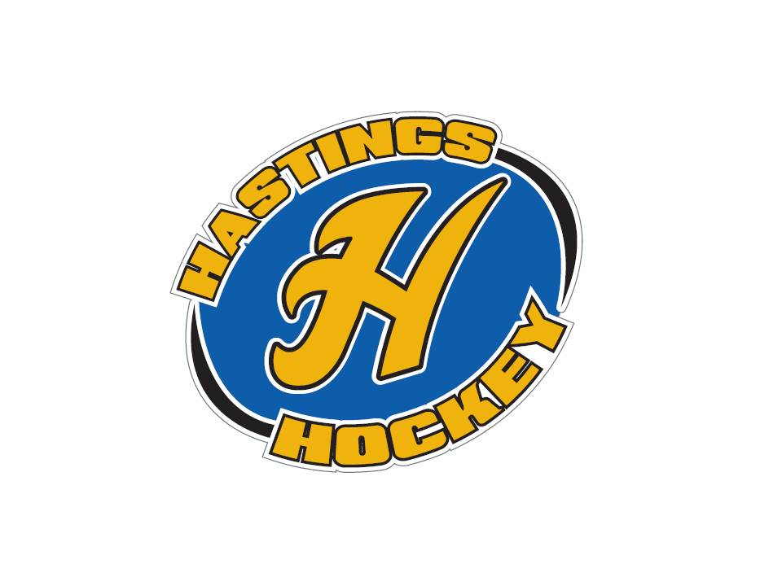
Not in Attendance: Travis Steele, Jeff Plank, Jay Stark, Jim Foster, John Klimek

- Approval of Agenda Motion made by KC, seconded by Brooks – motion passed
- Approval of Minutes Motion made by Ryan, seconded by Adam – motion passed

Coordinator Reports
- Referee – John Klimek – not in attendance
- Registrar – Shannon Callahan –
Can not get into website, looking to find a solution to that?
Volunteers , coaches etc. need to be screened and on USA Hockey SafeSport this is good for 2 years) prior to any 2015-2016 actvities. KC will get a list of all coaches who did SafeSport last year. If coaches do not complete this training, they will not be allowed on the ice.
Joe H. requested that someone assemble a master coaches email distribution chain from mites to Jr. Gold/U14. . Joe H. wants all of the coaches registered with Hastings Hockey with completed background checks before the start of each season too.
Register kids with exact same names as previous years
All WI skaters need to be waivered in each year
- Technology – Jay Stark/Randy Kruse
Nothing new – Joe H. wants to update logo banner on website and email distribution.
- Tournament Director – Jim Foster – not in attendance
- KC reported that the tournaments Hasting Hockey is hosting are filling up. Sponsorships – Terry Johnson
Working on golf tournament, hockey night – we have 6 new sponsors for the golf tournament
- District 8 – Brian Dooley
District 8 will have no chairs changes from previous season.
Hastings was approved for all tournaments
Need Coaches clinic hosts
Johnson /Como/North St. Paul are merging and will play in the District.
Minnesota Hockey adopted a classification change from U14 to U15 at its annual meeting. Goalie – Josh Colvin
- Josh will contact a vendor to order goalie equipment for upcoming season. Secretary – Bernadette Schaffer
Nothing new

Officer Reports:
- President – Joe Harris
- Hockey Night and Golf Scramble promotion, Strauss has delivered the protective gear from the spring sale. Joe H. mentioned that the breezers with the stripe and breezers look sharp with the jersey and socks. –Vice President – Brooks Savage
working with new scheduling program weekly
We are the first customer of this program, so it is a work in progress
Directors - please let Brooks know ASAP what tournament dates etc. are so they can get weekends scheduled
Coaches clinics?? Talk with Adam about getting those set up in the near future
Does have hours from Jeff
Try to get mites and termites in to have coaches clinics
- Treasurer – K.C. Erredge
Went over the profit and loss budget
Went over the balance sheet $52.240 is in the budget as of August 16th
10 families have asked for scholarships this year
8 families asked for it last year, but have not registered yet this year
Last year we did bag tags, looking for a new idea – let KC know if you have an idea
Approval of Financial Statements
- Motion made by Ryan, seconded by Brooks – motion passed

Director Reports:
- Volunteers – Terry Johnson
nothing to report
- Coach-In-Chief – Adam Welch
nothing to report
- Operations – Matt Zaruba
We now have an inventory of sizes etc.
Met with Vendor, he needs more $$$ to get the dryland idea going, he will meet with Joe about this
Boards update, grant was requested to go forward with these, and there will be a orientation for coaches to use the boards
Skate racks – are expensive so they will try to build something
- In-House Girls – Adam Hoffman
Registration going well
Adam has gotten many emails from interested parents

- Travel Girls – Travis Steele -not in attendance
Joe H. reported on his behalf
U14 – 12 registered, could go up to 16 possible players

- Ter-Mites – Vacant position
Joe H. is hoping to get a parent to fill this position here in the next month or so that either has a child at that age, or wants to be on the board.

- Mighty and Super Mites – Josh Colvin
Gave an update on numbers

- Squirts – Ryan Stoffel
Gave an update on numbers – looking to have 6 teams

- Peewees – Joe Kuhn
Terry Fischbach requested the Board consider having a B2 team this season. Extensive discussion ensued about variables that goes into this decision. Terry F. mentioned that two C-teams fared well the previous season. Joe H. suggested that Joe K. collaborate with coaches (past and present) for a recommendation.

- Bantams – Don Huemoeller
Gave an update on numbers – good showing so far
Looking to reach out to other towns for goalies – discussion was made on if there are “open tryouts”
Need to hire another coach

- Jr. Gold – Jeff Plank – not in attendance
Joe H. mentioned that a lot of potential Jr. Gold eligible players are expected to tryout for the high school team. He does not expect a lot them to register until after the high school selection process.
Joe Harris reported that the Board will support a Junior Gold B level rather than a U16 team to all include high school age players that have been playing in the program.

Old Business:
- KC met with accountant that discussed fraud and security, and there are new guidelines coming in for potential audits. A recommendation was made that the treasurer should be taking extensive notes on when and why checks are higher or different than what was discussed originally. Possibly add in a clause that checks over a certain amount will be checked over by the President or VP etc. Joe discussed a committee possibly meeting with KC every 3 months or so and sitting down and checking over her numbers.
New Business:
- Custom Game Pucks – T. Steele/ R. Stoffel
Travis has an idea for having custom game pucks made for home games with the intention of having coaches hand out pucks each game for the deserving MVP of that game. Joe would like these to go out as gifts for each player. Possibly find a sponsor for these pucks????
- Matt would like to get a higher deposit check for mites who use booster equipment as we have had many sets of equipment not returned.
- Joe H. urged the directors to read through the handbook to ensure that the management for each level reflects the operational structure.
Board Comment
Membership Comment
- Adjournment at 9:22 and Notice of Next Meeting: September 13th, 2015. Motion made by Terry , seconded by Brooks – motion passed

