COACHES CORNER: Volume 2
Hitting for beginners

1. Picking out a bat:
The young hitter must use a bat she can handle. There's a simple test to know if the bat is too heavy or not. Ask the child to hold the bat in her dominant hand (right hand for righties; left hand for lefties), and hold it straight out for five seconds. If the bat wobbles or drops, it is too heavy for her. If it can be held easily, it is the right weight.

2. KEEP IT SIMPLE!
At the early ages of instruction it is important to keep it simple and use key words as memory triggers for the kids. Over complicating the swing at an early age can cause frustration for both the kids and the parents. This guide will teach you key words and techniques you can use to get a basic swing developed.

3. The Stance
A. The Standard Grip: "KNUCKLES"
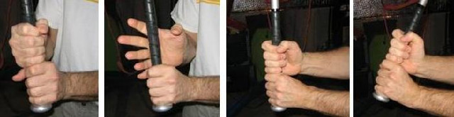
In this grip, the bat is placed where the fingers meet the palms and is held loosely with the fingers, not the palms, as shown in the photo above. Line up the middle set of knuckles on their top hand with the middle knuckles on the bottom hand. But you don’t have to line them up exactly – as long you hold the bat loosely, especially with the top hand, they will align naturally as you swing.
The standard grip also allows you to cock the wrist on your upper hand up, which gives you more rotation from the wrists and allows you to really drive the bat into the ball with your upper hand. The two photos to the right above show the wrists uncocked, then cocked, using the standard grip. You use your wrists to accelerate the barrel of the bat through the hitting zone at contact, so more wrist rotation = more acceleration = more power.

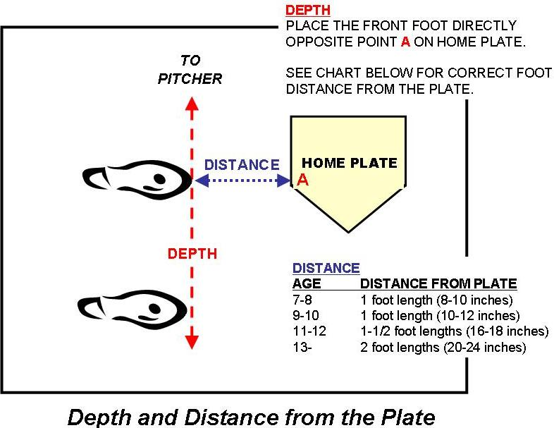
B. "FEET"
Feet should be slightly wider than shoulder width apart. The front foot slightly open (point toward 1B dugout for righties, 3B dugout for lefties) and located at point A on the diagram below.

The distance from the plate can be determined by extending your bat out and touching the back end of the plate. Usually for the younger kids about 8-12" from the plate. Most coaches at the beginning level will draw a line in the sand so that the kids can put their feet on the line until they get use to the distance.

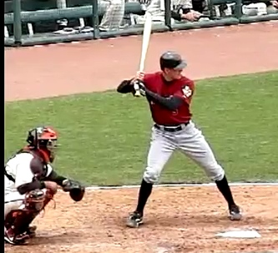
C. "KNEES BENT"

The knees should be bent with the weight on the inside balls of the feet and big toes. Their weight should be 60% on the back foot in the initial stance.

D. "HANDS UP"

Hands should be up and lined up with the rear shoulder and over your back foot. Your back elbow should not touch your body. The bat should be pointed up and tilted slightly towards the pitcher (not resting on the shoulder) so that the "sweet part of the bat" is directly over your back ear
E."EYES ON THE BALL"

From this point on you should watch the ball from the pitchers hand all the way through the swing motion. The batter should watch the ball in the pitchers hand, leave the pitchers hand, in the air, and when making contact with the bat and leave the bat. If you are truly following the ball your head should be down looking at your bat when making contact.

4. THE SWING:

"SWING AWAY"
This step can get very complicated and we recommend "KEEPING IT SIMPLE" for the beginners. As the batters become more comfortable with the basics and just swinging the bat, then you can introduce some of the more finer points of hitting that will help develop power and bat speed.

To keep it simple in this step the batter will do the following: Just before pitcher releases the ball:
A. Load: Shift more weight on the back foot. Turn front shoulder down and away from the pitcher and toward the catcher. Your back should should be higher than your front shoulder.
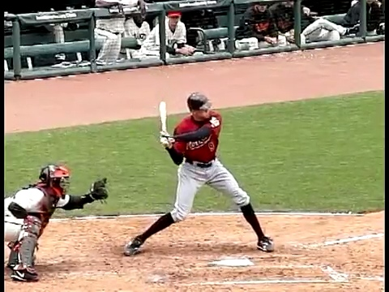
B. Launch: Drop your back elbow to your side which helps drop the bat barrel to a flatter position to get on the plane of the pitch. Shift 60% of your weight to your front foot, leaning toward the plate. You can take a small step at this point to help with the weight shift. Your back Knee should start to turn towards your front knee. This should allow you to turn your hips more easily which will give you more power.
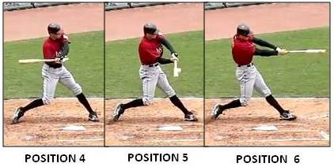
C. The swing: "SQUISH THE BUG with your Toes"
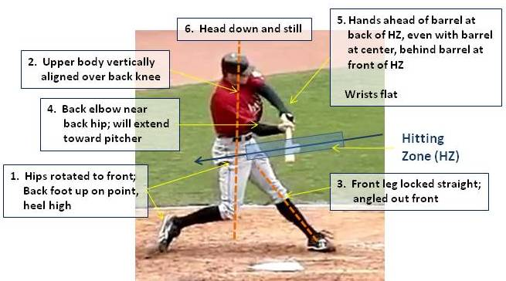
As you are ready to make contact. "Squish the bug with your toes lightly" The back foot turns over on to your toes with your back heel up and most of your weight is shift to your front leg. This will cause your hips to turn and shoulders to rotate open toward the pitcher. The knob of the bat is in front with the barrel of the bat directly behind so that the knob end of the bat is pointing toward the ball. (SEE POSITION 4) Your hands on the bat should be bottom hand palms down and top hand palms up as you are swinging. Do not turn your wrist until you make contact with the ball. (Position 5) Your head should be down on the ball watching the ball make contact with the bat. You hips should be rotated enough so that your belly button is facing the pitcher at contact.

5. "Follow Through"
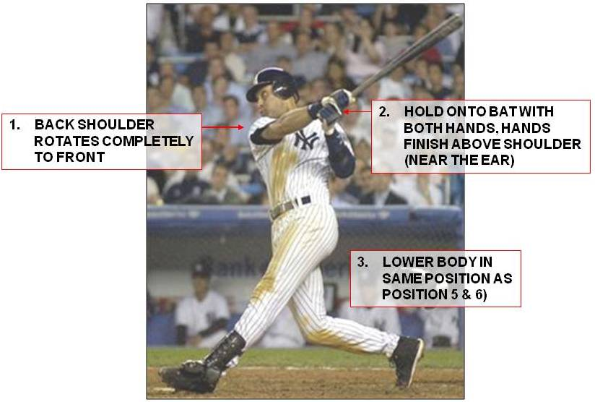
After making contact with the ball your hips should be rotated so that your belly button is facing the pitcher. Your wrist should start to rotate 180 degrees after contact and your arms extended out to make the Power V (see Position 6 above). Your hip rotation will continue after contact until your back shoulder is in the front facing the pitcher and your Hands are up near your ears.
After you have taught the basics on each portion of the swing, you can use key words to help trigger the batters memory when batting. For beginners, step 6 should be kept as simple as possible. Most of the time we just have them swing away with no technical direction until they get a little bit older and more experienced. Too much technical information and swing coaching can stagger development at an early age and for the beginning player. For more advanced hitters we recommend going to www.swingthebat.net by Phil Plante which breaks down Step 6-8 in more detail. This website can help focus on improving POWER and bat speed. Though it is always recommended to work on one aspect of the swing at a time and not try to overwhelm the player with too much.
---------------------------------------------------------------------------------------------------------------------
A Summary of the basic Key words to use in developing a new hitter.
THE BASICS SUMMARIZED
1. Knuckles: Middle Knuckles lined up
2. Feet: Slightly more than shoulder width apart
3. Knees bent: Knees slightly bent with 60% weight on back foot
4. Hands up: Hands lined up with back shoulder, bat pointed up with slight angle so fat part of bat is lined up above your back ear
5. Eyes on the ball: Watch the ball leave the pitchers hand and watch the ball hit the bat with your head down.
6. Swing Away: Head down on the ball and shift weight from back to front
7. Squish the bug with your toes Gently: Turn hips so your back foot is on your toes and your belly button is facing the pitcher. Most of your weight should be on your front foot so emphasize squishing the bug gently so they do not shift their weight to the back foot to squish the bug
8. Follow through: Continue to turn hip and shoulders so back shoulder is in front pointing toward the pitcher and your hands follow through up to your ears.
Some of the content above can be found courtesy of The Key Phases and Positions of the Swing
By Phil Plante http://www.swingthebat.net

