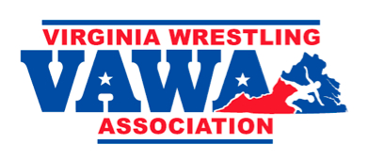
VAWA NATIONAL TEAM
2016 MASON-DIXON QUAD
Saturday, 02 January 2016
McDonogh School, MD

Event Description: This is one of the toughest dual meet tournaments in our region for Middle School (MS) / Elementary School (ES) wrestlers. Though it only has four teams, the teams from Virginia, Pennsylvania, New Jersey and Maryland have consistently been represented by great wrestlers. Many have gone on to high school and College All-American status. In recent history, Mason-Dixon Quad participants Jordan Oliver, Frank Molinaro, Quentin Wright, and Bubba Jenkins went on to win multiple NCAA Championships, and Kyle Snyder won the World Freestyle Championship Title. Who is next?

Eligibility: VA resident, enrolled in MS/ES, maximum of 14 years old as of 31 December 15.

Weight Classes:
61 and 66 (born 2004 or later only)
71, 76, 81, 86, 91, 96, 101, 106, 111, 116, 121, 131, 141, 151, 166
(No weight allowance to the numbers listed above)
Format: Team VA competes against each State All-Star team. Three duals.

Venue Address: McDonogh School, 8600 McDonogh Rd, Owings Mills, MD 21117.

Schedule:
Weigh-ins on site – 8:00 AM
Wrestling begins – 9:00 AM
Concludes -- ~3:00 PM

Uniform: VAWA will provide a uniform package for each team member at no cost to parents.

Entry Fee: VAWA will pay the team entry fee at no cost to parents.

Team Member Selection:
- We seek to identify and secure the best wrestler in each weight class for the team.
- Candidates based upon results at 2015 VAWA State Tournaments, and Fall 2015 results; new VA residents will be considered if known.
- Coach consensus. We will avoid/minimize wrestle-offs.
- We seek to lock-in the team as early as possible, but no later than 15 December 2015.

Parent Influence: If you believe that your wrestler should be on this team, and commit to taking a spot if selected, then immediately:
- Inform your Club’s Head Coach via email and Copy Furnish the organizer.
- Seek head-to-heads against likely candidates in the same weight class, then report those results to your Club’s Head Coach via email and Copy Furnish organizer.

Organizer: David Manville; david.l.manville.civ@mail.mil

