
Objectives
L:1 | Summarize the recruitment process.  .
L:2 | Examine the differences between Divisions I, II and III.
L:3 | Learn practical steps to take to start the recruitment process.
L:4 | Identify specific strategies to enhance your player’s visibility.
L:5  L  l | Develop an age-specific plan of action for your player.

Tsunami 15’s -18’s Recruiting Seminar, 101
December 29th 5:30-6:30pm

“A goal without a plan is just a wish”, A. Saint-Exupery

Time Frame | Alignment to Learning Objectives | Learning Task
5:30-5:35 | L: 1-3 | Session Overview, Learning Objectives, and Agenda
5:35 to 5:45 | L:2 | Discuss the recruitment process and what can be learned from players who have been recruited.
5:45 to 6:00 | L:3 | Discuss and analyze the differences between Divisions I, II, III, NAIA, and Junior Colleges.
6:00-6:05 | L:4 | Discuss player promotion and effective strategies to initiate now.
6:05-6:15 | L:6 | Explore a range of age-specific actions to take now.
6:15-6:30 | L:1-6 | Questions/ Close

Notes:

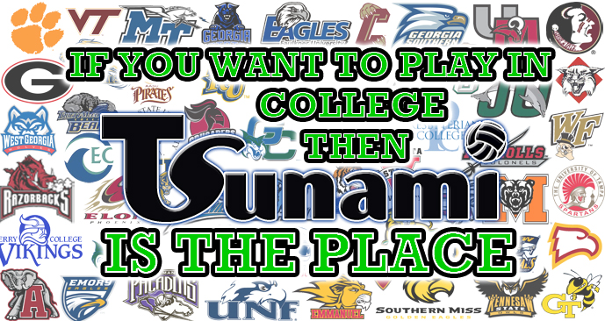

Tsunami Volleyball Recruiting Seminar
Anticipation Guide
STATEMENT | TRUE | FALSE
- If a player is “good enough”, she will be recruited.
- Only the top players get recruited to play volleyball in college.
- The most active time for recruitment is the Junior year of high school.
- Getting a letter from a school means you are being recruited by that school.
- Getting a summer camp invite means you are being recruited by that school.
- The best clubs get their players recruited.

Tsunami Recruiting Seminar Evaluation
December 29, 2015
For each of the statements below, circle the number that indicates your agreement with each statement using the scale provided.
1= Strongly Disagree 2 = Disagree 3 = No opinion 4 = Agree 5 = Strongly Agree
- The presenter displayed a strong knowledge of the material covered. | Strongly Disagree Disagree No Opinion Agree Strongly Agree  1 2 3 4 5
- The presentation was organized and well presented. | Strongly Disagree Disagree No Opinion Agree Strongly Agree  1 2 3 4 5
- Having attended this session, I now possess greater knowledge about the recruitment process and next steps for me/my player. | Strongly Disagree Disagree No Opinion Agree Strongly Agree  1 2 3 4 5
- I know what resources are available to help me/my player during the recruitment process. | Strongly Disagree Disagree No Opinion Agree Strongly Agree  1 2 3 4 5
- I would recommend this session to others. | Strongly Disagree Disagree No Opinion Agree Strongly Agree  1 2 3 4 5

Comments:

Other Topics I would like to learn more about:

