How to stop getting OAA emails
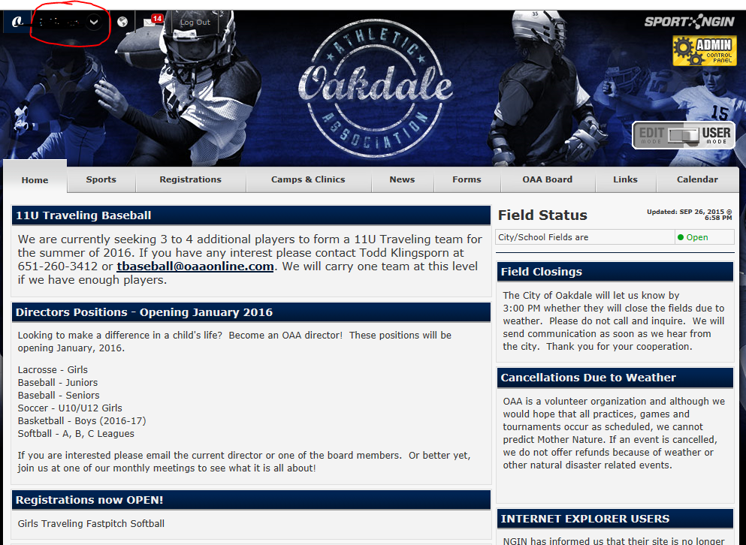
Log into your OAA account. Hit the arrow next to your login name and scroll down to My Profile.

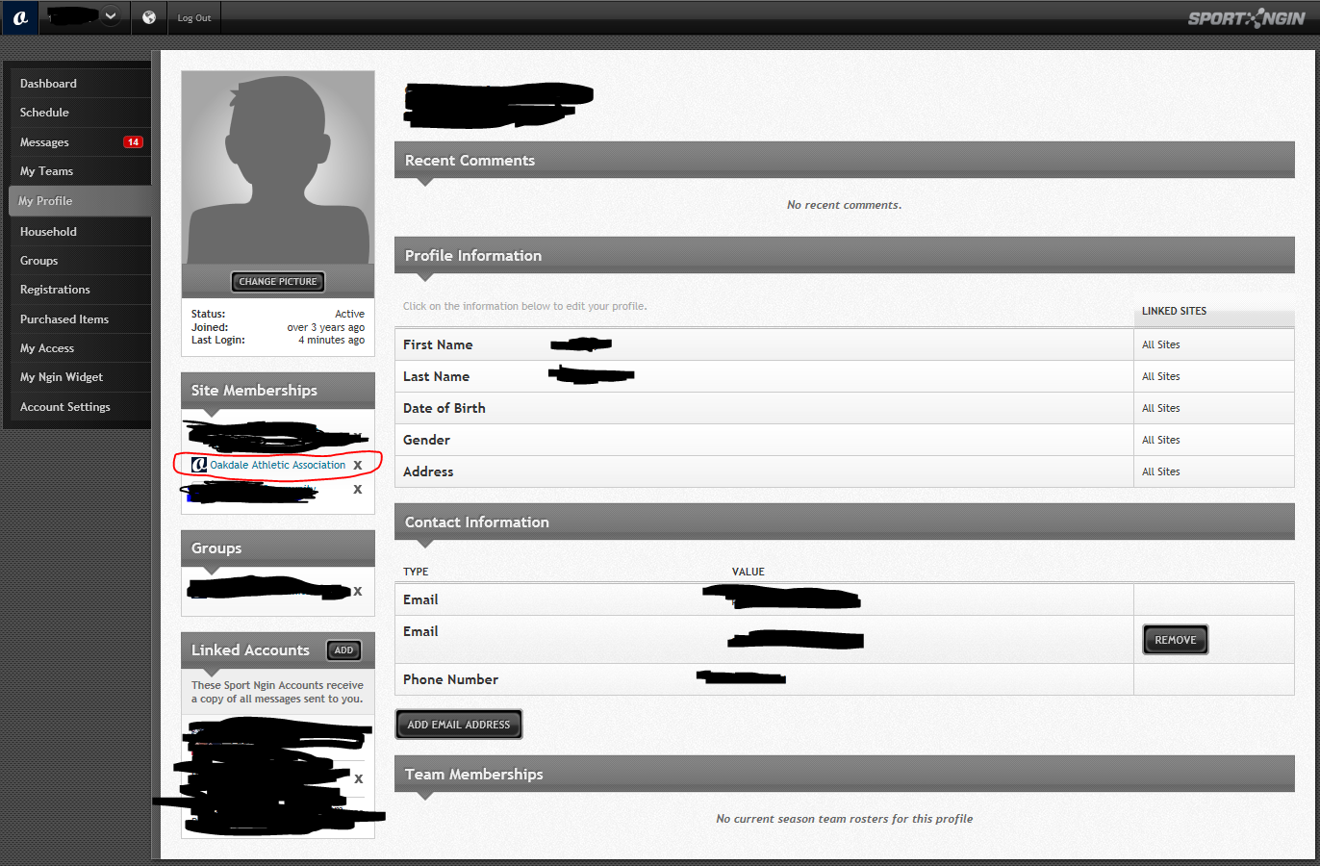
Find Site Memberships and hit the X next to Oakdale Athletic Association. That will remove you from all OAA emails.

