Hockey Skate Sizing
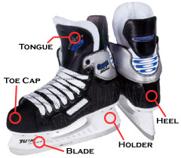 | A poor fitting skate can create bad habits and breakdown prematurely while holding back skate performance. Choosing the correct skate size is important. Going too big will result in blisters and a noticeable decrease in skating ability due to a lack of ankle stability. A strong stride comes from having a boot working in unison with the foot of the player. Consistent foot pain is common with players that use skates they have outgrown. The bones in the foot are cramped and put under considerable pressure with each stride. The tightness of the boot leads to a loss of circulation, limiting the function of the foot.  A proper fit for hockey skates should fit 1-1.5 sizes smaller than your street shoes. Your toes should barely touch the toecap, while having no more than 1/4 inch of space in the heel. When you're finished lacing up your skates, they should feel snug with the foot resting flat on the foot bed. When sizing children, follow the same method while allowing 1/2 size extra for growing room. Most skates use this formula (1 to 1.5 sizes down from shoe size).

Hockey Helmet Sizing
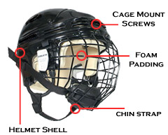 | All players must wear a HECC and CSA certified helmet. A helmet should fit snugly to maximize protection, but the helmet should still fit comfortably. Helmets are adjustable for a precise fit with certain helmets offering multiple adjustment points. Facemasks must be the same size as the helmet. Correct helmet sizing is imperative to maximize protection. Facemasks must be worn with clips on the side of the helmet to allow the mask to protect the jaw. Without the clips, the mask has no stopping point when you get hit in the face, so the jaw is susceptible to injury.  Measurements for Hockey Helmets – To properly fit a helmet, one must measure in inches the circumference of his or her head approximately 1" above the eyebrows. This length will aid in the proper sizing of the Helmet.

Shoulder Pad Sizing
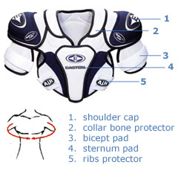 | A good shoulder pad will provide protection in all areas including the collarbone, ribs, sternum, chest, back, and biceps. A good fit is essential for the prevention of injury. Some shoulder pads come with removable abdominal guards and adjustable bicep guards. Shoulder pads worn too large will restrict movement in the shoulders, resulting in a loss of shooting and passing ability. When pads are loose, they do not fit to the body properly. Sticks can get in these gaps and cause injury.

Elbow Pad Sizing
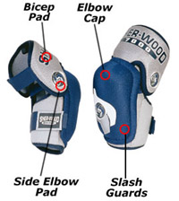 | Elbow Pads should be snug but comfortable. The elbow should fit into the cup of the pad to allow for maximum mobility. The top of the elbow pad should protect the bicep without restricting movement. The elbow pads should also protect the forearms from slashes without protruding into the glove cuff. Test the range of motion by bending the arm at the elbow, checking for any restrictions. Elbow pads worn too large will result in a noticeable decline in arm flex range due to pad movement during play.

Hockey Glove Sizing
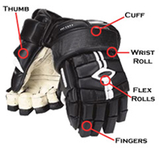 | Gloves should allow for ample movement of the wrist and fingers while preventing hyperextension of the thumb. Fit is up to the individual player, but the glove should protect the fingers and hands from sticks. Gloves come in both tapered and loose fits for the fingers. Your preference will similarly dictate whether you want a longer or shorter cuff. A longer cuff will provide more protection at the expense of mobility. A shorter cuff will provide mobility at the expense of slash protection.

Ice Hockey Pant Sizing
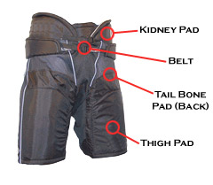 | Pants should fit comfortably while offering full range of motion for the player. Many pants come with zippers to open the leg panels and adjustable padding through the sides and back. If you wish to go with a larger size, keep in mind that the inseam will be longer. Pants have a waist belt, and many have buttons for suspenders for players that prefer a slightly more supported fit.

Shin Guard Sizing
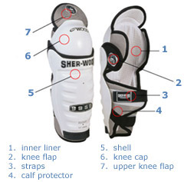 | To ensure proper fit, make sure that the cap of the shin pad is centered upon the kneecap. The flaps of the shin guard should wrap around the calf. Shin guards that are too large have two problems. If it is too long, the pad will extend down into the skate, preventing proper flexing of the ankle. If the knee does not fit into the cup of the shin guard, it will not be properly cushioned during impact, which easily leads to injury.

Under Apparel Sizing
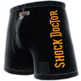 | The hockey jock should fit comfortably with the cup correctly positioned. Jocks can come in two types: loose or compression fit. Compression jocks are said to help decrease muscle fatigue, but some players find that loose jocks fit more comfortably. Compression items are meant to fit very snug, so keep this in mind. Loose jocks are meant to be an easier fit, but should still fit properly in order to maximize protection.

