1). Go to www.gotsoccer.com and click the user login tab.

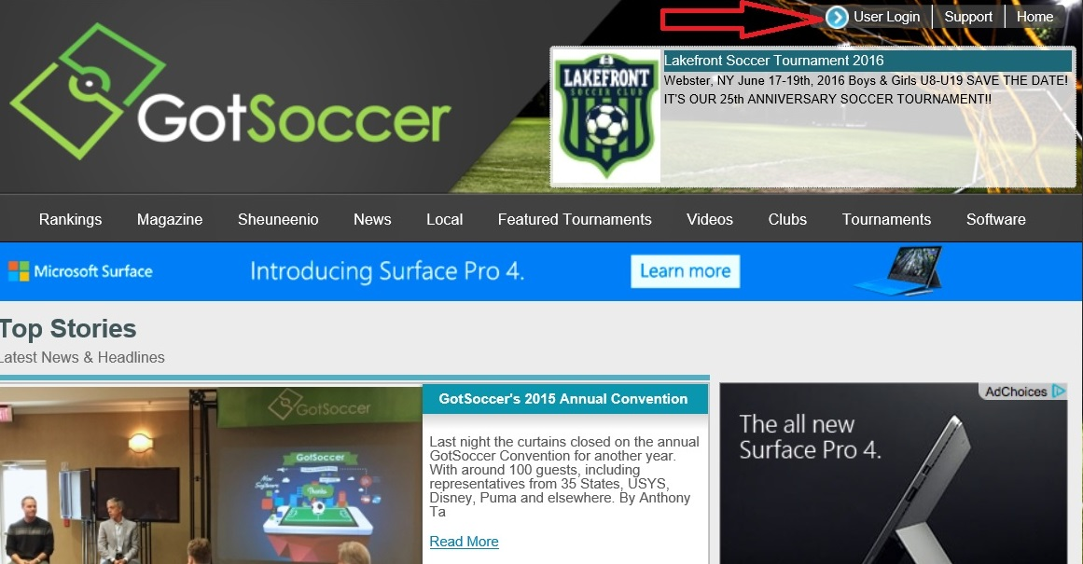

2). Click login on the “Player and Families” tab
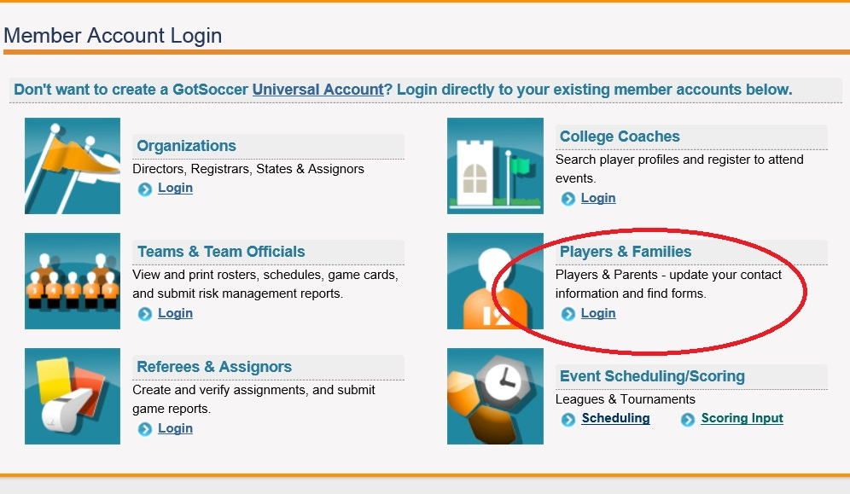

3). Sign into the individual OR family login with your username and password

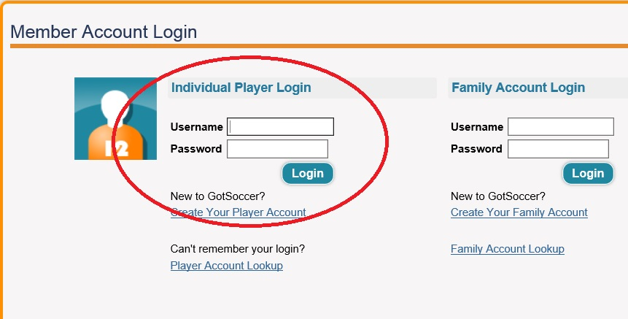

4. Click on the “My Profile” link in the player account- change or remove the player email address.
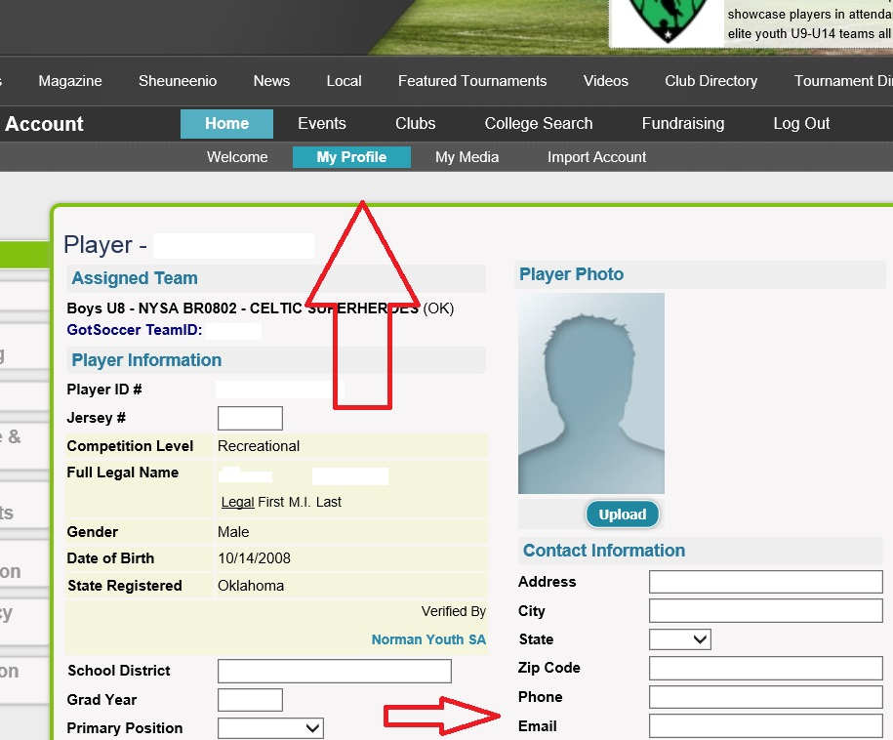

5). Click on the parents tab to edit or remove an email address
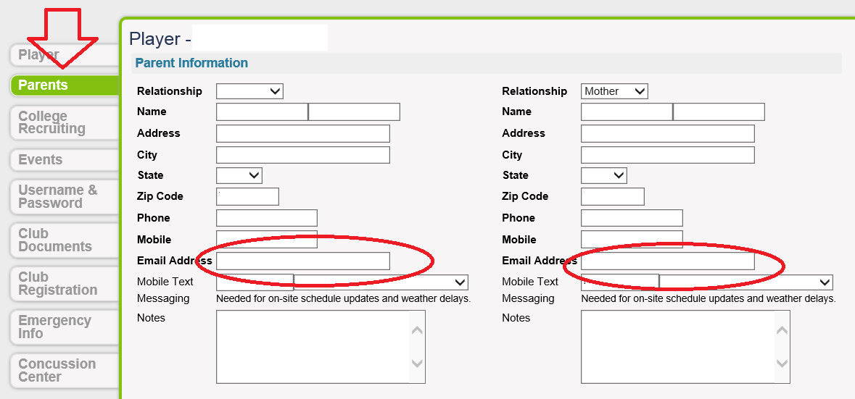

If it will not let you save the removal, please put nysa@normansoccer.org in the email box and your email will be removed.

