INSTRUCTIONS FOR COACHES AND FAMILIES ON HOW TO GET THE MOST BENEFIT OUT OF THE JYBSA WEBSITE’S NOTIFICATION FEATURES

This document sets forth the basic instructions we give to all our coaches on how to modify team pages on the JYBSA website. This document is somewhat lengthy but we provide this information because we know coaches and parents have these questions, and it helps everyone to get the most out of the system when everyone knows how the system works. If you have questions about how our system works, please read this document through to the end.

BASIC ACCESS INSTRUCTIONS

- GETTING ACCESS – COACHES. In order to modify a team page or send messages to a team, a coach has to be authorized by JYBSA to do it. Simply message Duffy Dillon (ddillon@brennansteil.com) and we will set you up. If you prefer to have a team parent handle your website features, that’s fine, but the team manager will have to send the request to Duffy so that JYBSA can be sure the parent is actually authorized by the team manager.

- LOGGING IN – COACHES. Coaches who want to update the team page or use the mobile app to send messages to the team must first log into the website or app using their Sport NGIN user ID and password. The login link for the WEBSITE is at the bottom of the team page (and every page). The login for the MOBILE APP is found in the app itself, under settings – just click "account" and enter the same user ID and password you use for our website.

- YOU HAVE ACCESS BUT FORGOT YOUR PASSWORD? Anyone can recover a password by clicking the login link on the website and following the instructions for resetting the password. JYBSA does not have any passwords and has no ability to look them up, so users have to do this themselves.

HOW TO UPDATE A TEAM PAGE ON THE WEBSITE

It is easy to customize a team page using photos, videos, links, documents, and so on. Here are the instructions for how to do it.

- GO TO THE TEAM PAGE AND ENTER "EDIT MODE."
  - Go to your team page and log in using your user ID and password.
  - After you log in, you should see a "light switch" on the upper left hand corner of the page that you toggle between "user mode" and "edit mode."
  - When you are in "user mode," you see what anybody visiting the site sees.
  - When you are in "edit mode," you are allowed to modify the page as you want. The website has a WYSIWYG (what you see is what you get) editing platform, so you can drag and drop things around, move things around, etc. More on how to do that below.

- FIRST STEP FOR EDITING: EACH TEAM PAGE MUST BE 'UNLINKED' FROM THE “TEAM PAGE TEMPLATE” BEFORE YOU CAN DO ANYTHING ELSE.
  - Every team page is created from a template. In order for a team manager to modify a team page, the link between the template and the team page must be broken.
  - Breaking the link is simple. At the top of the page, under the links for “home,” “roster,” “game schedule,” etc., you’ll find a gray bar that says “this content is generated by a connected template and cannot be edited directly.” To the right of that bar is a link stating “UNLINK.” To unlink the team page, click “UNLINK” and then confirm you are unlinking by clicking “Unlink” again. You will then be free to modify the page as you see fit.

- EDITING THE TEAM PAGE:
  - Once a team page is unlinked, a team manager can modify anything on it.
  - IMPORTANT WARNING: DO NOT DELETE THE CALENDAR OR NEWS ELEMENTS. JYBSA lets teams do anything they want with the team page, EXCEPT we do not allow teams to delete the calendar or news elements on the page. JYBSA uses those features to communicate across JYBSA to all the teams and need them to stay on your page. Otherwise, teams can feel free to do what they want.
  - EDITING THE PAGE:
    - Each page works with “layout containers” and “page elements.”
    - A “layout container” is like a column in a newspaper where photos, videos, etc., can be inserted. You can add or remove layout containers as you want by clicking “add layout container” on the page. You can then drag and drop layout containers anywhere on the page as you see fit.
    - A “page element” is anything that goes into a “layout container,” such as a photo, video, document, contact, etc. Like “layout containers,” you can add or drop page elements as you want, and you can drag and drop any page element a) within a layout container or b) from one layout container to another. What you do is totally up to you.
    - Adding page elements to a layout container: Within each “layout container,” you’ll see a link for “add page element.” If you hover and click on “add page element,” a pop up menu will appear with a list of things you can add to the page. The list will give you the ability to add text, photos, documents (PDF’s and MS Word files), links to other pages, contacts (coaches, for example), single photos, photo galleries, news stories, audio files, weather, and more. What you do is totally up to you. To add anything, simply click on what you want and then follow the step-by-step instructions. The interface is very user friendly so you should be able to follow along easily.
    - Reviewing what you’ve done: If you want to see how visitors to the team page will see a “page element” you’ve added, click the light switch in the upper left hand corner of the page to toggle from “edit mode” to “user mode.” You can toggle back to “edit mode” any time you want to keep editing the page.

USING THE SCHEDULE AND MESSAGING
FEATURES OF THE WEBSITE – COACHES

Each team page has a “back end” that allows team managers to update the team schedule and send messages to players and their parents quickly and easily. Instructions are as follows.

- GO TO THE TEAM WEBSITE AND ENTER “EDIT MODE” TO ACCESS THE TEAM MANAGEMENT PAGE. When you are in “edit mode,” you will see administrative options under the team name on the website, as shown below:

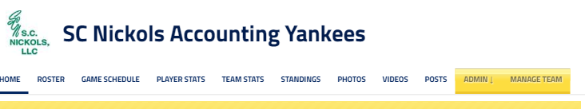

When you click on the “MANAGE TEAM” tab on the far right, you will be taken to a separate page where you have the ability to send messages to your entire roster or individual players that you can select. You can also use the separate page to update your team schedule to include events like practices, social gatherings, etc. The MANAGE TEAM page looks like this:

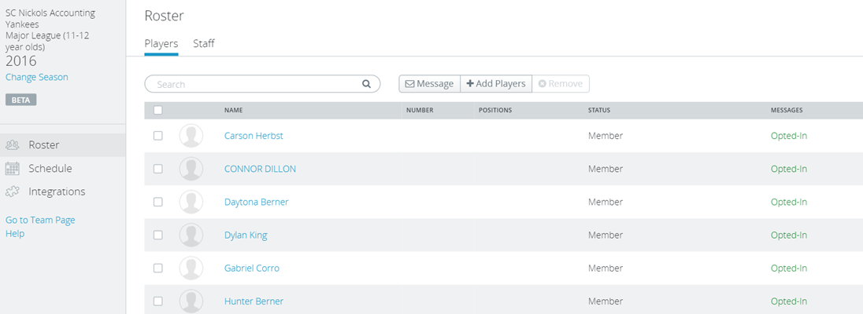

- HOW TO ADD EVENTS TO A TEAM CALENDAR:
  - To schedule calendar events, simply hit “schedule” on the MANAGE TEAM page and follow the self-explanatory prompts. If you schedule your practices using this system, you are able to invite all players and staff on the team. They get a message any time you add an event or change one. And, if they have installed the JYBSA app, followed your team, and set their notifications to receive messages from your team, they will also get push notifications of your schedule changes on their phone.

- HOW TO MODIFY EVENTS YOU’VE ALREADY ADDED:
  - In edit mode, go to the Team Calendar and click on the event you want to modify. You will see a gear logo. Click on the gear and you will be able to modify the event. This allows you to change dates, delete events, etc.

- HOW TO SEND MESSAGES TO YOUR TEAM OR INDIVIDUAL PLAYERS: To send messages to your team, you simply click on “Message” and it gives you a pop up where you can select whether you are sending a message to your entire roster board to select players. It looks like this:

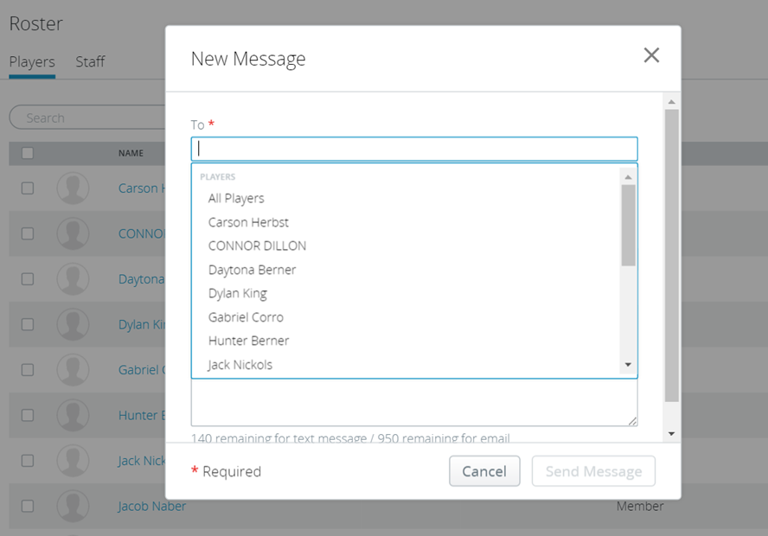

Select your recipients, type your message, and hit “send.” The message will be sent BOTH by email and by text immediately, and your parents will get the message so long as they have opted into the system as explained below. In

USING THE JYBSA MOBILE APP’S SCHEDULE AND MESSAGING FEATURES – COACHES AND PARENTS.

The mobile app allows coaches to send and receive messages and update the calendar just as easily as the website does. The mobile app also allows parents to receive any messages right on their phone. Instructions for how to set up the app are as follows.

- INSTRUCTIONS FOR PARENTS AND COACHES:

  - SPECIAL NOTICE TO PARENTS: TO RECEIVE NOTICES SENT TO A PLAYER ON A TEAM, YOU MUST FOLLOW THE INSTRUCTIONS BELOW ON “HOW DO PARENTS RECEIVE MESSAGES FROM THE WEBSITE AND ON THE MOBILE APP?” IF YOU HAVE NOT DONE THIS YET, DO THIS FIRST!! IF YOU SET UP THE APP AND ARE NOT RECEIVING NOTIFICATIONS, PLEASE MAKE SURE YOU’VE FOLLOWED THOSE INSTRUCTIONS, TOO.

  - DOWNLOAD AND INSTALL THE APP. Search for the app in the Google Play store and/or the App Store and install. It’s free.

  - LOG INTO THE APP USING YOUR JYBSA ACCOUNT INFORMATION. In the App, under “Settings”, simply enter your User ID and password under the “Account Information.”

  - PICK THE TEAMS YOU WANT TO FOLLOW. Once you’ve entered your account information, search the mobile app for each team you want to follow. Click on the magnifying glass for “follow a team” and then search for the name of the team you want to follow. IF MULTIPLE TEAMS COME UP WHEN YOU SEARCH, MAKE SURE YOU PICK THE CURRENT SEASON AND DO NOT PICK PRIOR SEASONS.

  - SET UP YOUR ‘PUSH NOTIFICATIONS’ FOR EACH TEAM YOU FOLLOW. To receive messages through the mobile app, you have to set up your push notifications for each team you follow. To do this, click on “settings,” click “push notifications,” choose the team you are following, and make your selections. You can choose whether you will receive notices of event updates, game updates, news articles, videos, photos, and posts.

  - WHAT IF I’M A PARENT AND I’M NOT RECEIVING MESSAGES? If you’ve followed the steps above and you are not receiving messages, it means you have not followed Step 2, above. This is your friendly reminder to review Step 2 and follow those instructions, too!

- ADDITIONAL INSTRUCTIONS FOR COACHES ON HOW TO USE THE APP:

  - USING THE APP – COACHES. In order to send messages or schedule events using the mobile app, a coach has to be authorized by JYBSA to do it. Simply message Duffy Dillon (ddillon@brennansteil.com) and we will set you up. If you prefer to have a team parent handle your mobile app messaging, etc., that’s fine, but the team manager will have to send the request to Duffy so that JYBSA can be sure the parent is actually authorized by the team manager.

  - HOW TO SCHEDULE EVENTS OR MODIFY SCHEDULED EVENTS: Once you’re authorized to use the mobile app, enter your team through the app. You will get a menu of Messages, Roster, Schedule/Results, Standings, News, etc. To enter or change a scheduled event, simply go to “Schedule/Results.”

    - To ADD AN EVENT (such as a practice), simply click on the pen icon at the upper right corner and follow the prompts.

    - To MODIFY AN EXISTING EVENT, click on the event in the schedule, hit the pen icon in the upper right corner, and follow the prompts.

    - NOTE: Every time you make a change, anybody following your team will receive a push notification on their phone telling them about the change.

  - HOW TO MESSAGE YOUR TEAM THROUGH THE APP: To send messages to your team, simply click on “Messages” in the team’s main menu. At the upper right corner, you’ll see a plus sign. To send a message, click on the plus sign. Choose whether you will send the message to all players and staff, or just to individuals. Enter the SUBJECT and the MESSAGE. Then hit the envelope in the upper right corner to send the message.

    - NOTE: ALL MESSAGES SENT THROUGH THE APP ARE SENT TO THE PEOPLE LINKED TO THE PLAYERS ON YOUR TEAM IMMEDIATELY. PARENTS CAN CHOOSE TO RECEIVE YOUR MESSAGES BY EMAIL, TEXT, OR BOTH. IF YOU SEND A MESSAGE THROUGH THE WEBSITE OR THE APP, IT WILL BE SENT BOTH AS AN EMAIL MESSAGE AND AS A TEXT MESSAGE TO THE PEOPLE WHO OPT INTO THE SYSTEM. NOTE THAT TEXT MESSAGES INCLUDE THE BODY OF YOUR MESSAGE BUT NOT THE “SUBJECT” IF YOU HAVE ONE.

HOW DO PARENTS RECEIVE MESSAGES FROM THE WEBSITE AND ON THE MOBILE APP?

JYBSA’s messaging system only works if parents “OPT IN” to receiving messages. We can't force a parent to opt in, so parents have to take some ownership for this to work well for them. Here are the basics that everyone needs to know:

      - EVERY PARENT NEEDS THEIR OWN ACCOUNT. JYBSA messages are sent to parents through their JYBSA accounts. Each parent must set up their own account with Sport NGIN to receive messages sent to a player. Each parent who has registered a player on a JYBSA team ALREADY has an account because they had to create an account to register their player in the first place. But other people who did not register the player and who are interested in getting messages sent to the player (other parents, spouses, grandparents, aunts, uncles, parents’ significant others, day care providers, etc.) may or may not have an account already. So, step one is that each adult needs to create his or her own account.

      - HAVE AN ACCOUNT BUT FORGOT YOUR PASSWORD? Parents with an existing account can recover a password by clicking the login link on the website and following the instructions for resetting the password. JYBSA does not have any passwords and has no ability to look them up, so users have to do this themselves.

      - NEED TO CREATE AN ACCOUNT? To create a new account, click the “login” link at the bottom of any page on the JYBSA website, and then follow the prompts. You will need to “activate” your account once you set it up.

      - TO RECEIVE MESSAGES FROM JYBSA BY EMAIL AND BY TEXT, EACH AND EVERY PARENT NEEDS TO “OPT IN” TO RECEIVING MESSAGES FROM JYBSA AND UPDATE THEIR ACCOUNT SETTINGS BY ENTERING THEIR EMAIL ADDRESS AND MOBILE NUMBER. JYBSA’s messaging system is a voluntary system. We can't send messages to parents unless they sign-up to receive messages and tell us how they want to receive them. In our experience, parents typically want to get messages sent to players, but we also have situations where grandparents or caretakers or other “extra persons” need to get messages because they are shuttling kids around. This can be done, but it requires cooperation from the “extra person” and the parent who registered the player to set this up. The instructions are as follows:

        - STEPS TO BE TAKEN BY EACH “EXTRA PERSON” WHO WANTS TO GET MESSAGES:
          - CREATE A USER ID FOR THE WEBSITE. The “extra person” needs to create a user ID and password on our website. After they do that, they will be asked to “Join the JYBSA Network.” They must do that, too.

          - ADJUST YOUR ACCOUNT SETTINGS TO “OPT IN” TO RECEIVING MESSAGES. After the “extra person” creates an account and joins it to our JYBSA Network as explained above, each “extra person” must adjust their “account settings” to get messages from JYBSA. To do this, the extra person must click on their user-name at the top of the page and then click “Account Settings” in the drop down menu. When the person arrives at the account settings page, they will get a screen that looks like this:

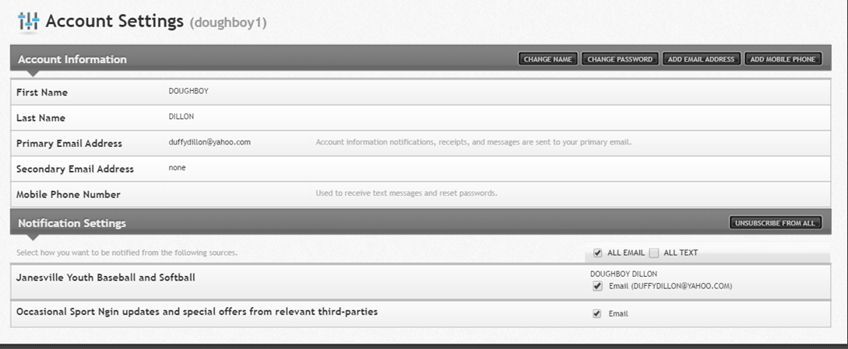

Under the “notification settings” bar, the extra person will have to click the boxes to receive notices from “All email” and “all text.” This will ensure that they get messages both by email and by text once the player’s parent links the person to the player account as described below.

          - ADD EMAIL ADDRESSES AND MOBILE NUMBER WHERE YOU WANT TO GET MESSAGES. Next, the person needs to click on the “add email address” and “add mobile phone” boxes at the top to add any email addresses or mobile numbers where they really want to receive messages from JYBSA. They will have to validate the mobile numbers and email accounts by using the system’s prompts.

          - THE FINAL STEP: THE PARENT WHO REGISTERED THE PLAYER MUST JOIN THE “EXTRA PERSON” TO THE PLAYER’S PROFILE! The final step in the process of adding an “extra person” to receive messages to a player involves linking the “extra person’s” account to the player in our system. This step can only be done by the parent who registered the player in the first place, but the steps are easy:

- The registering parent has to log into the website per the instructions above.

- Next, the registering parent needs to click on his/her user name at the top to get the drop down menu.

- In the drop down menu, the parent must select “Household.”

- In the lower left corner of the “Household” menu, the parent will see “Linked Accounts” that will list other Sport Ngin accounts that receive messages sent to the player. To add an “extra person” to the list of people who get messages sent to the player, simply hit the “add” button and then enter the email address of the extra person you want to add. The system will automatically send an “invitation” to the extra person to link their account to the player profile. Once the extra person checks their email and responds to the system’s prompts, and then they will be done, and the extra person should receive all messages sent to the player going forward.

