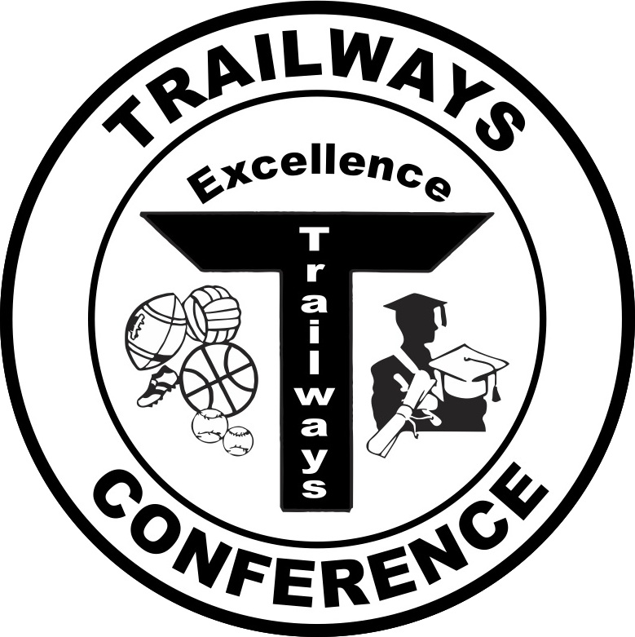

Rich Fronheiser, Commissioner
550 Vista Cir
Columbus, WI 53925
trailwayscommish@gmail.com
(920) 623-9660 - office

2016 Trailways North Softball All-Conference Teams

First Team
Player of the Year – Lauren Schiek, Junior, Lourdes Academy

Player | Class | School
Lauren Schiek | Junior | Lourdes Academy
Mollie Bartlett | Junior | Lourdes Academy
Ciarra Zemke | Junior | Lourdes Academy
Brooklyn Berenz | Seinor | Lourdes Academy
Brianna Sabel | Sophomore | Oakfield
Mikayla Newton | Junior | Oakfield
Alyssa Sabel | Senior | Oakfield
Karissa Ryan | Sophomore | Oakfield
Hanna Gibbons | Sophomore | Markesan
Cassie Miller | Junior | Markesan
Olivia Bancroft-Hart | Junior | Cambria-Friesland
Emma Grahn | Senior | Cambria-Friesland
Brooke Roberts | Senior | Randolph
Courtney Peterson | Sophomore | Pardeeville
Lauren Perrett | Senior | Pardeeville

Second Team

Player | Class | School
Paiton Proud | Senior | Lourdes Academy
Katie Spillane | Senior | Markesan
Abigail Gilbertson | Freshman | Markesan
Kendra Witthun | Senior | Markesan
Alexa Burmania | Junior | Cambria-Friesland
Devon DeYoung | Sophomore | Cambria-Friesland
Madison Ferron | Senior | Randolph
Brenna Huizenga | Junior | Randolph
Kirston Purtell | Sophomore | Pardeeville
Morgan Henning | Senior | Montello
Jaclyn Wilks | Senior | Montello
Kristen Baranowski | Senior | Princeton/Green Lake

