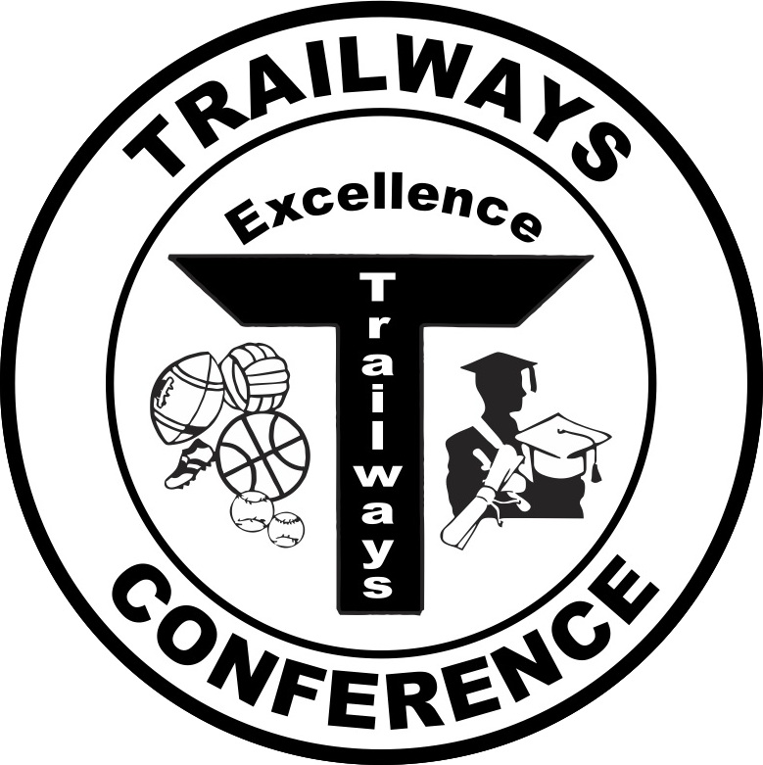

Rich Fronheiser, Commissioner
550 Vista Cir
Columbus, WI 53925
trailwayscommish@gmail.com
(920) 623-9660 - office
(608) 469-5722 - mobile

2016 Trailways South Softball All-Conference Teams

First Team
Player of the Year – Taylor Scott, Williams Bay

Player | Class | School
Sarah Schliewe | Junior | Horicon
Peyton Litterick | Junior | Horicon
Angie Laabs | Junior | Horicon
Cassie Laabs | Sophomore | Horicon
Taylor Scott | Senior | Williams Bay
Morgan Lippert | Junior | Williams Bay
Heidi VanderMeer | Sophomore | Williams Bay
Callista Schindler | Sophomore | Deerfield
Makenzie Kapral | Senior | Deerfield
Alexis Eilenfeldt | Senior | Deerfield
Elysa Doherty | Junior | Johnson Creek
Elizabeth Soter | Senior | Fall River
Kelly Tramburg | Senior | Fall River

Second Team

Player | Class | School
Emily Bjork | Junior | Horicon
Madison Mantai | Junior | Horicon
Payton Justman | Sophomore | Horicon
Amanda Kuehl | Sophomore | Williams Bay
Gracie Wilson | Junior | Deerfield
Bre Caminata | Sophomore | Johnson Creek
Kiana Gosh | Sophomore | Johnson Creek
Mady Heald | Sophomore | Johnson Creek
Nicole Cox | Junior | Dodgeland
Vanessa Ziehme | Junior | Dodgeland
Emma Passig | Sophomore | Dodgeland
Kelly Schiller | Junior | Hustisford
Brittney Fredrick | Freshman | Hustisford

