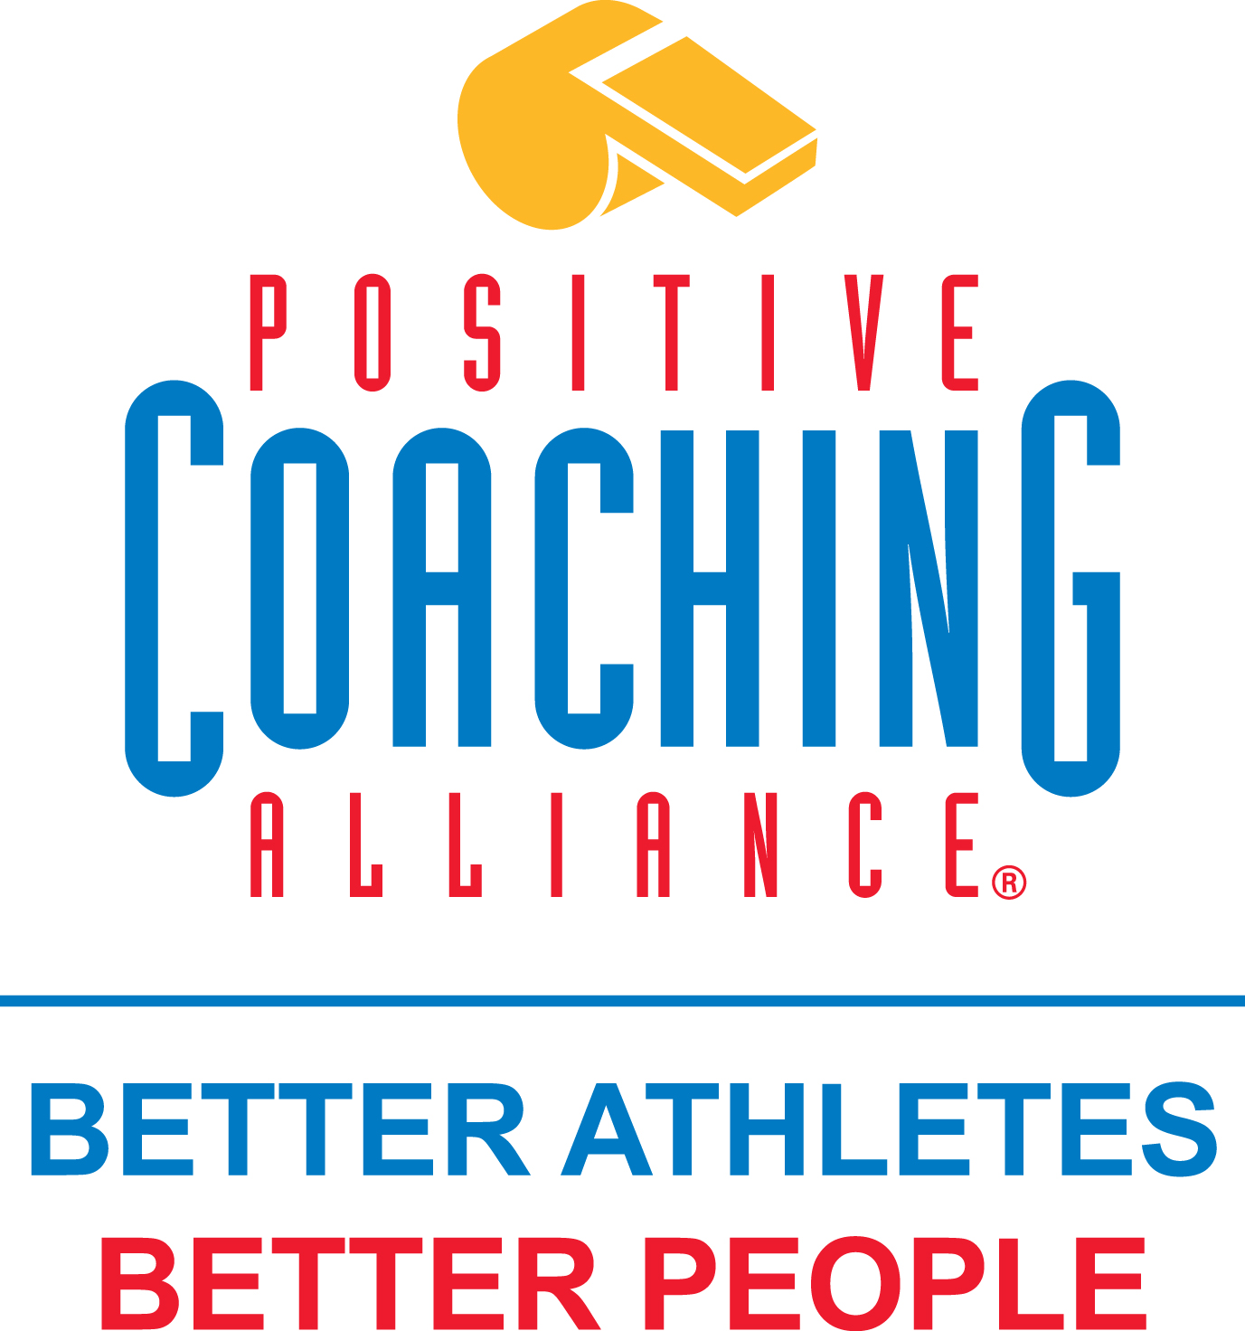

TO : All Attendees of the 2016 State Tournament for 8U

FROM: BFA Tournament Director & President

Bloomington Fastpitch Association has an established partnership with the Positive Coaching Alliance (PCA), a national non-profit developing BETTER ATHLETES, BETTER PEOPLE by working to provide all youth and high school athletes a positive, character-building sports experience.

The following are the models of behavior we wish to institute in our organization:

- Double-Goal Coach®, who strives to win while also pursuing the more important goal of teaching life lessons through sports
- Second-Goal Parent®, who concentrates on life lessons, while letting coaches and athletes focus on competing
- Triple-Impact Competitor®, who strives to impact sport on three levels by improving oneself, teammates and the game as a whole.

As part of the tournament experience, you will see banners reminding players, coaches and parents of the following mantras:

Honor the Game
Honoring the game goes to the ROOTS of positive Play:
Rules Don’t bend the rules to win
Opponents A worthy opponent is a gift that forces us to play to our highest potential
Officials We treat officials with respect even when we disagree
Teammates We never do anything that would embarrass our team on or off the field
Self We live up to our own standards regardless of what others do.

ELM Tree of Mastery
Competitors are leaders who make themselves and their teammates better by focusing on the ELM tree.
Effort Give your best EFFORT every time
Learning Constantly look to LEARN and improve
Mistakes MISTAKES are OK – focus on how you deal with them

We encourage you to institute these philosophies throughout your participation.

Feedback is welcome - please let us know if you see any BFA teams exhibiting these behaviors well or if you encounter an individual that is in need of additional training.

Jessica Musta – Tournament Director Karen Johnson - President
bfatourney@gmail.com karen_s_johnson@uhc.com

