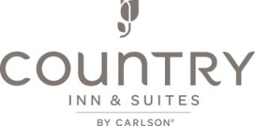
Thank you for choosing Country Inn & Suites in Albert Lea for your event needs. Your business is very important to us and we are very excited to be able to provide your group with a cozy and comfortable stay.

Country Inn & Suites by Carlson in Albert Lea, MN features 77 completely renovated guest rooms and suites. Your group is sure to enjoy the conveniences of our non-smoking hotel, elevator, refrigerator and microwaves in each guest room, hair dryers & coffee makers, cable TV with HBO, swimming pool with hot tub, and fitness center.
We have a large parking lot with additional parking in our back lot. Green Mill Restaurant and Bar is also located in our parking lot!

A complimentary hot continental breakfast is available from 7-10:30 on the weekends. Earlier times may be set up with prior notice.

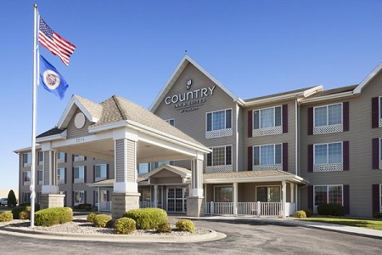
Guest Rooms:
Arrival date: February 3rd, 2017
Departure Date: February 5th, 2017

Room Rate:

Standard King (no pull out couch): $125.00 plus tax per night

We currently have 15 Standard Kings on hold for Dodge County Squirt B. These are nice sized rooms that could easily accommodate a twin blow up mattress or two. Roll a ways are on a first come basis with us having 4 available on property.

The block will be held for your group until January 13th, 2017. Please have all reservations in by this date as the block rate will not be honored after the close out date.

Please note that our hotel has a 10PM quiet time. At this time players are to be in a guest room and not in any of our common areas. Thank you for your cooperation in assisting us with the enforcement of this policy Knee hockey is also not allowed at our property and hockey sticks may not be stored in the guest rooms- we can hold behind the front desk for you

Please do not hesitate to call with any questions you may have! We look forward to having your group stay with us!

Heather Lee
General Manager

