Roll Call: Terry Johnson, Josh Colvin, Adam Hoffman, Sean McCabe, Don Huemoeller, Travis Steele, Bernadette Schaffer, Jaimie Schuster, Shannon Callahan, John Klimek, Adam Hoffman, Jason Stoffel, Jay Stark
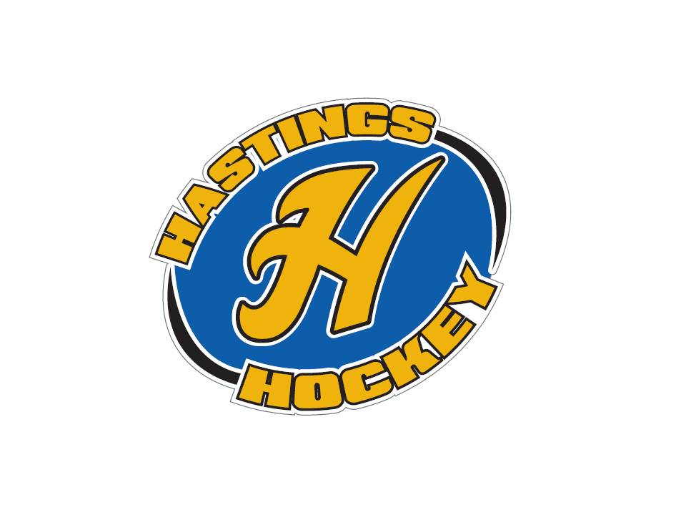

Not in attendance: Adam Welch, Matt Zaruba, Jesse Viall, Jim Foster, Tom Johnson, Jesse Viall

- Approval of Agenda – motion made by Josh, seconded by Travis – motion passed
- Approval of Minutes – motion made by Don, seconded by Sean – motion passed

Coordinator Reports
- Referee – John Klimek
will attend coaches meetings to help out, let him know when you are meeting
- Registrar – Shannon Callahan
nothing to report
- Technology – Jay Stark/Randy Kruse
- Tournament Director – Jim Foster
teams calling about hotel information – good sign…..
- Sponsorships – Terry Johnson
working on golf tournament , hockey night will be scaled down a bit???
- District 8 – Jesse Viall
chatted about auto ice schedules
- Goalie – Josh Colvin
nothing to report
- Secretary – Bernadette Schaffer
nothing to report

Officer Reports:
- President – Terry Johnson
Went to Positive coaching alliance – went very well!!!
Met with Strauss to work on attire
Discussion about MN Hockey coming to train coaches, looking at moving forward with a class for coaches
- Vice President – Jay Stark

- Treasurer – Jaimie Schuster (Approval of the Financial Statements)
motion made to approve financials – motion made by Josh, seconded by Don – motion was approved

Director Reports:
- Volunteers – Shannon Callahan
nothing to report
- Director of Hockey – Adam Welch
RAK and Adam chatted about how can we influence players to stay in the association. We as a board want to develop each and every player with the notion that they will stay in Hastings throughout their career.
- Operations – Matt Zaruba
- In-House Girls – Adam Hoffman
- Travel Girls – Travis Steele
- TerMites – Tom Johnson
- Mighty/Super Mites – Josh Colvin
Talked to both directors from Raider Nation and HYAA to hand out fliers for the association
Waiting to hear back from girls softball, soccer, and YMCA flag football
Would like to get a call into Tennis for some bins for equipment for donations and email out to parents for donating sticks that are too small….
Next year looking at a 3 on 3 tournament during Rivertown Days
- Squirts – Jason Stoffel
will be sending out info to players soon
- Peewees – Sean McCabe
registration almost done for tournaments
- Bantams/ Jr. Gold– Don Huemoeller
registration almost done for tournaments
met with Jay about fall ice and tryout schedules – will send out dates soon

Old Business:
- Budget
looked at the budget – motion was made by Josh, seconded by Donny and motion passed to approve the budget

New Business:
- Presentation at 8 from United Promotions – Did not show up, was intended to have more “mom wear”. We will continue with Strauss as that went well last year.
- Hockey Night discussion - We will tentatively have hockey night Saturday January 28th. A few details need to be arranged – but we are hoping for this date to work.

Board Comment
Membership Comment
Adjournment meeting adjourned at 9:45 pm - motion made by Josh “ice cream” Colvin, seconded by Donny.

Next Meeting: August 14th, 2016

