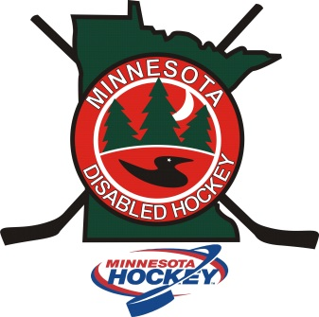

Minnesota Disabled Hockey 2016 Coaches Clinic
Saturday, October 22, 2016
10am to 4pm
Essentia Health Sports Center
502 Jackson Street, Brainerd MN
Minnesota Hockey is pleased to once again offer a coaching clinic for all those interested in either receiving their level 1 coaching certification or advancing to a level 2 or 3. This clinic is FREE and open to anyone who is coaching special, sled or Warriors hockey, or those interested in coaching someday.
This year we will be holding our clinic in Brainerd, MN to bring the opportunity closer to those in Central and Northern MN, while introducing the sport to the area as well.
There will be classroom and on-ice, so bring your equipment. Lunch will be provided. Please RSVP to Toni Gillen at agillen1968@gmail.com or by phone at 651-307-0660.

