  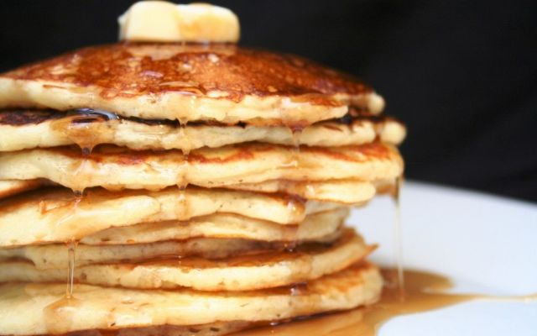
    - January 21, 2017
  Pancake Breakfast
  Paragon Lodge #788 24845 Woodville Rd. Millbury Oh 43447
  To benefit the Black Swamp Ice Frogs
  The Black Swamp Ice Frogs are a Non-contact, All ages’ hockey team for those individuals with special needs or disability. A member of ASHA (American Special Hockey Association), this 501c3 organization is based in Bowling Green Ohio and serves Northwest Ohio hockey enthusiasts.
  Paragon Lodge #788 Is located just outside of Toledo and is in the 11th Masonic District.
  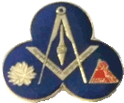
  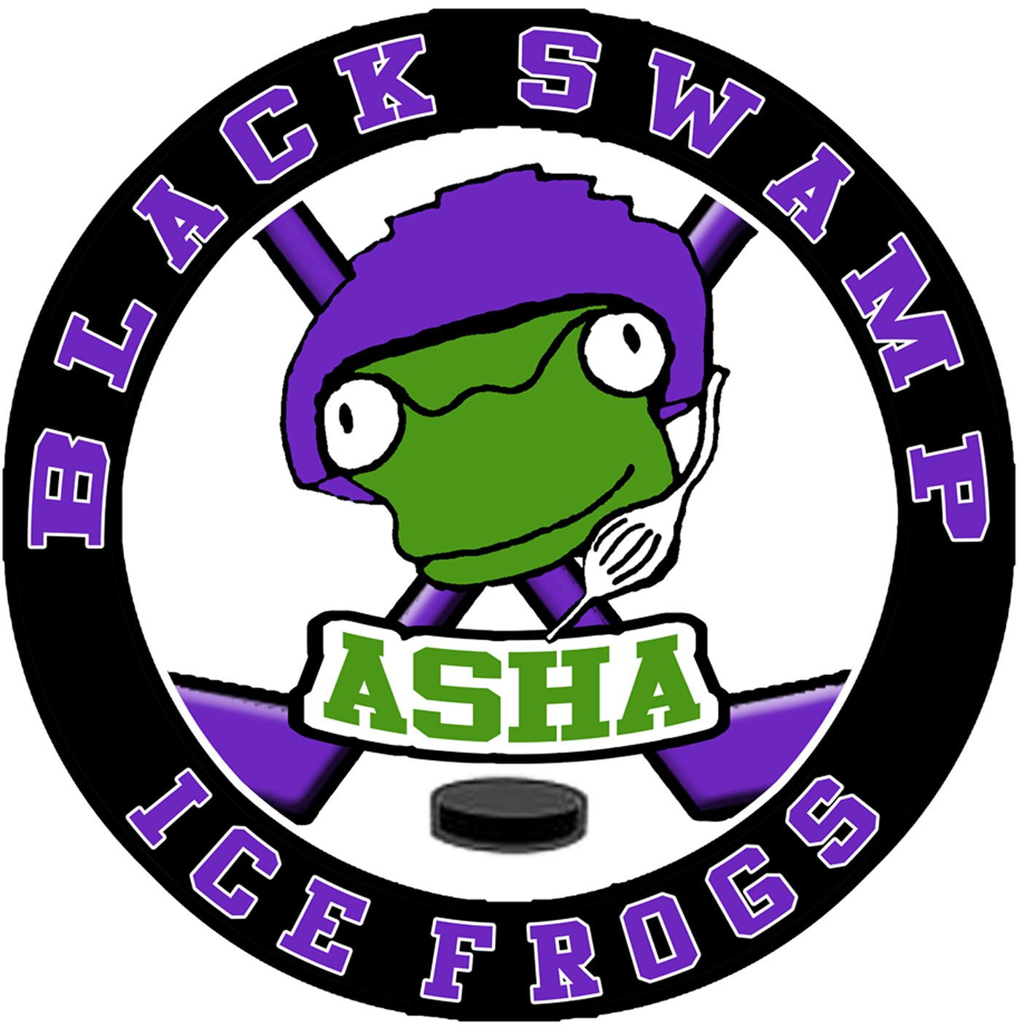
  
  
  Pancake Breakfast to benefit The Black Swamp Ice Frogs
  Enjoy an all you can eat breakfast
  Pancakes, Eggs, Ham, and Sausage are served
  Everyone is welcome
  Proceeds to benefit BSIF Hockey
  Pancake breakfast
  Paragon Lodge #788
  24845 Woodville Road
  (State Route 51)
  Millbury, OH 43447
  January 21, 2017
  8AM- 11AM

