Roll Call: Don Huemoeller, Sean McCabe, Josh Colvin, Jaimie Schuster, Terry Johnson, Jason Stoffel, Adam Hoffman, Adam Welch, Tom Johnson, Jay Stark, Shannon Callahan, Matt Zaruba, John Klimek
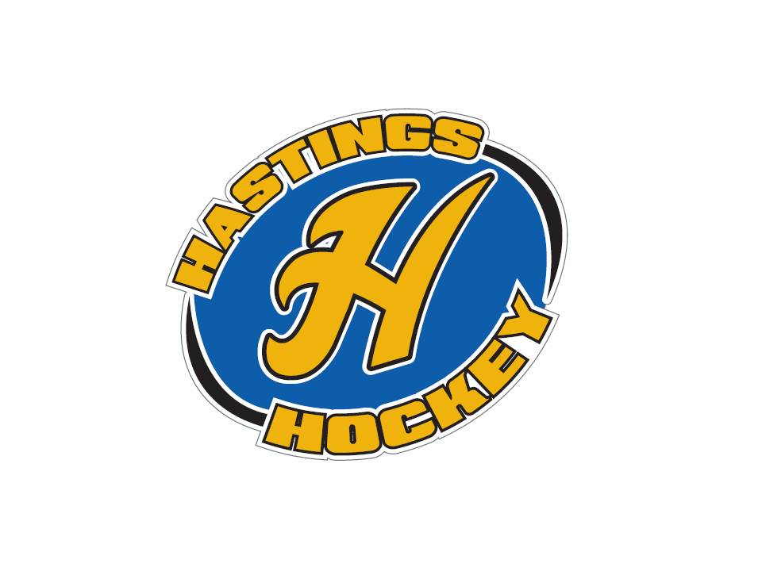

Not in attendance: Jesse Viall, Jim Foster, Bernadette Schaffer, Travis Steele
- Approval of Agenda - no agenda sent prior to meeting; no approval
- Approval of Minutes – Bernadette absent, no approval

Coordinator Reports
- Referee – John Klimek
Coaches meetings coming up
- Registrar – Shannon Callahan
Nothing to report
- Technology – Jay Stark/Randy Kruse
Nothing to report
- Tournament Director – Jim Foster
Not in attendance
- Sponsorships – Terry Johnson
Erik Goettl working on them; will attend next meeting
- District 8 – Jesse Viall (not in attendance/Jay reported)
Home teams provide pucks
Locker room monitors for boys & girls
Tournament Sanction forms
Report to MN Hockey Treasurer how we pay our coaches
- Goalie – Josh Colvin
Preliminary evaluation Bantam/Peewee/U12
Player moving from U12 to U15
Goalie numbers always a worry but look ok for year
Supermites ok; have minimum of one per team and try to develop 6-8
Fall Goalie Clinics going ok but not great; competing with football and nice weather
- Secretary – Bernadette Schaffer (not in attendance)

Officer Reports:
- President – Terry Johnson
NGIN email issues resolved
- Vice President – Jay Stark
Coaches registration is live
Working on dryland scheduling; D8 games and HS take precedent
Need each teams name and contact info for Ice Scheduler
Picture Day Nov 12th
District Tournament changes working with Auto Ice
- Treasurer – Jaimie Schuster (Approval of the Financial Statements)
Nothing to report
Month ended too close to meeting date to prepare financials; will report Sept/Oct together in November meeting

Director Reports:
- Volunteers – Shannon Callahan
Manager meetings to be set up
Volunteers for equipment handout; Matt will hand pick
- Director of Hockey – Adam Welch
Oct 24 squirt, goalie and mite coaches meeting
Oct 25 Peewee and Bantam coaches meeting
Josh will organize the girls side
- Operations – Matt Zaruba
Equipment handout
- In-House Girls – Adam Hoffman
Girls registration climbing
Motion made by Adam to allow three U8 players to try out for U10; Josh seconded; motion passed
Motion made by Adam for TJ to be acting In House Girls Director; Don seconded; motion passed
Adam resigned as In House Girls Director
- Travel Girls – Travis Steele (not in attendance)
- TerMites – Tom Johnson
Sent 80 kids to Wild game
31 skaters for Bring a Friend to Skate event
Do we look at different night/is there a better night than Friday?
- Mighty/Super Mites – Josh Colvin
19 boys registered for Might Mites
Bring a Friend to Skate again in November
Equipment for every kid that needs it through mites
Change In House levels to be “Learn to Skate/Mini mites”, “Mite 1”, “Mite 2” may make it less confusing to determine appropriate registration level
- Squirts – Jason Stoffel
70 registered
MEA 3x3 scheduled
Looking for old jerseys for that event
4 ice times prior to picking teams Nov 2
Jersey Unveil Nov 4
- Peewees – Sean McCabe
Fall clinics transitioning to tryouts
- Bantams/ Jr. Gold– Don Huemoeller
Tryouts started for Bantams over the weekend
U16 coach position open
Motion made by Don to approve Jason McCarville as JrGold B head coach; 2nd by TJ; motion passed and Jason approved as head coach

Old Business: Nothing to report

New Business:
- Mouthguards are in the office at the arena to start handing ou

Board Comment
Membership Comment
Adjournment meeting adjourned at 9:31 pm – motion made by Don, seconded by Jason

Next Meeting: November 6th, 2016

