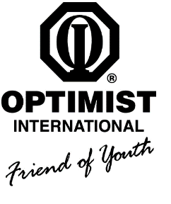
ORANGE COAST OPTIMIST CLUB
P.O. BOX 28802 – SANTA ANA, CA 92799

January 2017

Dear Scholarship Applicant,

“Bringing out the best in kids” is the motto of the Optimist International Organization. One of our main objectives is to aid and encourage the development of our youth. To this end, each year our organization, the ORANGE COAST OPTIMIST CLUB OF GARDEN GROVE, grants individual scholarships ranging from $250 - $1,000 to graduating Orange County high school seniors. Scholarships are awarded based on outstanding service to the community, school involvement and academic achievement.

Eligible applicants must:
- Be a graduating high school senior
- Have a minimum 3.0 un-weighted GPA or higher (most recent transcript required)
- Be a member of the OCO Octagon Club or a child of an active OCO member.

To be eligible for consideration, all of the following must be completed and submitted to Eunice Tanga at the address provided below and postmarked by March 9, 2017. DO NOT SEND APPLICATIONS TO THE OCO P.O. BOX.

- A typed and completed scholarship application listing organizations, all activities participated in, and individual hours volunteered for each activity (please detail all your activities including specific duties – attach a separate sheet with the information if necessary).
- An official copy of current transcript of high school academic records.
- At least two (2) letters of recommendation from advisors/adults involved in direct supervision/observation of your community service
- A one-page personal statement on one of the following questions:
  - How has community service helped you?
  - What is your vision of how you will make a better world?
- A senior or recent photo, which will be used for the scholarship program if you are selected.

Our scholarship committee will review submissions and select candidates to be interviewed. Interviews are (TBD) depending on committee availability.. The banquet will be on Friday, April 28, 2017. You must attend the interview and banquet in order to receive their scholarship. Your presence is also required at the Youth Recognition Fundraising Steak dinner in June.

Remember, the deadline to apply is March 9th, 2017. Only complete and typed applications, postmarked by the deadline, will be considered

If you have any questions, feel e-mail me at sandi.kosaka@gmail.com or call at 714-739-5165.

Sincerely,

Sandi Kosaka – Scholarship Committee Chair

