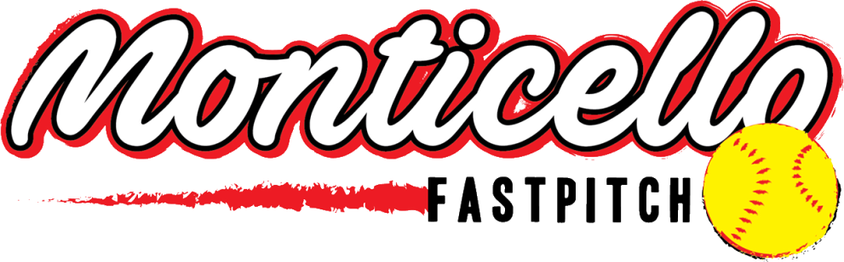
MGFA Parent/Guardian Code of Conduct
Participation in Monticello Girls Fastpitch is a privilege that should invoke a sense of pride in the athlete. It is also a responsibility that requires a commitment from the parents/guardians to support their daughter, her teammates, coaches, and the MGFA community. Standards of behavior are high and a willingness to live up to them is part of being a member of the MGFA.
In order to uphold these standards, we ask all parents/guardians to agree to the following Code of Conduct.
1. I will remember that the game is for the children, not the adults; to show my child that I care more about her than I do about the score of the game, and that winning and losing are both part of the game.
2. I will place the emotional and physical well-being of my child ahead of any personal desire to win.
3. I will refrain from consuming alcohol at any practice or game, or arriving at a game or practice while under the influence of alcohol or any illegal substance.
4. I will refrain from using profanity or offensive language.
5. I will demonstrate a positive and respectful attitude to players, opponents, coaches, officials, and other parents at every practice, game, or team related event to promote an enjoyable experience for all.
6. I will support my daughter’s commitment to her team by getting her to and from practice and games on time, and will notify the coaches in advance if a conflict arises.
7. I will encourage my child to put forth her best effort on and off the field, during practice and games alike.
8. I will refrain from making negative or inflammatory comments about my daughter’s coach, teammates, umpires, or opponents prior, during, or following games. I will not post negative comments on social media.
9. I will encourage my daughter to speak to her coach privately and respectfully if she has questions or concerns.
10. I will allow a 24 hour cool down period before communicating with a coach in an objective and adult manner. I will not confront a coach prior, during, or immediately following a game.
11. I will adhere to the grievance policy in the parent and player handbook, located on the MGFA website, if I am unable to resolve an issue with a coach, parent, or MGFA member.
12. I will read and abide by the Disruptive Conduct Policy in the parent and player handbook located on the MGFA website.
13. I understand that only coaches and team managers are allowed in the dugout or on the field during games. Per ASA rules, MGFA requires all adults that enter the dugout or the field of play to have a background check on file with their association.

I understand that my family and I must honor this pledge. I understand there are consequences that may include a suspension or ban from attending future practices, games, or team meetings if do not honor my commitments in this code of conduct.

Parent\Guardian: _____________________________________ Date: ________________

Parent\Guardian: _____________________________________ Date: ________________

