How to get Sports Engine on your Phone
- Go to your App Store on your phone and search for Sports Engine.
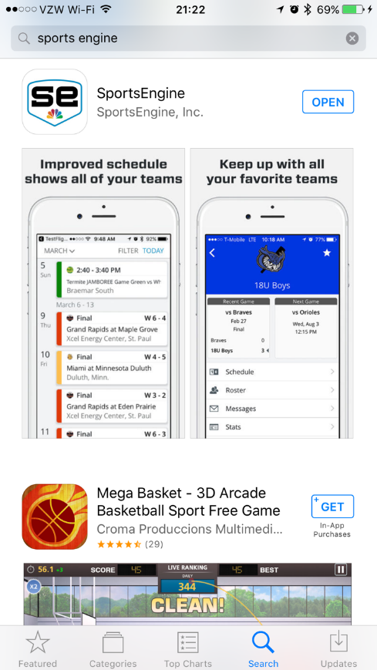
Choose this one and install.

- Select your “favorites” to have access to the teams you follow:
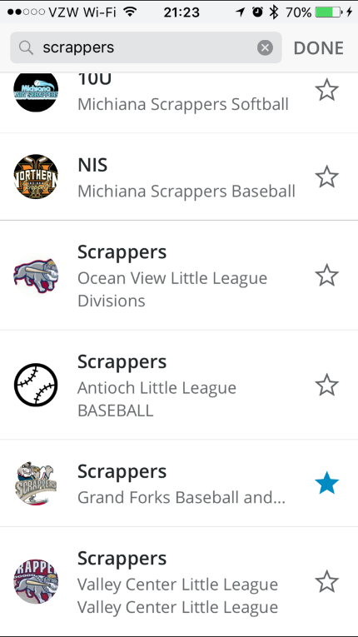
Type in “Scrappers” and click the star next to our team. You can add multiple teams to follow.

