CAPISTRANO UNIFIED SCHOOL DISTRICT
STUDENT ATHLETE/PARENT HANDBOOK
2017 - 2018

Kirsten Vital, Superintendent

33122 Valle Road
San Juan Capistrano, CA 92675
949-234-9200

TABLE OF CONTENTS

I. CUSD ATHLETIC PROGRAM INTRODUCTION 3 - 4
Introduction/Philosophy
Program Objectives

II. COACHES’/ATHLETES PROFESSIONAL EXPECTATIONS 5
Communication
Cooperation
Discipline
Form of Address
Management/Leadership
Professional Growth
Rapport/Relationships

III. BOOSTER CLUB ORGANIZATIONS 6-7
Booster Clubs General Information
Booster Club Responsibility
Booster Club Fundraising
Booster Club Communication
Booster Club Websites

IV. FUNDRAISING 8
Fundraising Guidelines
Fundraisers

V. STUDENT FEES 9
CUSD Guidelines

VI. TRANSPORTATION 10-11
Athletics and Co-curricular Transportation Guidelines

VII. OVERNIGHT TRIPS 12
Overnight Athletic Trips/Supervision

VIII. PRE-SEASON / IN-SEASON RESPONSIBILITIES 13-17
Attendance Accountability
Athletic Class Attendance
Athletic Clearance Procedure
Athletic Eligibility / Probationary Period
Athletic Awards / Varsity Letterman Criteria
Budget
Equipment / Inventory
Locker Rooms
Team Rooms
Media Relations / Score Reporting
Parent / Athlete Preseason Meeting
Program Expectations
Role Model
Scholar Athlete Distinction
Non-Discrimination Policy
Tryout Procedures

IX. POST-SEASON RESPONSIBILITIES 18
Banquets
Equipment / Uniform Return
Program Evaluation
Team Meeting / Post-Season

X. GROUNDS & WEATHER 19-22
Heat Illness
Adequate Hydrations
Gradual Acclimatization
Hydration Status
Additional Prevention Measures
Lightning Policy
Cloud to Ground Lightning
Out of the Blue
Lightning Safety Solutions
Best Practices

XI. RISK MANAGEMENT 23
Coaches / Risk Management
Concussion / Return to Play Protocol
Sudden Cardiac Arrest

XII. CIF-SS BLUE BOOK 24
Undue Influence
Pre-Enrollment Contact
Transfer Eligibility

XIII. DISTRICT POLICIES 25-27
Student Harassment / Bullying
Positive School Climate
Sexual Harassment
Hazing
Hazing Guidelines
Recognition of religious Beliefs and Customs

XIV. APPENDIX 28-39

I. CUSD ATHLETIC PROGRAM INTRODUCTION

PHILOSOPHY
The CUSD High School Athletic Programs are an important partner in the overall educational experience that a student-athlete receives while attending CUSD schools. Our athletic programs will be conducted in a way that is complementary and supportive of the academic programs, and will provide meaningful learning opportunities not otherwise offered in the school classroom curriculum. CUSD Athletics will assist in developing the habits, attitudes, and ideals necessary to compete in an ethical manner whether on the athletic field or in the workplace. The balance between enriching young people through a spirit of cooperation while learning how to compete and reach their individual potential are fostered by a well-conducted athletic program under competent leadership. Furthermore, the athletic program will provide our students with life-long lessons for personal growth such as sportsmanship, teamwork, ethical behavior, perseverance, commitment, loyalty, self-discipline, pride, responsibility, and leadership skills. We fully understand that academics will open doors for our young people and it is our expectation that our student-athletes will strive for success in the classroom each and every day. However, we believe that their athletic experience will allow them to “stay in the door” by empowering them to persevere and stay the course leading to a successful and fulfilling professional and personal life as they move forward.

Sportsmanship should be the top priority of interscholastic athletics. Commitment to fair play, integrity, and a genuine empathy for others should be taught, practiced, and modeled if coaches are going to make a difference. Athletics should assist in the development of a well-rounded individual, and encourage the qualities of good citizenship. Sports play an important role in developing a healthy self-image as well as a healthy body and mind. Student-athlete self-esteem and self-concept should be elevated throughout their experience in the CUSD Athletic Programs. As a result, our athletic programs should contribute to help elevate school and community pride.

Interscholastic athletics is a voluntary program. Thus, participation is a privilege and not a right. Along with that privilege, student-athletes have the responsibility to conform to standards and expectations established for the CUSD athletic teams. This privilege may be revoked when the athlete fails or refuses to comply with the rules. It is a primary goal of the CUSD to provide adult role models (coaches) who exemplify the kind of behavior and leadership that is to be developed from our athletic programs.

The ultimate goal of CUSD Athletics is to empower and enrich all student-athletes through their experience within our programs. Although we want to compete at the highest level possible when the athletes reach the varsity level, we will never compromise nor make a decision that is not in the best interest of the student-athletes themselves. We believe that the well-being of our student-athletes comes first, and that through their dedication and commitment, their performance on the field, in the water, on the track, or in the gym, success will take care of itself. CUSD Athletics will constantly strive to develop well-rounded individuals who will go on to make a positive impact on their community and our society.

CUSD ATHLETIC PROGRAM OBJECTIVES
By participating in CUSD High School Athletics, student-athletes will acquire and exemplify the following values, attitudes, and skills needed for personal growth, which will develop individuals in becoming contributing members to our society: commitment, dedication, discipline, leadership, character, sportsmanship, integrity, and pride. Athletes are encouraged to participate in more than one sport.

II. COACHES’/ATHLETES PROFESSIONAL EXPECTATIONS

COMMUNICATION
Successful coaches are also skilled communicators. Remember, communication is widely considered to be 70% non-verbal, so coaches must be aware of their facial expressions and body language, as well as their tone when delivering a message. Also, athletes do have a right to express their views and opinions when appropriate, so a coach must also become an active listener if effective communication is going to take place. Communication involving foul language is not appropriate from students and staff and will not be tolerated.

DISCIPLINE
Every facet of discipline is the coach’s responsibility. Before athletes can perform or compete at their best, clear behavioral expectations must be set. Rules and expectations must center on the greater good of the individual and the team to empower them to become responsible, disciplined, hard-working, and compassionate members of both our school community and society as a whole as they move forward with their lives. Discipline must be fair, consistent, clearly defined, and in line with athletic department, District policies. Good sportsmanship and good citizenship must be the cornerstones of your athletic program. Remember, a coach must “walk-the-walk” as well and must be willing to follow the expectations that are laid out for their athletes.

FORM OF ADDRESS
Student athletes shall address coaches as: “Coach” or Mr., Ms., Miss, or Mrs., as appropriate. Athletes will display respect to all school employees (home and away) regardless of their position.

MANAGEMENT/LEADERSHIP
In addition to possessing the necessary program management skills to run a successful individual athletic team, coaches must also exhibit unwavering leadership as positive role models. Showing up every single day with energy, enthusiasm, passion, and a genuine love for both the game and the players will pay dividends in a coach’s ability to be an effective leader. As role models both on and off the field, all coaches must be cognizant of appropriate dress, personal appearance, and physical condition as well as their own personal behavior not only in connection with school activities, but also out in our community.

PROFESSIONAL GROWTH/IMPROVEMENT
Coaches often take advantage of opportunities presented for self-improvement through professional growth. Attendance at seminars, clinics, and workshops are highly encouraged. Keeping abreast of current sport trends, literature, philosophy, and coaching methods are integral components of professional growth.

RAPPORT/RELATIONSHIPS
A coach must be able to develop good rapport with a multitude of individuals and groups including but not limited to: student-athletes on the team, the student body, professional staff (faculty, administration, maintenance, custodial, etc.) the community as a whole, spectators, officials, fellow coaches, media representatives, and the parents of his/her players. Coaching at the high school level is a relationship business and all coaches have an opportunity to positively affect every member of the team; as a result, communication and establishing an authentic and meaningful relationship with every student-athlete should be the goal for every coach.

III. BOOSTER CLUB ORGANIZATIONS

GENERAL INFORMATION
Booster Clubs and other Parent Organizations, composed of parents, community members, and staff members, come together for the purpose of supporting specific school activities for the benefit of students. These groups are commonly referred to as school-connected organizations. They are important means of connecting parents and other community members with the curricular and co-curricular activities of students and the Board welcomes and encourages parental interest and participation.

Booster and parent organizations are separate from school districts with which they are associated and are not governed by the Education Code. However, booster and parent organizations do not have free access to schools and their students. The school district governing board and administration have, and must maintain, exclusive control and management of its public school system. Education Code Section 51520 and 51521 require any school-connected organization and/or activity be one that is authorized by law and permitted by Board Policy.

In accordance with CUSD Board Policy 1230 and accompanying Administrative Regulation 1.75, the Governing Board has established regulations for school-connected organizations. In order to be recognized as a school-connected organization, applications must be completed, tax I.D. numbers must be on file and submitted to your school’s administrator. Once approved, the liaison for each school-connected organization will be notified. Approval of school-connected organizations are reviewed annually by the school administration.

BOOSTER CLUB/SCHOOL-CONNECTED ORGANIZATION RESPONSIBILITY
Organizations of parents and other community members are important to coaches and the athletic programs. Booster Clubs cannot have money that is co-mingled with any ASB and/or CUSD funds that exist at each school. Any funds secured by these Booster Clubs are used for the sole purpose of supporting our student-athletes. Coaches are the liaison between the school and the booster club to help them determine needs. All activities are coordinated in this manner. Fundraising is one of the main purposes for these groups so coaches must take an active role in this area. Budgets must revolve around balancing program needs and program wants. All booster groups must have the appropriate documentation on file at the district office and carry the required liability insurance.

Under no circumstances shall school-connected organizations or their individual members hire a person to be a District employee or pay any District employee directly. Any funds received for the purpose of funding extracurricular positions shall be paid through the District, but only after the funds are deposited with the District which will in turn hire personnel and pay the appropriate wage or stipend. (BP 1230)

BOOSTER CLUB FUNDRAISING
In accordance with Education Code 51521, programs, fundraisers or other activities sponsored by booster and parent organizations must be authorized and conducted according to local board policy, laws, and school rules. At the beginning of each school year, each booster and parent organization shall submit to the Activities Director a list of the fundraising events that each organization proposes to hold that year – this also includes any individual sport that conducts all financial business through the school ASB. The Activities Director shall review the proposed events and determine whether the events are in conflict with, or detract from, the school’s educational program.

The following are guidelines for booster/parent organizations fundraising activities within the Capistrano Unified School District:
1. Use of districts’/schools’ name in fundraising activities should be approved by the school principal/designee and will comply with district policies and state law.
2. Students shall not be involved in fundraising activities except as volunteers for the
booster organization. Students may be required to attend fundraising events/activities, but are not required to participate.
3. Penal Code Section 320 and 320.5 authorize, under defined circumstances, eligible organizations to conduct raffles which require the payment of a fee for a chance to win a prize. Examples may include raffles and donation drawings as long as they distribute at least 90% of the proceeds to beneficial or charitable purposes.. Public schools are not “eligible organizations” but parent organizations with a 501(c)(3) status are eligible. Information on how to conduct a legal raffle can be obtained by going to the California Attorney General’s website: www.ag.ca.gov
4. All booster funds are collected and maintained by the organization. The District’s tax identification number cannot and will not be used. No booster funds shall be kept in ASB accounts.

BOOSTER CLUB COMMUNICATION
All communication distributed by the booster club must be approved by the head coach prior to distribution (i.e. email, documents, flyers, website, etc.). Parents must give permission (opt in) for email to be used for correspondence. Once permission is granted, all group email distribution lists may not show individual email address. Head coaches must be copied on all emails sent to parents.

WEBSITES
Team websites are an invaluable tool for parents and the community to gain information about our programs quickly without having to call the school site. If you maintain a separate team website, it is expected to be kept up-to-date and should include the following:

- Game schedules (all levels, times, opponents, etc.).
- Player rosters - required for state reporting purposes.
- Coaches and their contact information.
- Copies of team rules & policies.
- Include any information you feel is important to mention about your team and program.
- If your website is Booster/Parent managed, the Coach must continually monitor all content so that it is in line with CIF, District, and School Policy.

IV. FUNDRAISING

FUNDRAISING GUIDELINES
In accordance with Education Code 51521, programs, fundraisers or other activities sponsored by booster and school-connected organizations must be authorized and conducted according to local board policy, laws, and school rules. At the beginning of each school year, each booster and parent organization shall submit to the Activities Director a list of the fundraising events that each organization proposes to hold that year – this also includes any individual sport that conducts all financial business through the School ASB. The Activities Director shall review the proposed events and determine whether the events are in conflict with or detract from the school’s educational program.

The following are guidelines for booster/parent organizations fundraising activities within the Capistrano Unified School District:
1. Use of districts’/schools’ name in fundraising activities must be approved by the school principal/designee and will comply with district policies and state law.
2. Students shall not be involved in fundraising activities except as volunteers for the booster organization. Students may be required to attend fundraising events/activities, but are not required to participate.
3. It is possible for a private, non-district, non-ASB nonprofit group, such as a parent group, education foundation or booster club, to conduct raffles as long as the organization is a tax-exempt nonprofit organization with an approved tax identification number pursuant to Revenue and Taxation Code 23701d. The organization must have been licensed to do business in California for at least one year, must register with the attorney general’s Registry of Charitable Trusts and must receive written confirmation of the annual registration before holding the initial raffle. These nonprofit groups must register every 12 months and distribute at least 90% of the proceeds to beneficial or charitable purposes. They must also submit an annual report with gross receipts, expenses, net profit and the charitable purpose for which they used the money. The raffle tickets and stubs must be numbered, and adults must supervise the drawing, which may not be conducted over the Internet.
4. All booster funds are collected and maintained by the organization. The district’s tax identification number cannot and will not be used. No booster funds shall be kept in ASB accounts.

FUNDRAISERS
ASB approval is required for all fundraisers. If Booster Club involved fundraising (see fundraising guidelines under Booster Clubs above).
- A request form must be filled out along with a revenue potential form for approval by ASB before the event.
- Ten (10) days after the conclusion of the fundraiser, all completed paperwork (sales analysis report) must be returned to the Activities Office.
- NO RAFFLES ALLOWED (Unless you have a license issued by the state through a charitable organization). Penal Code Section 320 and 320.5 authorize, under defined circumstances, eligible organizations to conduct raffles which require the payment of a fee for a chance to win a prize. Public schools are not “eligible organizations” but parent organizations with a 501(c)(3) status are eligible. Information on how to conduct a legal raffle can be obtained by going to the California Attorney General’s website: www.ag.ca.gov

V. STUDENT FEES

CUSD GUIDELINES
The Capistrano Unified School District continuously strives to offer students a comprehensive array of programs within the District. We know these programs are important to our students and the community. At the same time, the California Constitution requires that public education be provided to students free of charge, unless a charge is specifically authorized by law for a particular program or activity. Recently, a lawsuit against the State of California brought to light many practices that violated this right, and mandated the need for districts to monitor all activity related to student fees.

In general, the law is very clear: School Districts may not charge fees for school programs and extracurricular activities, except those for which a fee is specifically authorized by law. This means that CUSD, like all districts in California, must ensure that parents, staff, and the community are clear on the guidelines for student fees and donations, and that they are followed with absolute consistency. Please note that the law does not prohibit a school district or its programs from requesting voluntary donations or engaging in fundraising activities and programs. These donations and fundraised financial contributions are voluntary, and all students will be allowed to participate in school activities and extracurricular activities regardless of whether the parent or legal guardian makes a donation. However, it's the manner in which we make those requests that is crucial. Keep in mind that the term “fee” and its definition of requiring payment must be removed from your program’s vocabulary in all correspondence, mindset, perception and of course, reality. Any correspondence with parents/players with regard to budgets, fundraising, and voluntary donations must be approved by the Varsity Head Coach before being submitted for pre-approval to the School Administration – this applies to all Booster Club communication and Team Website content as well.

Education Code 49011b states that “All supplies, materials and equipment needed to participate in educational activities shall be provided to pupils free of charge.”
- A waiver process shall not render an otherwise impermissible fee permissible.
- School districts and schools shall not establish a two-tier educational system by requiring a minimal educational standard and also offering a second, higher educational standard that pupils may only obtain through payment of fee or purchase of additional supplies that the school district or a school does not provide.
- The school district or a school shall not offer course credit or privileges related to educational activity in exchange for money or donations of goods or services from a pupil or pupil's parents

Click on the link below for further guidance and allowable correspondence with regard to requesting voluntary donations for your specific High School Athletic Team/Program.

(Click link for more information: http://capousd.ca.schoolloop.com/staffstudentfees )

VI. TRANSPORTATION

ATHLETICS AND CO-CURRICULAR TRANSPORTATION GUIDELINES:
The following guidelines are provided in order to assist sites with decisions and administration relative to transportation for athletics and co-curricular activities:

- General Guidelines:
  - The safety of students must always be the top priority, and all decisions relative to transportation must be made with this in mind.
  - Any site funds/resources that may be designated for transportation must be offered equitably (in term of percentage of costs covered, not necessarily in terms of actual dollars) to all programs in accordance with ACLU guidelines, Title IX regulations and Board Policies.
  - Site Administration will work with coaches/advisors and parent booster/support groups to secure transportation funding in a way that best serves the needs of students, given the above criteria and the options below.
- Transportation Options:
The following options may be used relative to student transportation to athletic and co-curricular events (BP 3540 and 3541).
- District Bus/ Charter Bus: District or charter buses must be used whenever possible. Students must be transported during school hours or immediately following dismissal. Exception: Weekends or during other non-school days. This option should also be used any time student safety, distance traveled, or other factors (time/day of game) deem appropriate. Only the site Principal, in consult with the Assistant Superintendent-Secondary, can approve exceptions. Due to limited buses and drivers, charter buses may be available during the designated home-to-school transportation time windows, or whenever a trip’s logistics would encroach on this window.
- District van: Students may be transported via an available district van instead of a district bus provided the driver is a qualified and approved district employee with proper driver forms and valid insurance declaration on file with Athletic Director/Office Manager.
- Private vehicles of approved/cleared voluntary drivers: Other than as specified and required above, students may be transported by private vehicle using approved/cleared Tier I Volunteers (Appendix A) that are also approved as drivers provided that all conditions of BP 3541.1 are met relative to driver registration with the district, minimum private vehicle insurance mandates, parent permission, etc.
- Student-arranged self-transport: With coaches approval, students may choose to arrive at a destination by arranging their own transportation provided that ALL the following conditions are met:
    - It has been communicated to parents as to which events/dates students/parents will be required to arrange their own transportation, and the district “Parent/Guardian Permission Form for Student-Arranged Self-Transport to an Off-Campus Activity” has been completed for each student who will arrange self-transport.
    - The need for transportation does not occur during the normal school day or immediately following dismissal unless the Principal has granted a specific exception in consult with the Assistant Superintendent - Secondary.
    - The distance traveled one way does not exceed 20 miles. Exception: This mileage limitation does not apply to events held on weekends or during other non-school days.
    - No district employee may assist with arranging student self-transportation, assigning carpools, etc. under any circumstances. Students and parents must arrange self-transportation on their own.
- Transportation Invoices:
If CUSD Transportation (Buses) is used, the school site will be invoiced directly by CUSD.

See Appendix:
B - Parent/Guardian Permission Form for Student - Self Arranged - Transport.
C - Employee/Volunteer Personal Automobile Use Permission Form.
D - Transportation Authorization and Waiver Form.
E - School Related Trips.

VII. OVERNIGHT TRIPS

ATHLETIC FIELD TRIPS (OVERNIGHT TRIPS) - SUPERVISION
Any athletic trip that requires an overnight stay must have prior approval by the CUSD Education Services Division. A properly filled out Field Trip Request packet must be submitted to the appropriate site administrator). A complete itinerary and cost must be approved prior to the trip. Coaches should make every effort to schedule travel as to avoid student-athletes missing school (whenever possible). If a trip is outside of California and beyond a border State, approval must be obtained by the school Principal, school district, and the CIF-SS (see Athletic Director) (BP 6153).

Timelines (CUSD) must be followed well in advance in order for all overnight trips to be approved. If any parents are chaperoning the trip or acting as volunteer drivers, parents (chaperones) must be cleared Tier I Volunteers (Appendix A under section for clearance process).

VIII. PRE-SEASON / IN-SEASON RESPONSIBILITIES

ATTENDANCE ACCOUNTABILITY
All athletes are expected to be in attendance during their 5th and 6th period academic classes at all times unless one of the following circumstances arises:
- Home Game on day of 5th or 6th period academic class:
Athletes will be dismissed no earlier than one hour prior to contest start time.
- Away Game on day of 5th or 6th period academic class:
Athletes will be dismissed no earlier than 20 minutes prior to bus departure.

ATHLETIC CLASS ATTENDANCE
If a coach has an athletic class during the school day (academic periods 1-6), the head coach or member of coaching staff must be present to work with athletes. If there is a schedule conflict, it is the coach’s responsibility to contact the site Athletic director.

An athletic class may not be cancelled at any time. If inclement weather occurs or other unforeseeable circumstances arise, coaches will provide an alternate activity as students are not permitted to leave campus without appropriate authorization.

ATHLETE CLEARANCE PROCEDURE
Prior to participation in tryouts or team practice, all athletes must be cleared through the High School Athletic Office. Athletes are considered “cleared” when a completed CUSD Athletic Clearance Packet with proof of insurance is turned in and accepted by the Athletic Director. Athletic Clearance Packets are available on the CUSD website or in the Administration Office at your school site. Athletic physicals are valid for one year and must be updated for each school year; if a physical expires, an athlete is not eligible to participate until a new physical examination is completed.
- Coaches must have proof students have been cleared by the Athletic Office. Clearance includes a pre-participation physical form, proof of insurance/risk warning form, handbook acknowledgement form and academic eligibility. Student athletes are given a Clearance Pass when all requirements have been met.
- Coaches must submit a list to the Athletic Office of athletes prior to the first day of practice. School Athletic Directors will provide specific timelines and directions for clearance procedures.
- Each coach will abide by and instruct all student athletes according to the Athletic Codes and rules of the contests as established by CUSD, the Coast View Athletic Association (CVAA) and the California Interscholastic Federation (CIF).
- Coaches will issue uniforms and equipment and keep records of all issues regarding their issuance. Coaches will advise student athletes of the return procedure.

*See your school’s athletic website and follow the instructions for completing this process online at www.athleticclearance.com.

ATHLETIC ELIGIBILITY
- A student must meet CIF, League, and Capistrano Unified School District eligibility requirements.
- A student/athlete must pass a physical examination given by a physician.
- A student/athlete must obtain health insurance or show evidence of coverage to replace insurance that affords the required coverage.
- A student/athlete may not compete on an outside (of school) team in the same sport during the season.
- A student in Grades 9-12 shall have earned a minimum 2.0 GPA in all enrolled classes during the preceding grading period based on a 4.0 scale. GPAs of students in AP honors classes will be calculated using the 5.0 scale for AP honors course work.
An “A” is worth four (4) grade points, a “B” is worth three (3) grade points, a “C” is worth two (2) grade points and a “I” will receive zero (0) grade points. The grade point average will be determined by dividing the total number of grade points by the total number of courses.

All student/athletes must have a 2.0 GPA, and must pass four or more classes. Once the minimum standard is met, the athlete will be allowed to participate in contests. (BP 6145b) (Appendix F).

- PROBATIONARY PERIOD (FOR STUDENT-ATHLETES)
The CUSD School Board grants students with less than the minimum required GPA a probation period of one semester (grades 9-12) as long as they pass at least four (4) classes (CIF Rule). Students granted probationary eligibility must meet the required standards by the end of the probationary period in order to remain eligible for participation.

The Superintendent or designee may grant an ineligible student a probation period of not more than one semester (BP 6145c) (Appendix F).

ATHLETIC AWARDS/VARSITY LETTERMEN CRITERIA
Varsity head coaches will establish the requirements for the awarding of varsity letters for their sport. Those requirements must be provided in writing to the athletes and their parents before the beginning of the season. Copies of the requirements must also be provided to the athletic director for approval before distribution. Coaches will be provided with a set amount of awards as well as individual certificates to honor all athletes at the team's sport banquet. Communicate with your athletic director regarding award budget for team, league, and CIF awards.

BUDGET
During the pre-season (or even earlier if possible) the head coach will formulate a budget for their specific program based on needs vs. wants. The budget should include the basic needs of the program, as well as a prioritized list of needs versus wants, based on the amount of funds secured. Remember that all financial goals cannot include any solicitation of fees of any kind; they are to center on Fundraising and Voluntary Donations.

EQUIPMENT/INVENTORY
The Varsity Coach is responsible for the issuing and collection of all equipment. Coaches are responsible for all team equipment; the support of student managers may assist in this process. If athletes fail to return equipment, they are not be allowed to move onto another sport; any monetary charges need to be communicated to the Athletic Director and Activities Clerk.
LOCKER ROOMS
It is the responsibility of each Head Coach to ensure that all locker rooms are kept secure and that the environment is a safe place for all athletes and is free of harassment, bullying, hazing, and any other destructive behaviors. The locker room must be kept clean at all times and athletes must abide by the rules of NO FOOD, NO CLEATS, NO DRINKS (except water). Remind your athletes daily that lockers need to be secured and to avoid storing valuables inside.

TEAM ROOMS
If your team has access to any specific “team” room it is the responsibility of the Head Coach to ensure all rules are followed (see locker rooms above). The biggest difference between a team room and a general locker room is supervision. Any specific room designated for a particular team must be supervised by an approved coach at all times. Obviously gender issues and athletes using the room for changing their clothes presents challenges, but nonetheless the coach is accountable for athlete behavior.

MEDIA RELATIONS/SCORE REPORTS
Full cooperation with all representatives of the news media is vital if “good press” is to be expected.

PARENT & ATHLETE PRE-SEASON MEETING
Coaches are responsible for conducting a parent meeting prior to the beginning of the season. Meeting dates must be communicated to the Athletic Director/Activities Director prior to meeting date to avoid conflicts with other school events. The parent meeting is an opportunity to discuss program goals, team rules, practice schedules, budget, fundraising, etc. Additionally, the chain of command needs to be explained if a parent has concerns with the program as follows:

- Chain of Command for parent communication
- Coaches-coach; Players-play; Parents-parent
- Athlete talks to Coach
* If not solved, then…
- Parent and Coach meet
* If not solved, then…
- Parent and Coach meet with Athletic Director
- Program Expectations (including behavior/conduct) are to be addressed with parents. Remind parents that both the athlete and parent must sign a form acknowledging receipt and agreement to follow rules/expectations as communicated in the handbook. A copy MUST be presented to the Athletic Director prior to the start of the season (see student-athlete handbook section below).

PROGRAM EXPECTATIONS
Topics to be addressed may include, but are not limited to the following:
- Head Coach’s Philosophy
- Team Objectives for the year
- Calendar of Events
- Informed Consent
- Lettering Requirement for Varsity
- Team Rules and Expectations for Players
a. Attendance (excused vs. unexcused)
b. Punctuality
c. Dress Code
d. Academic Eligibility/Expectations
e. Drug/Alcohol/Steroid Policy (Education Code 48900)
1. CUSD 90-Day Suspension from Co-Curricular Activities Policy
2. Encourage enrollment in Voluntary Drug Testing Program
f. Calendar – Practices, Games, and other organized Team Activities
g. Hazing/Bullying/Sexual Harassment Prevention Policies
h. Classroom Behavior; Study Habits; Off-Field Behavior (In-Season/Off-Season)
i. Social Media Responsibility (Appendix G)
j. Signature page for both athlete and parent to sign/date to acknowledge and agree to
program rules and expectations.
- Schedule of games and practice times
- Transportation policy
- Discuss drug, alcohol, tobacco and steroid usage, signs, prevention
- Discuss sportsmanship expectations - athletes, coaches, fans
- Solicit volunteers at your meeting for booster club help
- Encourage parent/booster involvement, stress importance of supporting their child
- Parent attendance at games/contests - crowd control
- Discuss the parent/coach role – chain of command

*Note: A copy of Student-Athlete Program Expectations must be submitted to Athletic Director prior to publishing/distributing.

ROLE MODEL – CLEAR EXPECTATIONS FOR COACHES/PARENTS
Please carefully consider the language you use when speaking to or in the vicinity of any of our student-athletes and/or members of the community. Remember that your school is an educational institution first and foremost and that you are part of a team of educators. The language and habits that your student-athletes observe will undoubtedly become a part of their make-up. If you lose control of your emotions, don’t expect the Student athlete(s) under your direction to maintain theirs. Profanity laced outbursts can never be defended by the Administration and can lead to termination.

SCHOLAR ATHLETE DISTINCTION
Any Varsity student-athlete with a 3.75 total weighted GPA from the previous semester will earn Scholar-Athlete distinction.

NON-DISCRIMINATION POLICY
The Board of Trustees desires to provide a safe school environment that allows all students equal access and opportunities in the district’s academic and other educational support programs, services, and activities. The Board prohibits, at any District school or school activity (including athletics), unlawful discrimination, including discriminatory harassment, intimidation, and bullying of any student based on the student’s actual or perceived race, color, ancestry, national origin, nationality, ethnicity, ethnic group identification, age, religion, marital or parental status, pregnancy, physical or mental disability, sex, sexual orientation, gender, gender identity, or gender expression or association with a person or group with one or more of these actual or perceived characteristics.

TRYOUT PROCEDURES
- Measurable criteria for evaluating student-athletes shall be established in writing. The criteria must be reviewed and understood by all coaches involved in the player/team selection process. The criteria shall also be provided to each evaluating coach no later than the first day of tryouts.
- Measurable criteria for evaluating student-athletes shall be established in writing and clearly articulated to all players participating in a school team tryout. The criteria will be provided to each student-athlete no later than the first day of tryouts.
- A program’s Head Coach and/or the site Athletic Director shall maintain all rating documents utilized by coaches during the evaluation and assessment of individual student-athletes during a school team tryout for no less than one year (12 months). Each rating document must clearly identify the rater and contact information, to include name, address and phone number.
- All coaches participating in a school team tryout shall be solely focused on player evaluation and have no secondary assignment or task during player assessment and evaluation.
- Upon request, a player or parent will be provided a copy of the individual student-athlete’s tryout evaluation ratings.
- Tryouts will be open to all eligible students, per CIF and district guidelines. Tryout dates will be announced at a minimum via school public address announcements and the school website for at least five school days prior to the first day of tryouts.
- Tryouts will take place over multiple days in order ensure that each player is given proper consideration. No player will be cut any sooner than the end of the second day of tryouts.
- All student-athletes participating in a school team tryout will be prohibited from wearing any attire indicating a private club team affiliation. Thus, each student should be instructed to wear (or be provided with) a plain or generic non-club shirt and be given a generic number or name to identify who they are.
- Coaches affiliated with a private club team may not advertise the school’s logo or mascot on their private club website.
- All coaches also involved with a private club team may not indicate the name of the club team to which they are affiliated on the school website or the website for any school program (i.e. the team’s official website or webpage) or wear private club attire.

IX. POST-SEASON RESPONSIBILITIES
BANQUETS
Scheduling of sports banquets must be coordinated with the Athletic Director. If utilizing a school facility, all paperwork must be filed with the Activities Director to reserve space and custodial support. If utilizing an off-campus facility, no alcohol can be served. Athletes will not be charged to attend end of season team banquets. Booster clubs assisting with banquet coordination may charge parents and guests if they choose to eat at the banquet, but attendance will be free of charge if guests simply want to attend the award portion of the banquet ceremony only.

EQUIPMENT/UNIFORM RETURN
Set up immediate equipment and uniform return so that athletes moving to another sport can do so without unnecessary delay. Any athlete that fails to turn in any item can be billed for it. Athletes cannot move into another sport until this process is completed. The coach should submit an athlete debt notice to the ASB office following equipment return.

PROGRAM EVALUATION
All aspects of the program will be evaluated after the season concludes by the Athletic Director or Site Administrator. From practice plans to financials to personnel needs, every aspect of the program is evaluated, so improvement can take place moving forward. Great athletic programs that are successful over long periods of time continue to self-evaluate with the purpose of seeking improvement each and every year, even after a championship run.

TEAM MEETING (POST-SEASON)
Review season’s goals:
- Recognize athletes and staff
- Encourage 2nd sport participation
- Recommend off-season camps, clinics, and supplemental conditioning opportunities
- Set-up uniform/equipment return (if not done already).

X. GROUNDS & WEATHER

Heat Illnesses
This heat index chart is designed to provide general guidelines for assessing the potential severity of heat stress. Individual reactions to heat will vary. In addition, studies indicate that the susceptibility to heat disorders tends to increase with age. Exposure to full sunshine can increase Heat Index values by up to 15° F.
How to use Heat Index:
1. Locate on the chart above the current Air Temperature down left side
2. Locate the current Relative Humidity across the top
3. Follow across and down to find Apparent Temperature (what it feels like to the body)
4. Determine heat stress risk on chart below
Heat Illness Risk
Apparent Temperature | Heat Stress Risk with Physical Activity and/or Prolonged Exposure
80° to 90° | Exercise caution; dehydration likely if athlete fails to drink adequate fluids
91° to 103° | Exercise extreme caution: Heat cramps or heat exhaustion possible
104° to 124° | Danger: Exertional heat cramps or heat exhaustion likely, heatstrokepossible
125° and up | Extreme Danger: Exertional Heatstroke highly likely

Listed below are general guidelines for preventing heat related injuries during practice, or any athletic event:
Adequate Hydration
- The athlete should arrive at practice well-hydrated to reduce the risk of dehydration.
- Water or sports drinks should be readily available to athletes during practice and should be served ideally chilled in containers that allow adequate volumes of fluid to be ingested.
- Water breaks should be given at least every 30-45 minutes and should be long enough to allow athletes to ingest adequate volumes of fluid.
- Athletes should be instructed to continue fluid replacement in between practice sessions.

Gradual Acclimatization
- Intensity and duration of exercise should be gradually increased over a period of 7-14 days to give athletes’ time to build fitness levels and become accustomed to practicing in the heat.
- Protective equipment should be introduced in phases (start with helmet, progress to helmet and shoulder pads, and finally fully uniform).

Hydration Status Record Keeping
- The amount of fluid lost should be replaced by the next session of activity. An athlete should drink approximately 16 oz of fluid for each kilogram of fluid lost (1 kg = 2.2 lbs).
- The color of the urine can provide a quick guess at how hydrated the athlete. If the urine is dark like apple juice means the athlete is dehydrated. If the urine is light like lemonade in color means the athlete seems adequately hydrated.

Additional Prevention Measures
- The use of lightweight synthetic clothing which aids heat loss.
- Athletes should wear light colored clothing.
- Well-balanced diet which aids in replacing lost electrolytes.
- Avoid drinks containing stimulants such as ephedrine or high doses of caffeine.
- Alteration of practice plans in extreme environmental conditions.
- Adequate rest breaks in the shade.
- Allow athletes to remove unnecessary equipment during rest breaks.
- Athletes with febrile or gastrointestinal illnesses should not be allowed to participate until recovered.

Lightning Policy – A Significant Threat to Sports
Lightning is of particular significance to the sports and recreation sector because most events are held outdoors and often in wide-open areas with limited shelters.

Compounding the open-area issue is the fact that it can take considerable time to clear the large number of fans and participants from these open areas. For example, often the courses played on the PGA Tour are so large and filled with so many spectators that it can take more than 30 minutes to successfully clear people from danger.

It is not surprising, therefore, that 45 percent of injuries due to lightning in the United States each year occur at sports and recreation events.

Cloud-to-Ground Lightning
This type of lightning, the most dangerous, accounts for approximately 20 percent of lightning occurrence. It is the result of the connection between the negative charge at the base of the cloud and a positive charge at the ground.
Out of the Blue
The most dangerous type of cloud-to-ground lightning is positive lightning, a net transfer of a positive charge from the cloud to the ground. While some positive lightning strikes reach the ground directly beneath the cloud, many emanate from the top of the storm (positive region), travel horizontally – sometimes more than ten miles away – and then veer downwards, striking an object on the ground (negative region). This strike is far from the storm and often appears, literally, from blue sky – hence the term ‘bolt from the blue.’ Because of the distance traveled, these positive lightning strikes tend to have five to ten times the voltage of a conventional lightning strike, increasing the probability of fire ignition or damage to infrastructure.

Positive lightning can move in the direction of the storm track or backward to the area that had already experienced the storm, or to either side. Regardless of strike location relative to the storm, it strikes many miles from its origin thunderstorm cloud. For this reason, there continues to be lightning danger when thunderstorms have passed but are still in the region and waiting 30 minutes or more after rain ends before resuming outdoor activities is recommended.

Lightning Safety Solutions
“Flash-to-bang” timing
The ‘flash-to-bang’ method sometimes is used to determine how far away lightning is when real-time lightning detection is not available. This method involves counting the time lapse between observing a lightning flash and hearing the associated thunder – the “one Mississippi, two Mississippi” approach. This method assumes sound travels approximately one mile every five seconds; accordingly, thunder heard within 30 seconds of lightning signals a storm to be within six miles – a point at which authorities commonly initiate field evacuation.

FOR THIS REASON, WE RECOMMEND DOUBLING THE 30-SECOND / MILE RULE TO 60-SECOND / 12 MILES.

This ‘no-technology’ lightning safety solution has several drawbacks, making it a last-resort method for determining the location of lightning:

- Six miles is a conservative but not safe distance, as we know positive lightning can strike as far as ten miles from the thunderstorm.
- If the storm is fast moving, the 30-second threshold probably doesn’t provide ample time to safely clear a sports area crowded with spectators.
- Studies have shown that local geography and atmospheric conditions can bend sound waves upward so that they miss the ground – invalidating the 30-second measurement.
- Storms with a high flash rate can make it very difficult to correlate thunder with the appropriate flash.

Best Practice: establish an alert system. Adequate alerting allows the time and resources needed to clear the sports or recreation area and get spectators to safety. Large crowds and venues such as golf courses that cover a large area require additional clearing effort and longer alert lead time. (Note: our experience is that it can take up to 30 minutes to clear the course during a major golf event.)

- Warning alerts for suspension of play are commonly issued when lightning is detected at a minimum distance of eight miles (ten-mile minimum for golf events).
- Resume-play alerts are typically issued 30 minutes after the last lightning strike has occurred. Most thunderstorms travel around 25 mph, which means that after 30 minutes, the thunderstorm will be about 10 to 12 miles away from the area, minimizing the risk for a “bolt out of the blue.”

Best Practice: take shelter in a safe location.
What is Safe...In a large, enclosed building:
- Away from windows
- Away from electronics and appliances
- Enclosed metal vehicle
- Crouched at lowest point if caught outdoors
- Away from windows
What is Unsafe:
- Dugouts, stands, under trees, near tall objects, near power lines, or close to water in pools
- Open, higher ground near metal objects, canopies and tents, or picnic areas
- Smaller open shelters

XI. RISK MANAGEMENT

COACHES AND RISK MANAGEMENT
The definition of risk management is exactly what it says, managing risk. Your objective is to provide the safest environment possible. In an effort to reduce risks, coaches consider the following duties:

CONCUSSION/RETURN TO PLAY PROTOCOL
CA State Law AB 25 was passed a few years ago and mandates certain concussion protocols for athletes return to play. A few highlights include that no athlete can return to play sooner than seven days after being diagnosed with a concussion of any magnitude. In addition, there is a four stage recovery that our new trainer will be following. It is important to note that an athlete cannot move to Stage II until after they have returned to school (“Return to Learn”). So, protect your athletes as best you can and make sure that the protocols are followed with an ultimate written medical clearance needed from either your team doctor or your own physician. In addition, the attached Return to School form must be filled out by the attending physician and submitted to the school nurse by the athlete (or his/her parent) (Appendix H) .

SUDDEN CARDIAC ARREST
CA State Law AB 1639 was passed in 2016. AB 1639, Maienschein. Pupil health: The Eric Paredes Sudden Cardiac Arrest Prevention Act.

Existing law requires a school district, charter school, or private school that elects to offer an athletic program to comply with certain requirements relating to pupil safety, including, among other things, removing an athlete who is suspected of sustaining a concussion or head injury from an athletic activity.
In CUSD, coaches are certified every two years through NFHS and we have implemented acknowledgments in regards to sudden cardiac arrest information within our online athletic clearance process (Appendix I).

XII. CIF-SS BLUE BOOK

An electronic version of the CIF Southern Section Blue Book (www.cifss.org) is available for download.

Undue Influence: Any pre-enrollment contact by any persons associated with the High School to induce a student to enroll or transfer to that High School may cause the student to be ineligible for high school athletics for a period of one (1) year (CIF Blue Book Rule 510).

Pre-Enrollment Contact: Any student who transfers to a High School after the beginning of their 9th grade year who has participated on a team (travel ball / club / etc…) that is coached by a current coach at that High School in the same sport could be declared ineligible for a period of one (1) year.

Transfer Eligibility: Any student that transfers to a High School after the beginning of the school year must be cleared through the athletic director (paperwork submitted online to CIF). If an athlete and their entire family moves into one High School’s boundaries from another, they will be immediately eligible (undue influence / pre-enrollment contact not included). If an athlete does not change residences (goes from Private to Public) or moves from one parent to another (divorce/separation) and this is their first transfer, they can obtain varsity eligibility after a Sit-Out-Period (SOP).

XIII. DISTRICT POLICIES

STUDENT HARASSMENT/BULLYING
Every student is entitled to a safe school environment free from discrimination, harassment, intimidation, and bullying. The District’s policies are available on the CUSD website and in each of our school’s offices. The District prohibits bullying as defined in Education Code Section 48900(r) including, but not limited to, discrimination, harassment, intimidation and bullying based on the actual or perceived characteristics set forth in Penal Code section 422.55 and Education Code Section 220, which are disability, gender, gender identity, gender expression, nationality, race or ethnicity, religion, sexual orientation, or association with a person or group with one or more of these actual or perceived characteristics.
Acts of discrimination, harassment, intimidation or bullying must be brought to the attention of the principal. A complaint may be made anonymously by contacting the school administration. If there is sufficient corroborating information, the District will commence an investigation. Complaints will be considered confidential. However, it may be necessary to disclose certain information in order to effectively investigate. Students who violate the District’s policies on discrimination, harassment, intimidation and bullying may be subject to discipline, including suspension and expulsion. The District prohibits retaliation against individuals who make complaints or provide information related to such complaints.

POSITIVE SCHOOL CLIMATE (BP 5140)
The Governing Board desires to provide an orderly and caring learning environment in which students work diligently on their studies, feel comfortable, share responsibility for maintaining a positive school climate, and take pride in their school and their achievements. District staff shall encourage and reward success and achievement, participation in community projects, and positive student conduct. The District shall encourage attitudes and behaviors that promote mutual respect and harmonious relations. The schools shall promote nonviolent conflict resolution techniques and provide students with opportunities to voice their concerns about school policies and practices in responsible, appropriate ways. The Superintendent or designee may initiate student campus beautification projects, buddy systems, vandalism prevention campaigns, and other programs in which students may identify and solve problems that affect their schools.

Students shall not bully or injure other students, use vulgar, obscene or inflammatory language which challenges others toward violence, or damage or deface school or personal property. Students who do so shall be subject to appropriate counseling and discipline in accordance with law.

The Board encourages classroom use of conflict resolution and cooperative learning techniques and other strategies that foster positive social interactions among students from diverse backgrounds. The District shall provide instruction and counseling designed to promote positive racial and ethnic identity, help students understand diverse cultures, teach them to think critically about racial bias, and show them how to deal with discriminatory behavior in appropriate ways.

SEXUAL HARASSMENT (BP 5183)
The Governing Board is committed to maintaining a learning environment that is free of harassment. The Board prohibits the unlawful sexual harassment of any student by any employee, student, or other person at school or at any school-related activity.

Any student who engages in the sexual harassment of anyone at school or a school-related activity shall be subject to disciplinary action. For students in Grades K-3, this disciplinary action shall depend on the maturity of the students and the circumstances involved. For students in Grades 4 through 12, the disciplinary action may include, but is not limited to, suspension and/or expulsion.

Students shall be informed that they should immediately report any incidents to either the principal, or their designee if they feel they are being harassed. Any student or parent on behalf of the student, who feels that he/she is being sexually harassed may pursue the complaint in an informal process or may file a formal complaint with the District. Within 24 hours, staff shall report complaints of sexual harassment to the principal or designee and to the Uniform Complaint Officer’s office, who will immediately log the complaint. Staff shall similarly report any such incidents they may observe even if the harassed student has not complained to the principal or designee.

The District prohibits retaliatory behavior against any complainant or any participant in the complaint process. Information related to a complaint of sexual harassment shall be kept confidential to the extent possible, within legal constraints and individuals involved in the investigation of such a complaint shall not discuss related information outside the investigation process.

HAZING
Hazing comes in many forms and no matter what form it takes; such behaviors cannot be tolerated – ever. People often picture hazing as serious behavior that includes harassment, violence, forced alcohol consumption and other illegal acts. Yes, that is a more serious and illegal side of hazing but it can also take the form of seemingly innocent acts that are often thought to be part of “team building” or “team bonding. “Soft” hazing can take the form of forced dress up days and face painting for new team members to be “embarrassed” at school. Anytime a group is singled out for embarrassment or as a way to “initiate” them to the team could be considered hazing – and that will not be tolerated.

HAZING GUIDELINES
(a) It shall be unlawful to engage in hazing, as defined in this section.
(b) “Hazing” means any method of initiation or preinitiation into a student organization or student body, whether or not the organization or body is officially recognized by an educational institution, which is likely to cause serious bodily injury to any former, current, or prospective student of any school, community college, college, university, or other educational institution in this state. The term “hazing” does not include customary athletic events or school-sanctioned events.
(c) A violation of this section that does not result in serious bodily injury is a misdemeanor, punishable by a fine of not less than one hundred dollars ($100), nor more than five thousand dollars ($5,000), or imprisonment in the county jail for not more than one year, or both.
(d) Any person who personally engages in hazing that results in death or serious bodily injury as defined in paragraph (4) of subdivision (f) of Section 243 of the Penal Code, is guilty of either a misdemeanor or a felony, and shall be punished by imprisonment in county jail not exceeding one year, or by imprisonment pursuant to subdivision (h) of Section 1170.
(e) The person against whom the hazing is directed may commence a civil action for injury or damages. The action may be brought against any participants in the hazing, or any organization to which the student is seeking membership whose agents, directors, trustees, managers, or officers authorized, requested, commanded, participated in, or ratified the hazing.
(f) Prosecution under this section shall not prohibit prosecution under any other provision of law.
RECOGNITION OF RELIGIOUS BELIEFS AND CUSTOMS (BP 6141.2(a))
If you would like further information regarding board policy 6141.2 please visit: www.capousd.org
Instructional programs may include references to religion and may use religious literature, art, music or symbols to illustrate the subject matter being taught. Such instruction should be designed to broaden student understanding of social and cultural history and extend tolerance for the multiple ways of life practiced by the peoples of the world. Instruction about religious holidays shall be carefully tied to these educational objectives.
CUSD shall be sensitive to its obligation not to interfere with the philosophical/religious development of each student in whatever tradition the student embraces. School-sponsored programs should not be, nor have the effect of being, religiously oriented or a religious celebration.
Instruction which is contrary to a student's religious beliefs and teachings may be optional for that student who shall be excused upon written request of the parent or guardian, in accordance with the Education Code or at the discretion of the Superintendent or designee.
The Governing Board recognizes that holidays demonstrate the diversity and rich heritage of our community members. Classroom decorations and costumes may express seasonal themes that are not religious in nature.
Students may be released for religious instruction under the following conditions:
1. Students shall be permitted to be absent from school to participate in religious exercises or to
receive moral and religious instruction.
2. Each pupil so participating shall attend school for a period equaling at least the minimum school
day for their particular grade.
3. Each pupil shall not be excused for religious exercises or instruction for more than one hour per
day and for no more than four days per school month.
4. The religious institution shall assume full responsibility for students while under their charge.
5. The religious institution shall call for the students at the school of attendance and shall return
them to the school at the conclusion of the exercise of instruction. P 6141.2(b)
6. Religious instruction and exercises shall not take place on school property.
7. Prior consent of parents shall be received.
(cf. 5113 - Absences and Excuses) (cf. 6144 –Controversial issues)
Legal Reference: EDUCATION CODE 51240
Excuse from health instruction and family life and sex education due to religious belief 51511 Religious matters properly included in courses of study
Policy adopted: February 8, 1999 CAPISTRANO UNIFIED SCHOOL DISTRICT San Juan Capistrano, California

XIV. APPENDIX

Appendix A - Volunteer Assistance - Board Policy 1240
Appendix B - Parent Permission Form for Student-Arranged Self Transport
Appendix C - Employee/Volunteer Personal Automobile Use Permission Form
Appendix D - Transportation Authorization and Waiver
Appendix E - Board Policy 3541.1a – School Related Trips
Appendix F - Board Policy 6145 – Extracurricular and Co-Curricular Activities/Probationary Period
Appendix G - Social Media Agreement
Appendix H - Physical Clearance to Return to School
Appendix I - Sudden Cardiac Arrest

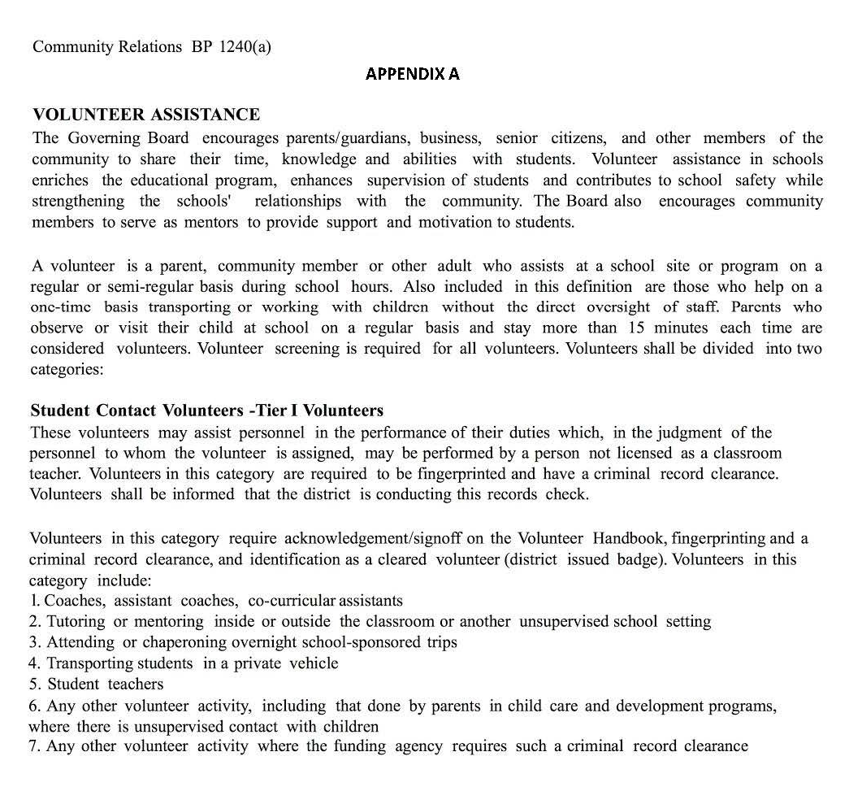

APPENDIX B

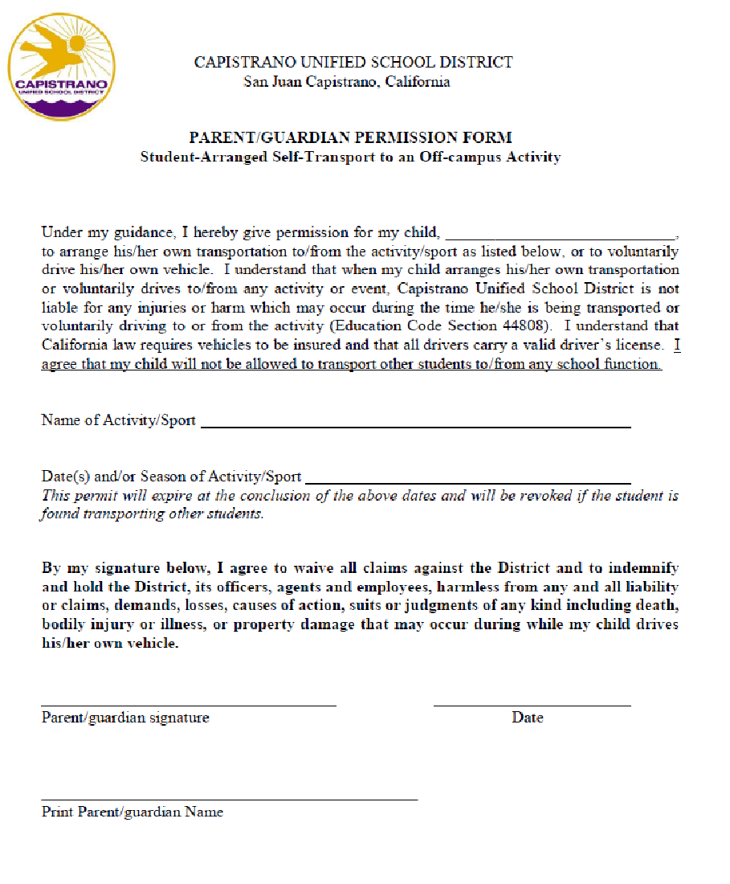

APPENDIX C
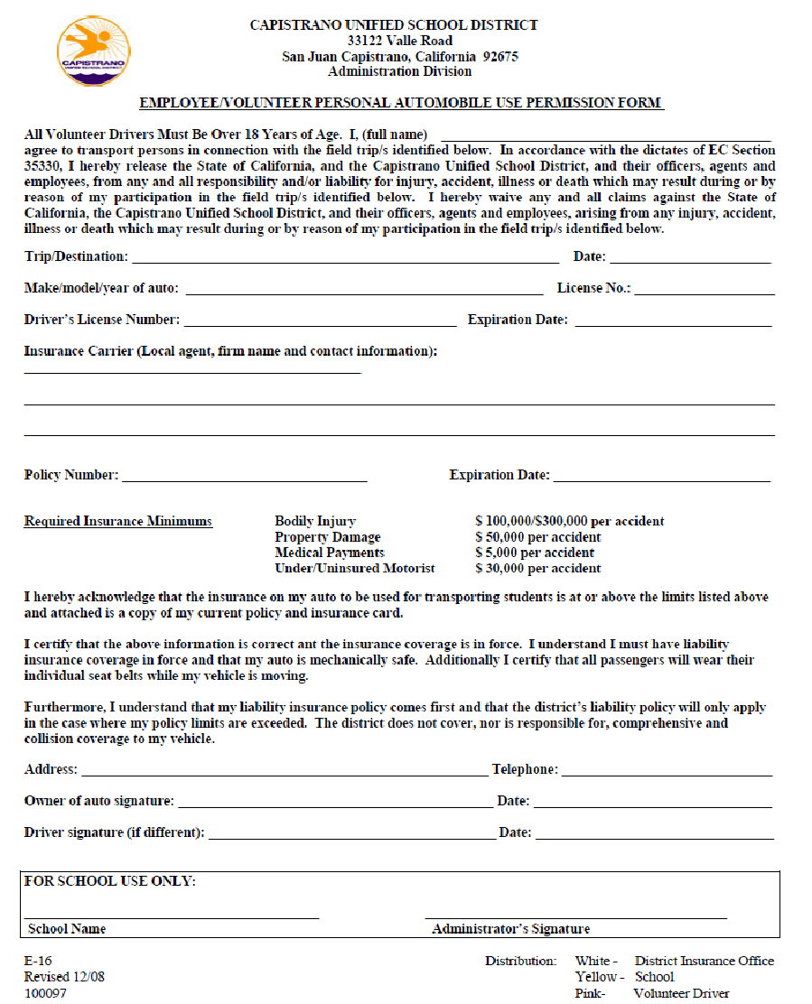

APPENDIX D

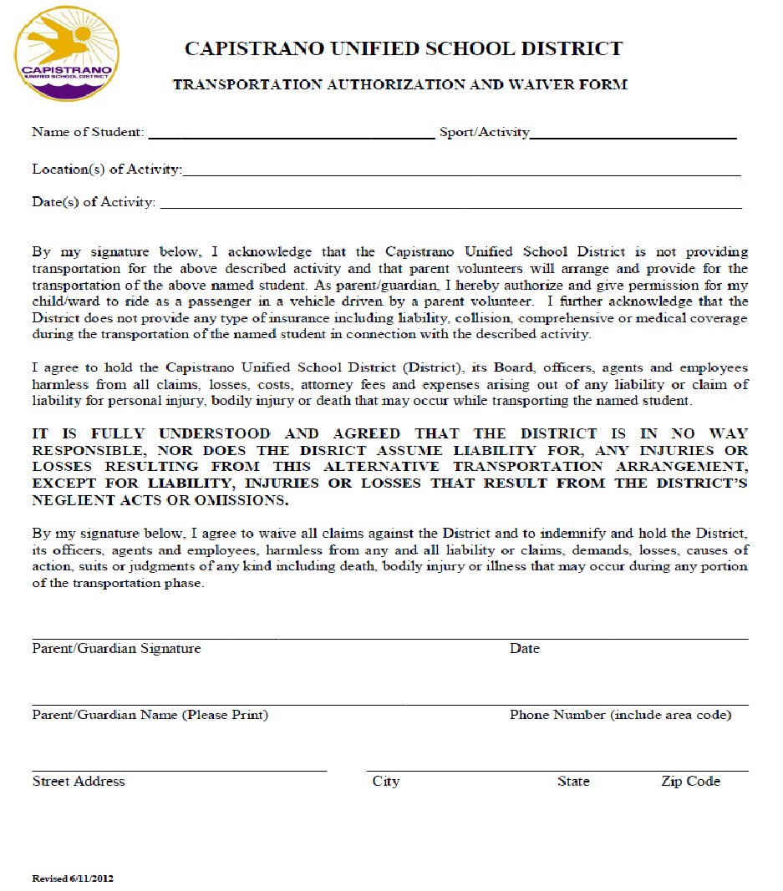

APPENDIX E

Business and Non-instructional Operations BP 3541.1(a)

SCHOOL-RELATED TRIPS

The District may provide transportation in school buses, school pupil activity buses, or on public transportation vehicles for field trips and excursions in connection with instruction or school-related social, educational, cultural, athletic or school band activities as approved by current Governing Board policy and administrative regulations.
(cf .35330 – Excursions and Field Trips)
(cf. 3541.1 – Transportation for School Related Trips)
(cf. 3541.5 - Alternative Transportation Arrangements)

School-related organizations requesting transportation shall be fully responsible for the costs of their trips unless funding has been approved by the Board.
(cf. 1230 – School Connected Organizations)
(cf. 3250 - Transportation Fees)
(cf. 3542 – School bus Drivers)
(cf. 3543 - Transportation: Emergency and Safety Procedures)
(cf. 6153 - School-Sponsored Trips)

Transportation by Private Vehicle
The Superintendent or designee may authorize the transportation of students by private automobile for approved field trips and activities when the vehicle is driven by an adult, age 18 or older, who has registered with the District for such purposes.

Before transporting students on any field trip or activity, drivers shall register with the District. Drivers shall receive safety and emergency instructions which shall be kept in their car. All student passengers shall provide permission slips signed by their parents/guardians.

Drivers shall be required to possess a valid California driver's license and liability insurance of at least $100,000 per occurrence. CUSD reserves the right to require volunteer drivers to provide a copy of their DMV records prior to transporting students.

Owners, drivers and passengers shall be informed that the registered owner and his/her insurance company are responsible for any accidents which may occur. District personnel who frequently transport students in their private vehicles are urged to carry single limit liability insurance of $300,000 or more per occurrence.

All drivers and passengers shall wear seat belts in accordance with law. (Vehicle Code 27315)

Trucks and pickups may not transport more persons than can safely sit in the passenger compartment.

BP 3541.1 (b)
SCHOOL-RELATED TRIPS (continued)
The number of passengers, including the driver, shall not exceed the capacity for which the vehicle was designed and should not in any case exceed ten. (Education Code 39830)

APPENDIX F
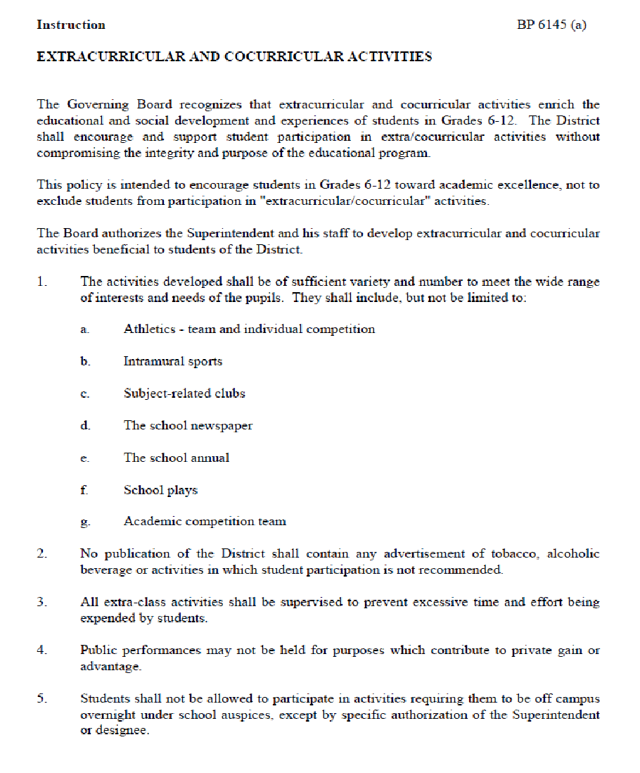

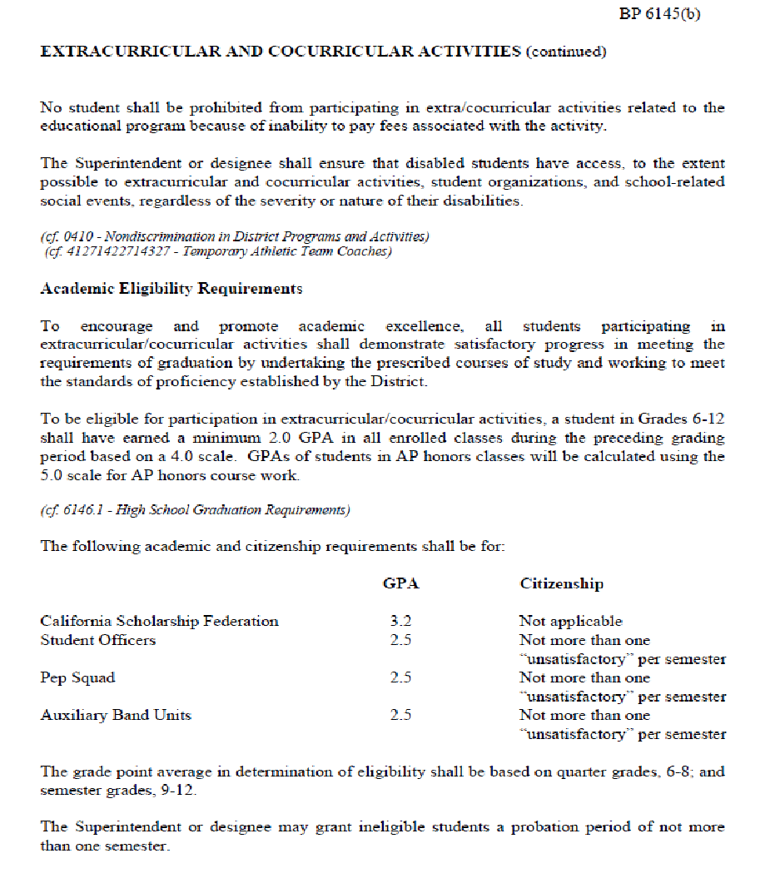

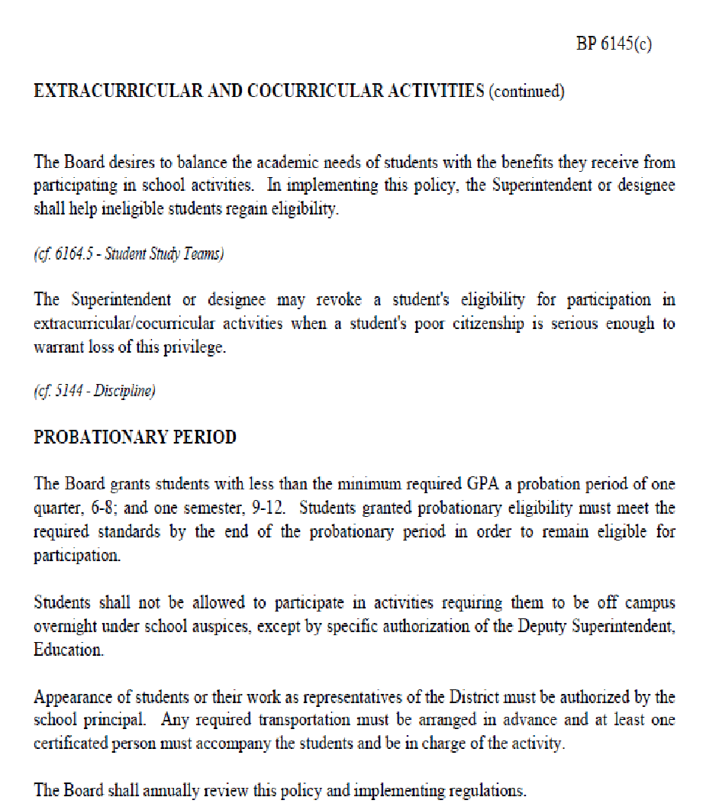

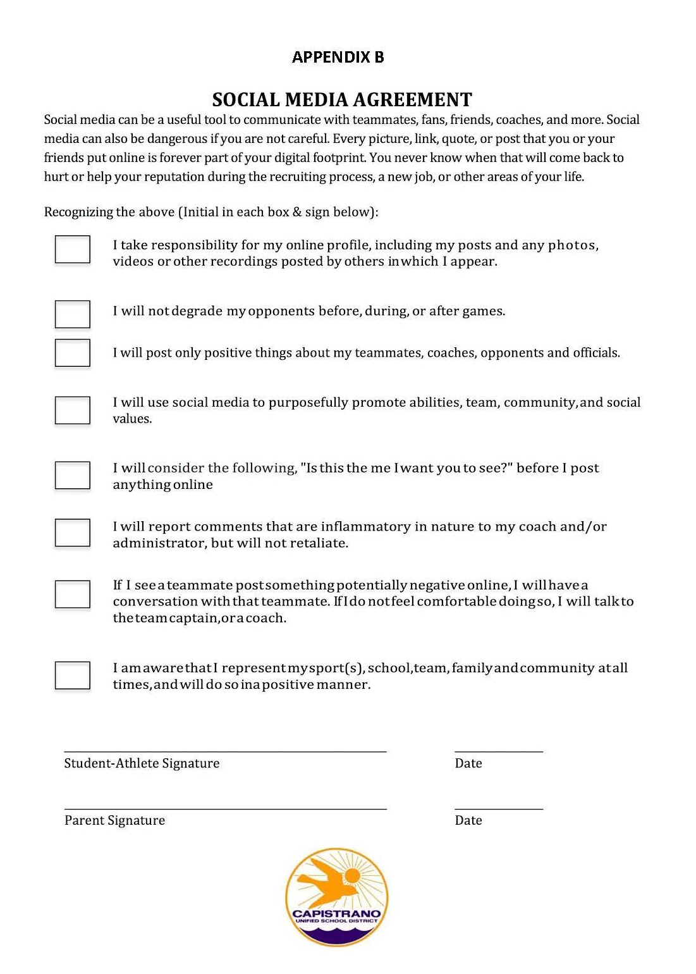
APPENDIX G

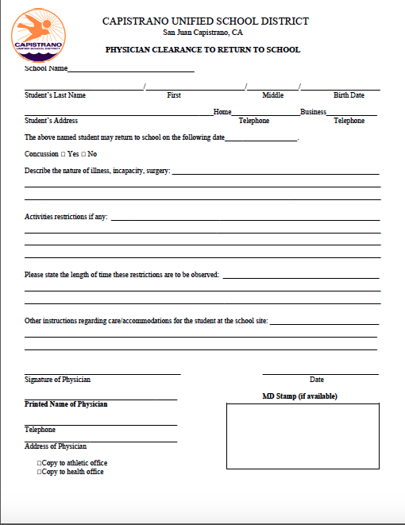
APPENDIX H
(Must be signed by the initial physician/MD who treated the athlete)

APPENDIX I

What is sudden cardiac .arrest?
Sudden cardiac arrest (SCA) is when the heart stops beating, suddenly and unexpectedly. When this happens blood stops flowing to the brain and other vital organs. SCA is NOT a heart attack. A heart attack may cause SCA, but they are not the same. A heart attack is caused by a blockage that stops the flow of blood to the heart. SCA is a malfunction in the heart's electrical system, causing the heart to suddenly stop beating.

How common is sudden cardiac arrest in the United States?
There are about 300,000 cardiac arrests outside hospitals each year. About 7,000 patients under 25 die of SCA each year.
Are there warning signs?
Although SCA happens unexpectedly, some people may have signs or symptoms, such as: Dizziness, Lightheadedness, Shortness of Breath, Difficulty Breathing, Racing or Fluttering Heartbeat (Palpitations), Syncope (Fainting), Fatigue (Extreme Tiredness), Weakness, Nausea, Vomiting, and Chest Pains.
These symptoms can be unclear and confusing in athletes. Often, people confuse these warning signs with physical exhaustion. SCA can be prevented if the underlying causes can be diagnosed and treated.

What are the risks of practicing or playing after experiencing these symptoms?
There are risks associated with continuing to practice or play after experiencing these symptoms. When the heart stops, so does the blood that flows to the brain and other vital organs. Death or permanent brain damage can occur in just a few minutes. Most people who have SCA die from it.

Sudden Cardiac Arrest Prevention Act (the Act)
The Act is intended to keep student-athletes safe while practicing or playing. The requirements of the Act are:

Information about SCA symptoms and warning signs.
Every student-athlete and their parent or guardian must read and sign this form. It must be returned to the school before participation in any athletic activity. A new form must be signed and returned .each school year.
Schools may also hold informational meetings. The meetings can occur before each athletic season. Meetings may include student-athletes, parents, coaches and school officials. Schools may also want to include doctors, nurses and athletic trainers.
Removal from play/return to play
Any student athlete who has signs or symptoms of SCA must be removed from play. The symptoms can happen before, during or after activity. Play includes all athletic activity.
Before returning to play, the athlete must be evaluated. Clearance to return to play must be in writing. The evaluation must be performed by a licensed physician, certified registered nurse practitioner or cardiologist (heart doctor).The licensed physician or certified registered nurse practitioner may consult any other licensed or certified medical professionals.

