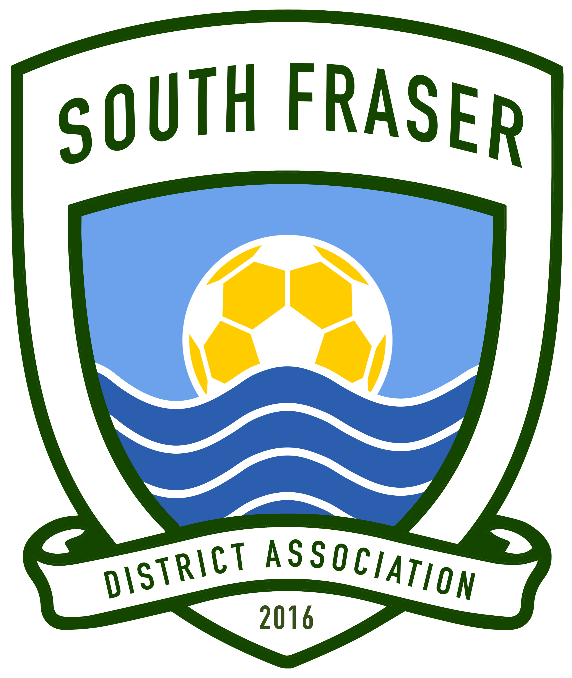
South Fraser District Association
www.southfrasersoccer.ca

South Fraser District Association / Player Development Series League

The following are the Rules and Guidelines governing the South Fraser District Association (SFDA) and the Player Development Series (PDS) League are agreed to by the member clubs of the SFDA and participating clubs in the South Fraser District League.
The member clubs, by agreeing to these Rules and Guidelines are responsible for their respective teams’ adherence to these Rules and Guidelines. The member clubs also agree to appoint a person responsible for District for the coaches to contact and to report any problems to the South Fraser District Rep. All CSA, BCSA, FIFA and Laws of the Game Rules apply in addition to these rules and in the event of a contradiction between the District Rules and Guidelines with any aforementioned rules, the District Rules will prevail.

Each District is responsible for the general operation and promotion of soccer within their respective geographic boundaries. All boys' youth teams will include SFDA, Richmond Soccer Association and Langley teams (Fraser Valley Youth Soccer Association). All girls' youth teams will include SFDA, Richmond Girls Soccer Association, and Langley teams (Fraser Valley Youth Soccer Association).

South Fraser District Association Grassroots Board
2017 / 18 Playing Season
(See attached- district reps)

Playing Season

For players, the "coastal" playing season shall commence on August 1st and terminate on July 31st the following year.
Affiliation
- The district or any affiliate shall have the power to prohibit the teams and players under its jurisdiction from playing with or against any team, which is not a member of the Canadian Soccer Association or an affiliate Association
- A "mini-team" shall be recognized when a minimum of the number of players specified in the table below (U6-U12, or as approved under BCSA policy 2) par registered with the district registrar or designated under one team name

U6 U7 U8 U9 U10 U11 U12
3 4 4 7 7 8 8

- A mini-team shall not exceed the following number of registered players in a particular age grouping.

Age Group | Game Format | Limit (Max. # of players)
U6 | 3v3 | 6
U7 | 4v4 | 8
U8 | 5v5 | 10
U9 | 6v6 | 10
U10 | 7v7 | 12
U11-U12 | 8v8 | 14

Player Registration
All players must complete, file, and register on BCSA player/team registration forms with a member club of the SFDA, Richmond Soccer Association or Fraser Valley Youth Soccer Association in order to qualify to play in South Fraser District League. These forms can be obtained through your club coordinator or District Registrar and should be carefully completed. Players are grouped as per the BCSA age categories using calendar years as cut-off, i.e. under a given age until midnight December 31st during the year of play.

The District Registrar is the sole authority in determining when a player is properly registered with the District.
Failure to register all players, by any club shall result in the directive from the board leading to the expulsion and/or suspension of that club from the district. Such a suspension or expulsion shall remain in effect until the matter has been rectified to the satisfaction of the board.
A player at U11 or U12 when first applying to the district for membership shall be required, to provide proof of age, such as a birth certificate, baptismal certificate, citizenship papers, passport or other evidence acceptable to the district registrar.
All players in the U12 divisions shall be issued with a photo identification card once they have been registered with the district registrar or designate. Cards will be issued on or before September 30.

Playing Up
The League Board has approved playing up within Divisions 1 to 4, the focus is on player development and there are a number of rules that must be followed for this initiative to be effective.
Management of the Playing up Permits is done by the District Registrar or their appointed designate.
To be valid, the permit must be fully completed and handed to the game official and the opposing team prior to the start of the game, and from October 1st onward the permit must be accompanied by the player’s valid ID card. Approval may only be authorized by District Registrar or approved designate.

The rules are as follows:
1. The league shall grant a player registered with a team playing in the league permission to play for a South Fraser District League team operated by the same club, provided the player has the consent of their registered team and the approval of the youth district, as follows:
Players playing in the South Fraser District League at U11 and U12 may play on permit for a league team in the same Club playing at a higher caliber in their own age group, or may play in an older age division at an equal or higher caliber
2. No permit required for U11 and below
3. A Playing Up Permit will be allowed for league games. Players under suspension shall not be eligible to play under permit.
4. Any player requesting a Playing Up Permit must apply for permission by completing a permit form supplied by the District Representative or appointed designate. The application form bearing the consent of the releasing team must be approved by the District Designate prior to the game (digital signatures are permitted). Each District may set additional conditions for approval or elect to not approve any Playing Up Permit as it deems appropriate. Permits must not be approved if doing so would imperil the players registered teams' ability to meet its scheduled commitments.
5. A Playing up Permit is valid only for the team, day and league game stated on the permit application form.
6. An approved Team List and Permit Form must be presented to the game official and the opposing coach prior to the start of the game.
7. From October 1st onwards, any District U12 player with a Playing Up Permit must also present a valid ID card to be eligible to play.
8. Teams shall not be granted permits for more than three (3) players for any one league game.
9. Teams shall not exceed the maximum players allowed per team by adding players on a playing up permit (ie max. 14 players for U11 to U12 on game days).
10. Any disciplinary action applied from misconduct reported while playing in a game under permit shall be served during future games of their registered team, as per discipline rules.
11. Any team playing a player on a permit that does not conform to the above rules risks suspension, a fine of up to $250 for playing an ineligible player, and will have permit privileges withdrawn. Any District approving permits not conforming to the above rules can be sanctioned by withdrawal of permit privileges for its District for up to one year, as well as a fine of up to $250

Team Registration Deadlines
Deadline for registration is August 15 for PDS League teams, August 15 for U11 and U12 SF house league teams and September 15th for all mini teams. Clubs will be fined $50 for any registered team that withdraws from the league after the August 25 deadline and the first game of league play. Late registered teams will not be guaranteed play in the league and will be accommodated only if no disruption to the schedule will occur, and must be approved by the SF District League Rep. An additional $150 fine will be charged, if a team withdraws mid-season resulting in rescheduling due to the team/s withdrawal.

League Operation
The league schedule is prepared by the District Scheduler appointed by the SFDA Board and covers all regular league play throughout the season.

Rules of Play
SF District plays under the guidelines established by SFDA
.
Duration of Play

Age Group | Game Duration
U6 | 2 x 15 Minute
U7 | 2 x 15 Minute
U8 | 2 x 15 Minute
U9 | 2 x 25 Minute
U10 | 2 x 25 Minute
U11 | 2 x 30 Minute

RETREAT LINE:

The use of a retreat line will be introduced to promote young players during goal kicks to improve their ability to play out from the back rather than kicking the ball away from their goal and down the field.

Age Group | Retreat Line Location
U6 – U9 | Half way line
U10 –U12 | 2/3 line

Retreat Line Procedure:
The Retreat Line comes into play when the ball has gone out for a goal kick. All opposing players will retreat to the offside line or on the side indicator (cone or marker) which should already be in place. Opposing players may not pressure the ball and until:

- The ball is received by a teammate OR,

- The ball travels over the retreat line OR,

- The ball leaves the field of play.

If a team chooses to play quickly, they can. The ball will be in play as soon as it leaves the penalty area regardless of the opposing team’s position.
If an opposing team repeatedly infringes the retreat line, an indirect free kick shall be awarded from the place where the offense occurred.

Home Team
The home team must be able to show the coach contacted the visiting team no later than Thursday evening before 9:00 PM to confirm the upcoming game time, location, and team colours. If the visitors have not received confirmation from the home team coach by the dead line stated earlier, the visitor coach must also be able to show they attempted to contact the home team coach as well and report the lack of contact to their club’s 1 District Rep. Should this not happen the visiting team should contact the home team. Home team must line the field to the satisfaction of the referee.
In the event the team’s uniforms are of the same or close match in colour clash then the HOME team must change their uniforms to avoid confusion. The use of same coloured pinnies is an acceptable alternative

Referees
The Home Club supplies the Referees. If the referee has not arrived 10 minutes after the scheduled start time and both teams agree to play the game, the home team will referee the first half and the visiting team the second half, unless it is agreed one person will referee the whole game. Team cards should be exchanged and the score will stand as if the referee was present. If the teams do not agree to play the game, the same procedures will apply to rescheduling as apply to games from field closures.

Player Identification
By October 1st all U12 teams in SF District League must have photo ID supplied by the District for all matches. This includes photo I.D. for all team officials. These cards are the property of the District and are to be given to the referee before the game starts. These photo I.D. cards are not proof of player registration with BCSA.
Should there be a red card offence, that person’s photo I.D. card will be retained by the referee and sent to the Discipline Board along with the referee’s report.

Validating I.D. Cards
All Player and Coaches ID's must be stamped, initialed and laminated by the SFDS District Registrar or the affiliate association registrar every year. Only Player IDs produced by the SFDA, Fraser Valley or Richmond District Registrar will be accepted as valid I.D. cards. Any attempt to "forge" I.D. cards will bring serious disciplinary charges against team officials and possibly players.

Lost cards
All lost cards will be replaced at the expense of the club the team is registered with. Please ensure that you get your cards back from the referee at the end of each game. The exception for referees returning cards is when a player’s ID card is confiscated by a referee for an expulsion from a game. Please note, that referees forward ID cards to Discipline where it is held until the offender appears before the district discipline committee.

Player Eligibility U12:
Only players with valid ID cards in the referee's possession are considered eligible to play in the game. If a team is unable to supply valid ID cards because of lost cards, a letter from the Registrar, District Chair or their designate will be allowed for one (1) game only. Coaches are responsible for having lost cards replaced except in discipline matters. If a team is unable to supply ID cards for the minimum of seven (7) players after October 1 of every season the game will be forfeited. Teams may appeal the eligibility concerning players at half time and the referee will witness. If questions arise on the eligibility of the player, the coach can announce that they will protest the match but must announce the intent to protest before commencement of the second half of play. No team can protest or appeal a game because of an ineligible player after the game has concluded unless a protest was announced before the second half.

Substitutions
Unlimited substitutions are permitted for all League games. Substitutions may be made at stoppage of play at the referee’s discretion. "Fair play dictates you substitute while the ball is in your possession".

League Standings
There are no league standing for Mini and or small sided games as per BCSA rules and regulations. Scores must be reported either thru the club scorekeeper coordinator, district rep and or league officials for re-tiering purposes. Every effort will be made by the SF District League to re-tier teams if the league deems teams are playing in the wrong division.
The Club Coordinator must report all games scores to their SF League Scheduler no later than 9:00 PM the Monday following game day.

Coaches Responsibilities for Both Coaches
- Confirm field and game time with opposing coach, by the Thursday prior to game day.
- Confirm team colours with opposing coach.
- Report your score immediately to the Coordinator. Win Lose or Draw.

Home Coach Only
- Line Field and set up nets.
- Inform visiting coach of directions to the field and field closures.
- If necessary, obtain two alternate dates for makeup games.

No Approach Rule
Parents will not be allowed to approach any game officials at any time during or after the match. This includes the volunteer AR's. If there are concerns and or queries, parents can approach team officials to approach the game officials or use the proper channels through their clubs representatives to discuss the game's officials. If parents are found approaching game officials (referees) during or after the game, a warning will be sent to both the club and the coaches. A second warning will result in either a suspension for the coach and or a fine to the club

No Shows
Games are to start promptly at the scheduled time subject only to the discretion of the referee.
Should either team not be at the field by the scheduled time, the referee will allow a fifteen-minute grace period. If the team does not show at that time, the referee will call the game.
A minimum of seven (7) registered players are required to begin a game in U11 and U12. Less than seven players is forfeiture. Under no circumstances are teams to use unregistered players. A $100 fine will be issued for not playing a regular scheduled league game without forty-eight (48) hours written notification to the SFDA District League Representative.

Grass versus Gravel Fields
Grass or turf fields are preferred over gravel or sand fields. If the away team is notified that the home team has had their game moved to a gravel or sand field, the away team can arrange for the game to be played on a grass or turf field. In this case, the home team must be notified by noon on Friday that the game has been moved to the away team's grass or turf field. The assignment and payment of referees is the responsibility of the team who supplied the field.

Field Closures and Cancellations
Please do not make private arrangements to change times, venues or dates of scheduled games.
Referee schedules are based on league schedules and player insurance may be jeopardized.
Clubs are responsible to inform coaches and the referee scheduler of field closures, and home coaches are responsible for notifying opposing coaches. Field closures will not be consistent throughout the Lower Mainland area. Various municipalities may close grass fields while others are left open.
League games that are postponed will be rescheduled soon as possible by the home team offering two alternate dates to the visiting team. If it is not possible to offer two dates within two weeks due to lack of field availability, then the games maybe rescheduled by the last day for makeup games. Failure to do so will mean that there will be a shortfall in your total number of games played by the end of season. Visiting teams offered two alternate dates must accept one and play the game.

Abandonment
Games that have been cancelled or abandoned by the referee due to rough play, spectator interference or other reasons will be reviewed by the SF Discipline Committee. The SF District Representative will inform teams of the results of protests and appeals.
Team officials are responsible for the behavior of their own fans. If requested by the referee to control the behavior of a sideline fan, team officials could be reported for failing to give best efforts towards complying with the request.

All players, coaches, and managers taking part in the SF District League are subject to the control of the SFDA District Board. SFDA District Board may investigate any of the following and refer the issues to the SMSA Discipline Committee if further action is required including sanctions.
- Abandoned Games
- Teams with excessive Yellow or Red cards
- Excessive no-shows or forfeitures
- Misconduct of players or officials
- Violations of field closures.

All players, coaches or managers who have received a red card must attend a district discipline hearing.
All red cards carry an automatic one game suspension. This one game is served automatically by sitting out the very next League game after the game in which the red card was issued. There are no exceptions to this rule unless the Chair of the District Discipline Committee agrees to waive the automatic suspension in a writing reinstating the player.
Yellow cards have the same automatic provision. Anyone with a total of three yellow in one season must sit out a game immediately after the game in which the third yellow card was issued.
It is the responsibility of the player’s coach to ensure that the suspension is carried out and the District will verify this. Failure to comply will result in the coach being held accountable by the S Discipline Committee.

Note:
Games cancelled because of weather or stoppages in the schedule do not count as a game suspension completed. Also, players under suspension are not eligible to play in tournament games until they have sat out their required League or playoff suspension.
All red cards require attendance at a disciplinary hearing. Failure to attend when called may result in an indefinite suspension. The District's Discipline Committee acts within the Rules, Guidelines, Policies, and Procedures established by the Canadian Soccer Association, the B.C. Soccer Association and South Fraser District Association. To appeal a decision made by the Discipline Board please follow the procedure laid out by BCSA on the BCSA website. Please note that an appeal of a decision rendered by a District Board must be submitted within 15 days from the day such a decision is received.

Protests and Appeals
A team may protest any scheduled game. The referee must be notified of the pending protest prior to the start of the second half of a game. All protests must be submitted in writing, signed by the affiliated team coach or manager, and submitted by email within seven (7) days of the date of the match to the SFDA
Secretary with the original copies of the protest to be received by mail including a cheque or money order in the amount of $75.00 payable to the SFDA before any Protest or Appeal will be heard.

