CHICAGO HOCKEY CHARITY CLASSIC
August 5th - 3:00 @ Fox Valley Ice Arena
Benefitting SPECIAL OLYMPICS-CHICAGO
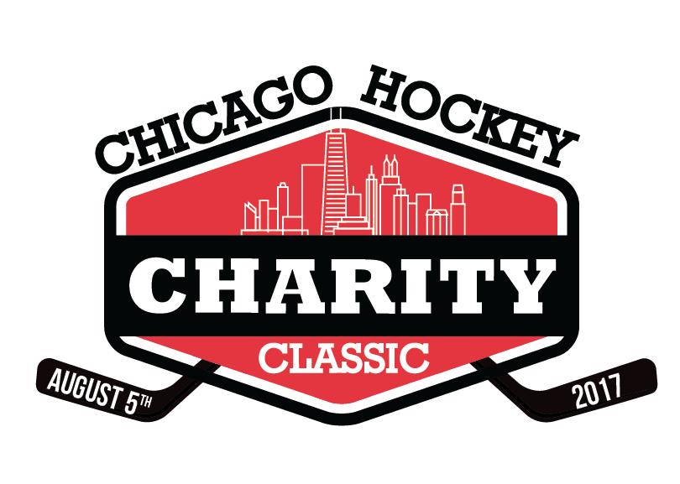
Joe Nagle
Executive Director
Special Olympics-Chicago
joe.nagle@sochicago.org
312.527.3743

Contact:
Topher Scott
Event Chair
tscott@prodigy-hockey.com
607.229.2232
607.229.2232

sdlfkjh
Player Sponsorship Commitment Form

__ Skybox ($5,000) __ Current NHL Player ($3,000) __ USA Women’s Olympian ($3,000)

__ Former NHL Player ($1,500) __ Local Youth Hockey Celebrity ($1,000)

Business name (as you would like it to appear in print):

Address:

Phone: Email:

Your name:

Number of players you wish to sponsor: Total amount enclosed: $

Please send completed Sponsor Commitment Form to Topher Scott: tscott@prodigy-hockey.com

I will send a check (Mail to Special Olympics Chicago, 541 N. Fairbanks Ct, Chicago IL 60611 – payable to Special Children’s Charities, Federal Tax ID Number: 23-7026774).

Please bill my: (circle one) VISA / MASTERCARD / AMERICAN EXPRESS
Name/Number on card (please print) _________________________________________________
Billing address (if different than above)
Exp. date CSC# (from back of card) Signature

I will donate by going to http://sochicago.org/donate/

Please bill me on for my commitment
Date you would like to pay

Player Sponsor Courtesies:

- Your business name on a player’s jersey – and you keep the signed jersey after the game!
- Your business name and logo on the player’s online page, distributed to all youth orgs.
- Your business name and logo in the official program distributed at the event
- A number of free tickets to the game
- Access to the VIP Pre-Game Party – meet all the players!
Limited number of slots available – Send in your commitment form now!

