Dear Kansas USAG Professional Members,
The Kansas Administrative Committee is excited to announce that we will be accepting applications for those interested in an educational scholarship. Scholarships can be requested for educational opportunities. Education includes, but is not limited to National Congress, Regional Congress, and USAG online courses. The purpose of this scholarship opportunity is to continue to improve gymnastics in the State of Kansas.
Any USA Gymnastics member who is active in the state of Kansas is welcome to apply. The state has allocated $5000 for scholarships this year. Kansas members can apply for a scholarship in the amount of $500 or less. There will be a maximum of two scholarships awarded per club. Applications are due to morgan.kuchynka@gmail.com no later than December 1st. Applications will be reviewed by the Kansas State Administrative Committee and scholarships will be rewarded by January 1st.
If you are selected please make sure you can attend all sessions of your educational opportunity. Also, please make sure you can provide receipt of your registration/travel.
If you have any questions please do not hesitate to ask!
Sincerely,
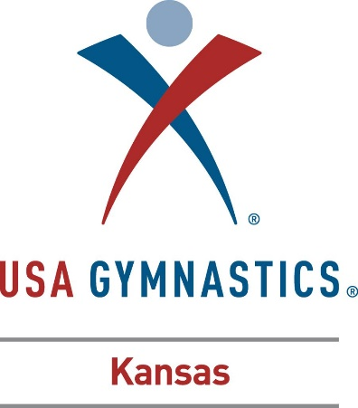
The Kansas Administrative Committee

