TRFAHA
General Manager's
Handbook
(Updated 2019/20)
Youth Hockey
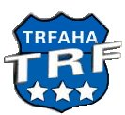

Dear General Manager,
Along with the duties listed in this handbook, we will ask you to be a liaison between your child's Coaching Staff and the parents to obtain and maintain an open line of communication in all the operations of the team. You may be asked, from time to time, to forward announcements from TRFAHA or the Coaching Staff. The Coaching Staff may also want you to plan team events for team building and moral boosting on your team. You are not responsible for any on ice instruction or any issues from players/parents in regard to coaching, playing time, schedule ice time, and other on ice duties. All questions, concerns, or complaints should be directed to the coaches of your team. If the coaches feel that further assistance is needed, they will contact the TRFAHA Board.

We hope that you will find that working closely with your daughter's/son's hockey team is great and rewarding experience.

We would also like to take this opportunity to thank you for agreeing to support the TRFAHA organization as a general manager for your daughter's/son's hockey team. We will be here to assist you in any way necessary, so please feel free to contact the TRFAHA board members with any question or concerns that might come up during the hockey season.

Sincerely,
The TRFAHA Board
Table of Contents

- Parent Meeting
- Website Responsibilities
- Game Responsibilities
- Home Tournament
- Away Tournament
- End of the Season Banquet

Parent Meeting
A parent/coach/GM meeting should be scheduled as soon as teams have been decided. This can be done at the same time as the TRFAHA parent meeting or at another time depending on what the coach decides.
Prior to Meeting
- Prepare Player/Parent Info Sheet, See examples on the TRFAHA website in the Manager section.
- Call and set up a block of rooms for TRFAHA sponsored Away Tournament.
- Make Info sheet to hand out to parents with hotel info so they can make their reservations,
Include phone number, address, and deadline for reservations.
- Print out a game schedule - Double check and make sure we have an Away game and a Home game scheduled for each team in District 16. If not, contact Rick Nordhagen 218-289-2408 and bring it to his attention. See examples on the TRFAHA website in the Manager section (to access – go to Game Schedule on team page, at the bottom click ‘printable version’ at the bottom of the page).
Meeting topics to cover
- Hand out Player/Parent Info Sheets - Collect these filled out at the end of the meeting,
- Hand out hotel info sheet for TRFAHA sponsored Away tournament.
- Hand out Game Schedule (This will need to be updated as games are canceled/rescheduled throughout the year.) Highlight Home tourney dates and remind everyone to mark their calendars because they will be expected to work this tournament.
- Coaches should cover their expectations of the parents/players for their season.
- If your Home tournament is in the beginning of the season you may have to get the ball rolling right away for that. If this is the case also use this meeting as the planning meeting for that. See Tournament Checklist for Home Tournament instructions.
Post meeting
- Make a spreadsheet with Parent/Player/Coach Info and email a copy to all parents and coaches. See examples on the TRFAHA website in the Manager section. For future communications – create a team email group, and set up a team group messaging (Remind or GroupMe, etc).
- Send a reminder one week before Hotel Deadline reminding parents to make reservations.
- If coach wants you to highlight his comments/rules made during the meeting, do this and email it out to parents.
- Make roster cheat sheets to be handed out at first game with players’ name and number. Make extras for grandparents! See examples on the TRFAHA website in the Manager section.
- Make a spreadsheet with minor official work schedule and email out. See examples on the TRFAHA website in the Manager section.

Team Website Responsibilities
Team Page
- TRFAHA webmaster will create a team page for you on the TRFAHA website, they will give you privileges to modify the team page.
- You should update the team page with information you have given the parents like game duties, Team Roster, away tournament information, home tournament information, etc.
- Add coach(es) and team manager(s) contact info on the page – helpful for away teams to contact you, if they need to.
- Customize the page and use it as a central point to communicate with your team.
- Update the game outcomes and scores. You will have permissions to do this during game time (live) for parents and grandparents that could not attend using the SportsEngine App.
- Update the player roster information (jersey number and position, in known, and add picture)
- You will have permissions to add, update, and delete the items on the team calendar (ex. Dryland practice, special team events). If parents are subscribed to this calendar it will reflect on their smart phones as well as in the app if they are using that.
- You are responsible to double check the game schedule (especially for away games) and calendar items to ensure that they are correct – contact Rick Nordhagen if game do not match. It is also helpful to add a map link for out of town games (in the venue section).
- You may want to consider using other applications like Remind, Teamer, Team Reach, GroupMe, etc. to handle communications with your team, but anything that is sent out with these applications should be reflected on the team page if appropriate.

Game Responsibilities
Home Games
- Prepare Stat book - Put Team's roster stickers in the Stat book and collect the Visiting Teams stickers from GM or Coach and put them in the Stat book. Coaches need to assure proper listing of all players with their correct numbers. Use of preprinted labels is nice but coaches need to assure the proper names and numbers. In addition, if a player is not playing be sure to scratch them off. If a player is sitting because of a previous infraction please indicate it on the scoresheet. Scorekeepers please indicate yourself by printing your name legibly. At least one referee’s name needs to appear in legible fashion (preferably all indicating ref vs linesman in 3 man system.
- 20 minutes before the game make sure Referees are there and that there are two. If not, you will have to check the ref schedule to see who is supposed to be there and call them ASAP. If you cannot reach the scheduled referee, call Jeremy Williams (218-689-6919), the referee coordinator.
- 15 minutes before game, make sure Minor Officials are there and at their proper stations.
- You can score the game live for parents and grandparents that could not attend using the SportsEngine App.
- ‘Stats’ person should ensure game sheet is filled out completely at the end of the game (sign their name in scorer section, fill in total fair play minutes for both teams and max. limits for this level. See below from the Minnesota Hockey Handbook for penalty minutes criteria. And ensure coaches sign once they review the roster).

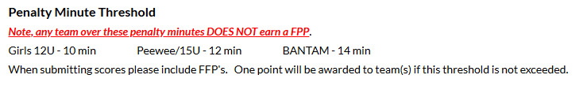

- Give a copy of the Stats to the visiting coach or GM.
- Fill out Scoreboard Report (on Team Manager Resource Center) and email to the noted email addresses. This needs to be done the same evening if it's during the week or by Sunday night if it's a weekend.
- Use Google Doc to report District 16 home game results for Squirt level and higher - save this link to your phone.
- https://docs.google.com/forms/d/e/1FAIpQLSe0K_-LFq5QiaZgMe-xQoKneNpssgLhV9HGdzaHYCXNwZ4_9w/viewform
- Note the following from the District 16 website regarding home games
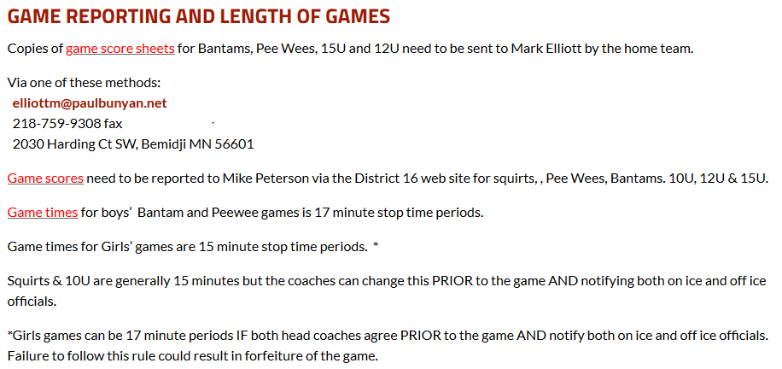

Away Games
- Bring Roster Stickers to the Score's Table or to opposing team’s manager.
- Collect a copy of the Stat Book from Scorer's Table.
- Fill out Scoreboard Report and email to the proper email addresses.
- It is the responsibility of the ‘home’ team to submit District 16 games to the D16 Statistician – so you may want to check the District 16 Standings to ensure your game has been recorded.

Home Tournament
- The tournament committee will have Tournament design done. For Tournaments in the 2019-2020 season – a vendor will make apparel on-site – no pre-ordering required.
- Organize a team meeting to brainstorm ideas for possible fund raising, treats, or prizes, and assign various tournament planning activities. (This should take place at least 1 month prior to tournament.) Please do not approach local business for fund raising items if they are a sponsor of any TRFAHA tournaments.
- Tournament Sponsor(s) (If applicable) Prominently display/call out the tournament sponsor by name in emails, programs, tournament website. Sponsor also may have tournament special for the weekend for Hockey Teams. This will be decided before the season starts.
- Budget for tournament – for programs, welcome baskets, beverages, etc – submit to the TRFAHA treasurer. There will be a set budget for each team set by the board. REA can print programs cheap. Email word file to Ashley – ahejlik@citytrf.net (for a 10 team tournament – print ~250-275 programs)
- Email a welcome letter to visiting teams. *Example 7* (3 weeks prior to tournament) TRFAHA tourney coordinator (Rick Nordhagen) or TRFAHA Tournament Committee Chairperson (James Hurst) will provide you with a contact person for each visiting team. Emails can also be located on the Tournament tab … look for your tournament list and there is an account email for each team.
- Include TRFAHA Locker Room policy
- Set deadlines payment to be turned in by. (No gate fees for TRFAHA tournaments)
- Request a team roster that you can use to make tournament programs (Include Coaches and GMs) and obtain a team logo and Team GM contact information (cell number)
- Make note of the Tournament Sponsor(s) and any sponsor deals.
- Have teams email you their approved USA Hockey Roster
- Assign minor officials.
- Once you get the tournament brackets from the hockey office, create a schedule of tournament parent to cover the: penalty boxes (2), stats/announcer, time clock and front gate(1 or 2). (You do not need to assign concessions for TRFAHA tournaments.)
- Send a copy out to parents. *Example 10*
- Create a Program.
- Create a tournament program listing the team rosters, tournament schedule, brackets etc. Request visiting team rosters when you send welcome emails. Programs can be printed in the hockey office. *Example 11*
- Have the REA print these for you.
- Program needs to have the Tournament Sponsor(s) (if applicable) prominently displayed. Be sure to include Visit TRF logo
- Create a Tournament page off of your TRFAHA team page – out of town teams appreciate an on-line source for Sunday Match-ups – update in a timely fashion
- Create Posters or Signs.
- Hang TRFAHA’s Welcome Banner and Visit TRF banner at tournament locations (these need to be returned to the Huck storage room after the tournament!)
- Tournament Bracket poster will be printed by the Times and will be in the Huck storage room prior to your tournament
- Make decorations using team logos to promote teams in the tournament
- Trophies have been selected and purchased by TRFAHA from a 3rd Party. Currently James Hurst will be responsible for getting you the tournament trophies. 218-689-5562. They will be in the Huck storage room for you to set up at the tournament.
- Tournament warm-up pucks, Player of the game pucks, Welcome Banner, table cloths and other supplies will be in the Huck storage room and when tournament is complete – return them to the storage room after the tournament so they are ready for the next tournament.
- **make sure to secure the warm-up pucks at the end of each day and if there is a gap between games.
- Provide music for the National Anthem (USA & Canada). To be played at the first game of the tournament, before the first game of the day, and before the Championship game. Only need to play Canadian anthem if we have a Canadian team in out tournament.
- Provide music to be played while players are warming up, and between period and plays.
- On the first day of the tournament, decorate the front gate table. Non-helium balloons, table cloth, display trophies, lay out programs, etc.
- Hang Welcome Signs and Tournament Bracket
- Update Tournament Page on Website (update game results in a timely fashion)
Items for Front Gate
- Have envelops for all games ready for stat keepers – have teams submit all stickers at check in and prep round robin game sheets (keep a set of stickers for final games on Sunday).
- A tote with tape, scissors, markers, pens, extra tournament programs etc.
- A 3 ring binder that includes the following:
- Referee schedule (get on-line)
- Copy of tournament rules *Example 12*
- Copy of Minor Official Assignments and a detailed explanation of those duties. *Example 9 & 10*
- List of team parents and their contact phone numbers. *Example 3*
- Locker Room assignments (City will assign, REA, and Huck arenas, you do Old Arena)
- Extra stat book
Scorers Box
- Stat Book
- Microphone (if available)
- Music (National Anthem and warm up music)
- Tournament Rules
- Copies of Program

Away Tournament
Prior to Tournament
- Call and block rooms at a hotel in the city your team will be visiting, this should be done right at the beginning of the season. Hotels book up very fast when there's a hockey tournament in a city. Check with board first as this may have already been done earlier in fall.
- When making reservations also reserve the hospitality room in the hotel so your players and parents have a place to hang out in the evenings. If you reserve a block of rooms, you can usually reserve the hospitality room for free.
- Make info sheet to hand out to parents with hotel info so they can make their reservations. Include phone number and address of the hotel and the deadline for reservations (send via email or other team group communication method)
- Make signs to hang in the arena or hotel, supporting your team and cheering on your players. Noisemakers to use during the games are fun also (if allowed)
During the Tournament
- You will need to be at the arena 1 hour prior to your first game. You will need to bring your GM book and the team roster to the tournament director and check in your team. **This is very important** It needs to be done or your team will not be allowed to participate in the tournament.
- Coaches will probably want the team to eat together for meals. If so, check with parents and get restaurant suggestions and make reservations for the team. Another option is to plan a team meal. To do this, you can split between families the items for the meal (such as Taco in a Bag-Johnsons bring Lettuce and Cheese, Andersons bring Onion and Tomato, Olson’s bring Chips, Hanson’s bring 2 pounds Taco Meat in crock pot, etc, etc.). If you choose to do this, it's very important to reserve the hospitality room so you don't have all the mess in your room. Whichever choice you make, be sure to get coaches approval before making final decisions. Coaches are very conscious about what and when the players eat during a tournament. It can really have an effect on the player’s performance.
- After each game of the tournament, you should make sure all parents are aware of the time and location of the next game. Sometimes brackets or pool play is confusing for parents who are new to hockey.
After the Tournament
- If your team places in the tournament, take photos with coaches after the final game. Send these photos in to the TRF Times newspaper.
- If your team receives a trophy, take possession of the trophy and place it at the Old Arena. This can be done on our own or as a team.

End of the Season Banquet
Prior to Banquet
- Email a questionnaire to parents/players. Ask for suggestions as to place, dates, activities, food, etc. You will also have the funds from your home tournament to use. As a team you need to decide how to use the funds. Suggestions... Coaches gifts, Player gifts/gift cards, player’s meals, etc.
- Take information and suggestions from parents into consideration and decide when and where you will have the banquet. You will never please everyone, so pick the date and place that the majority are comfortable with. It is most important that all the players can attend. If it works for parents, that's a bonus! You may have to make reservations at a restaurant if need be.
- Mail –or hand deliver USA Hockey Award Request Form to Mandi Lund along with copies of the Stat book *Example 13*
Banquet
- During the banquet, you should plan a time for the coaches to talk a little about the season and hand out USA Hockey Awards and Trophies along with player evaluations.
- Most of the time a meal is planned. You can do this at a restaurant, a potluck at someone's house, a water park party, etc.

Example of Player/Parent Info Sheet:
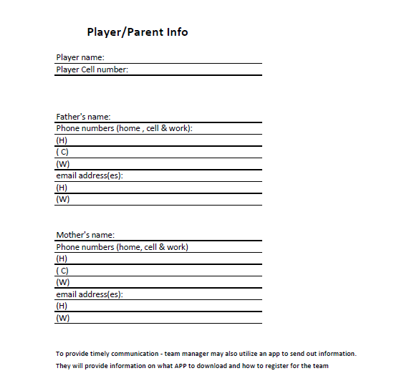

Example of Player/Parent/Coach Contact Info:

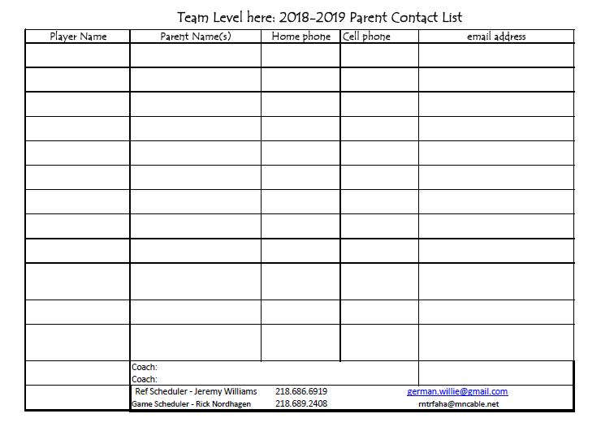

Example of game schedule to print – on Team schedule – click ‘printable version’
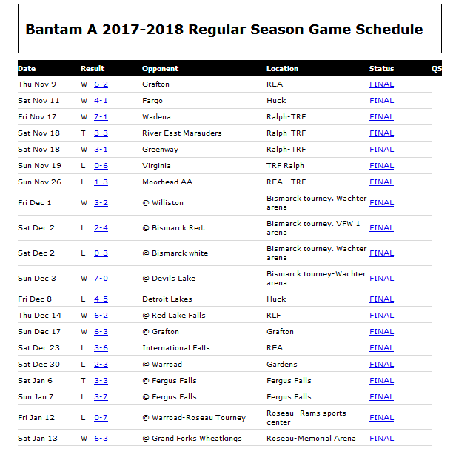
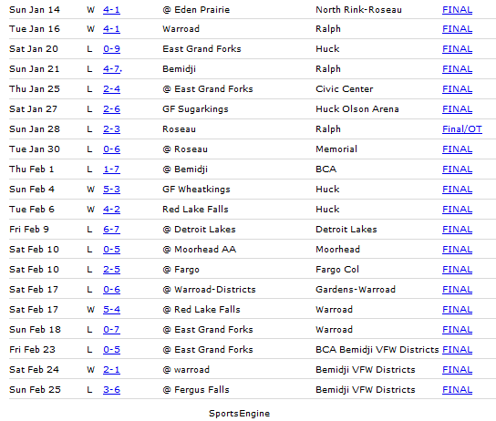

Example of Home Game Minor Official Assignments – link to file is on the Team Manager Page on the TRFAHA webpage

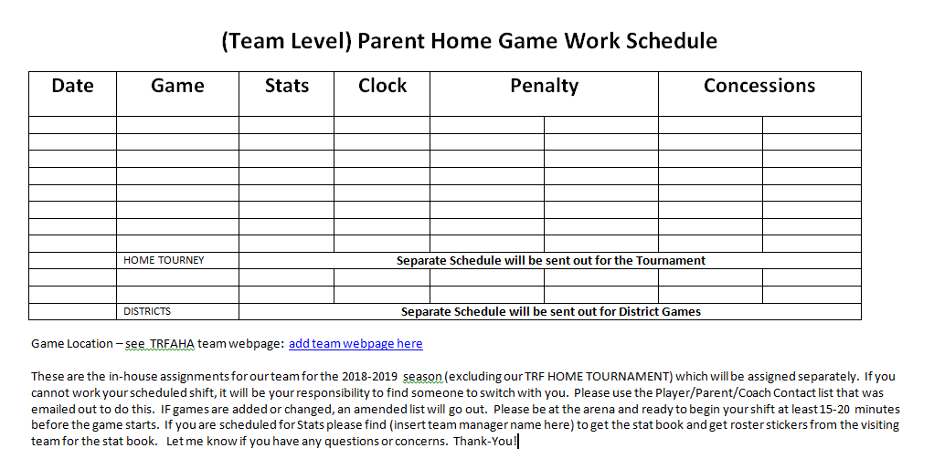

Example of Roster Stickers – link to file is on the Team Manager Page on TRFAHA webpage 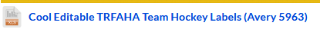

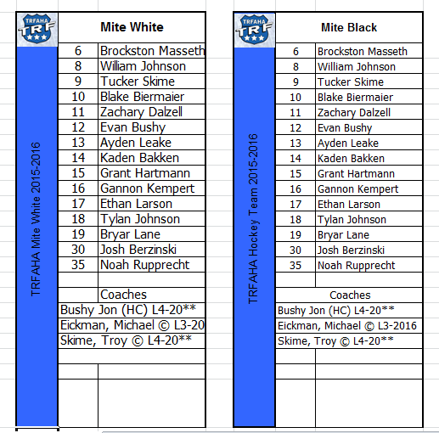
Example of Tournament Welcome Letter:

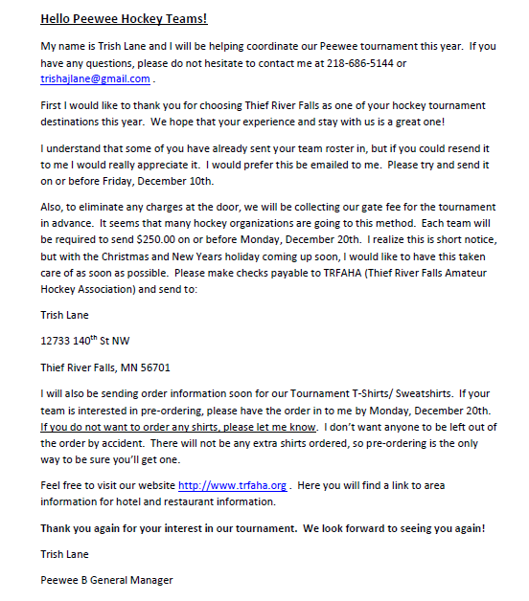

Example of TRFAHA Scoreboard Report – link for this is on the TRFAHA Team Manager tab on the webpage

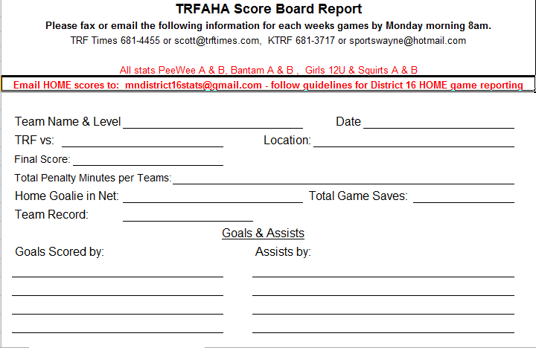

Example of Tournament clothing order form:
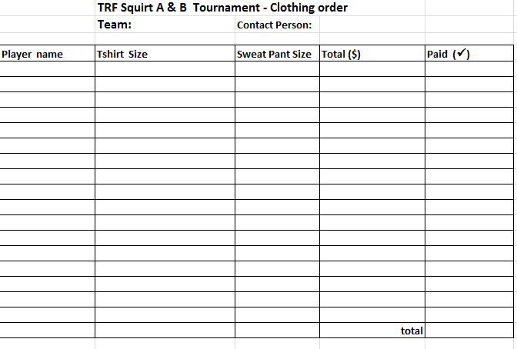
Example of Tournament Minor Officials Duties – note – game length will depend on level of play
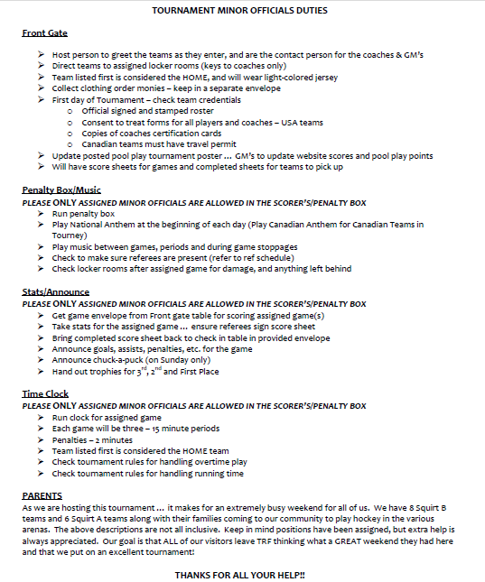

Example of Announcing Starting Line-Up

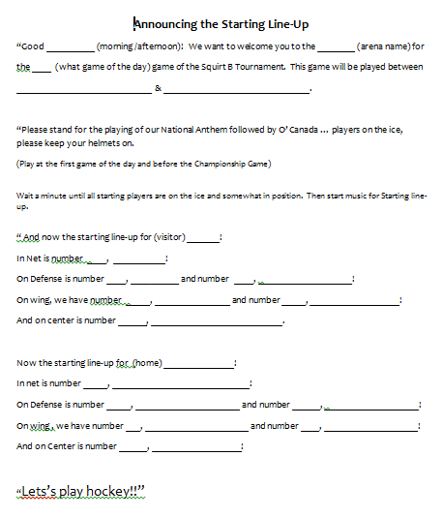

Example of Awards Request Form – this form is available to print on the Team Manager tab on the TRFAHA webpage

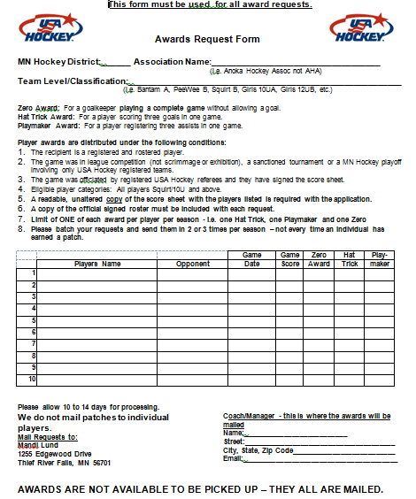

Example of TRFAHA Tournament Rules – available on the Team Manager tab on the TRFAHA webpage. They should be e-mailed to you with your tournament information.
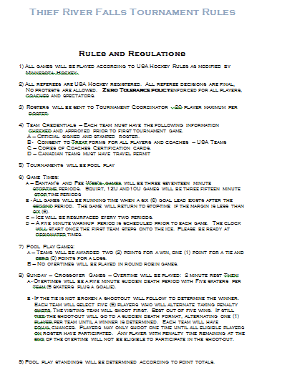
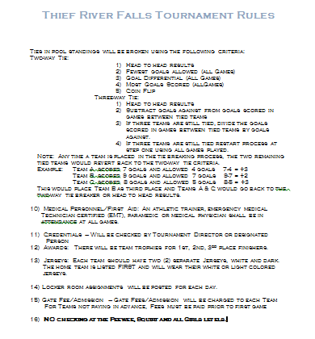

Example of Tournament Program
