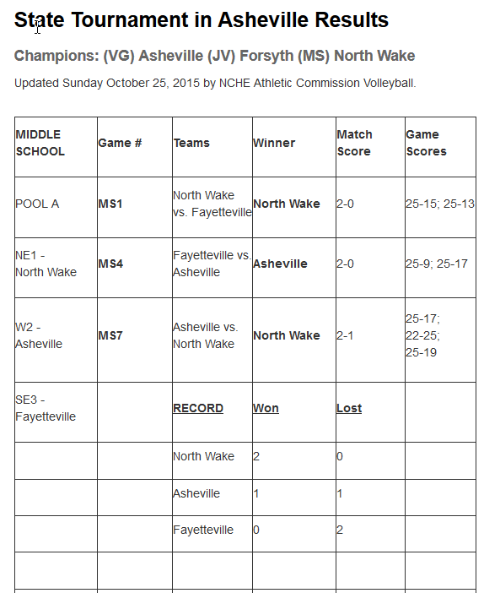
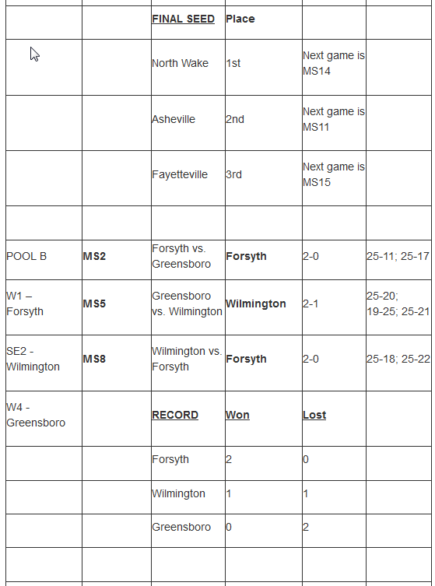
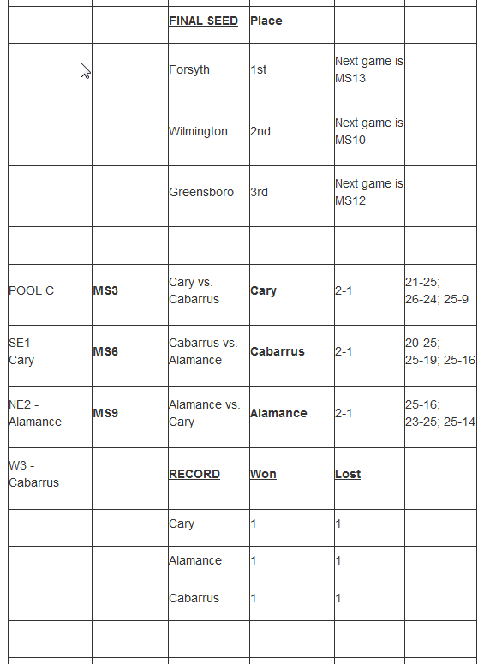
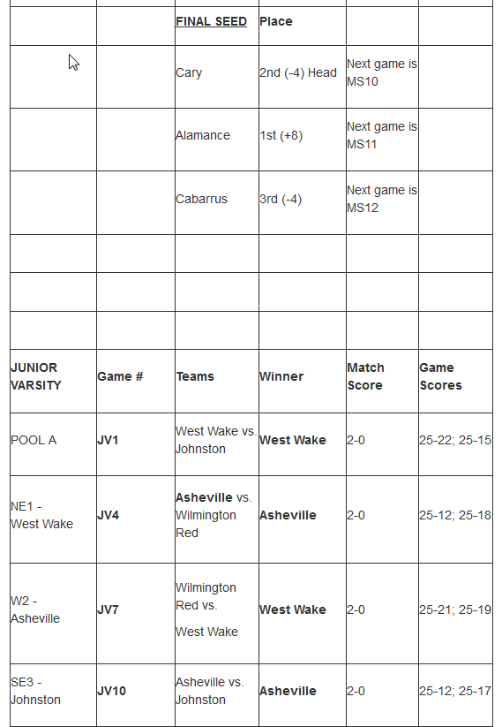
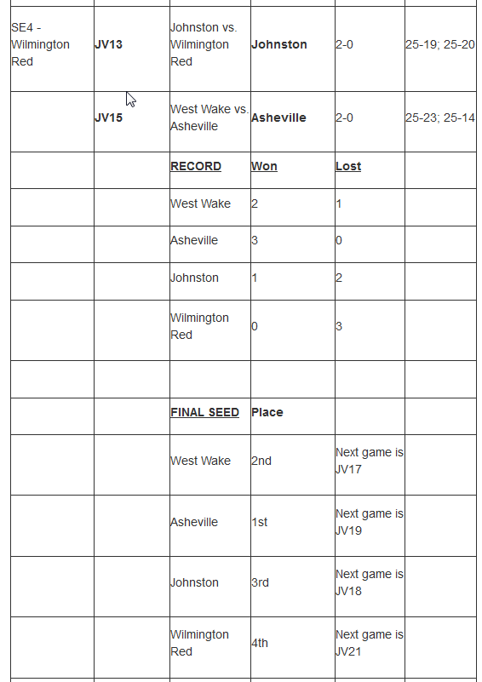
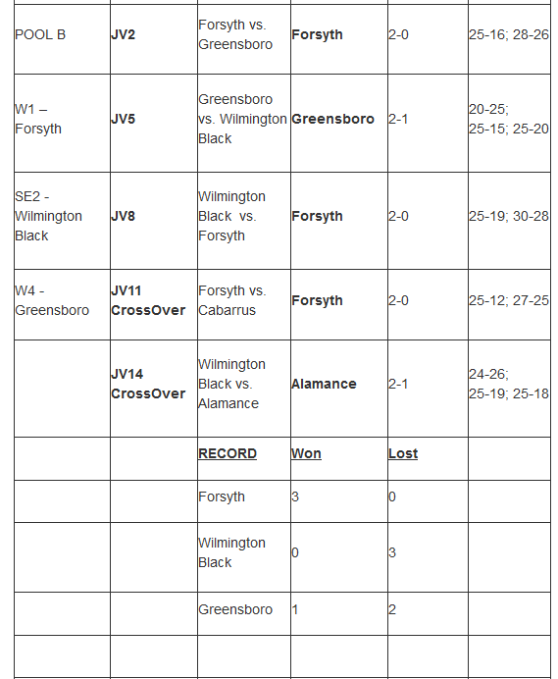
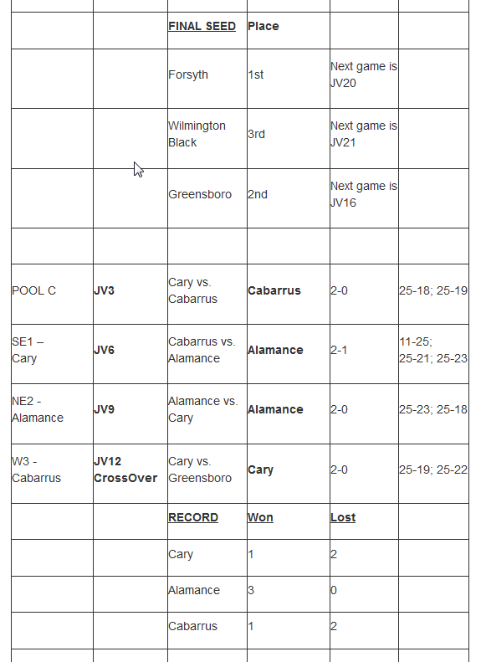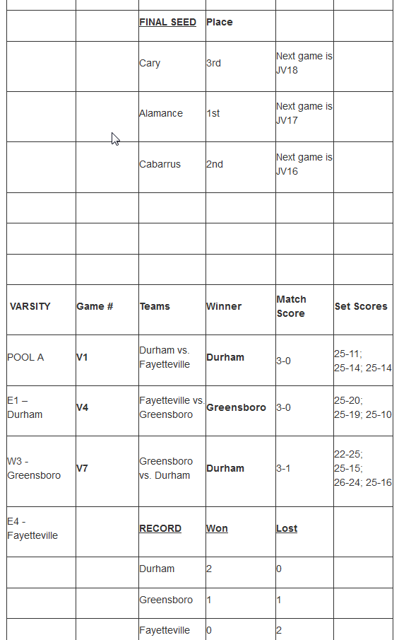
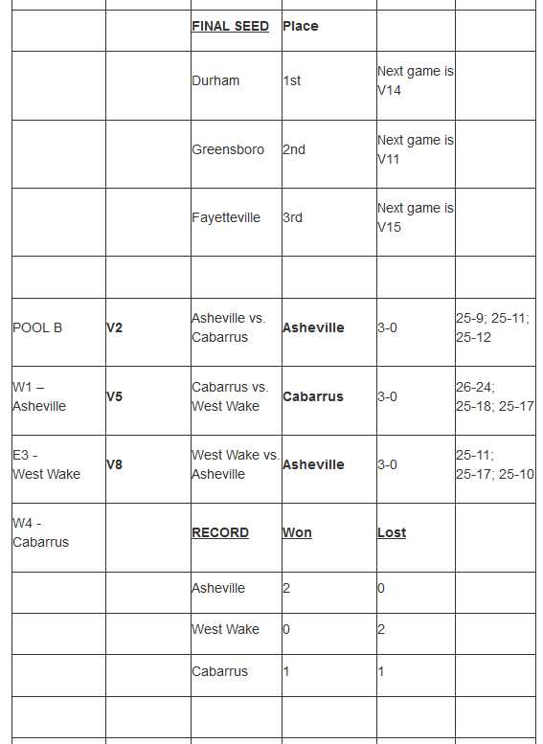
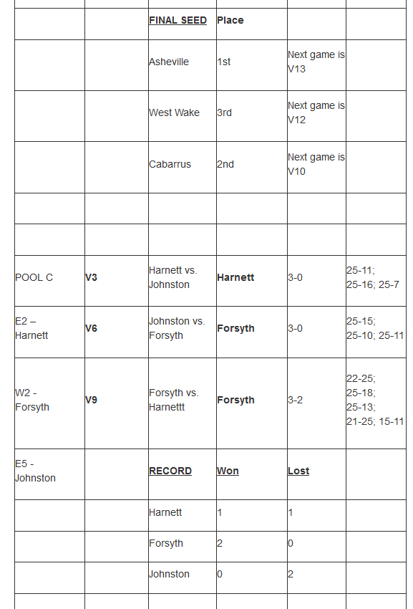
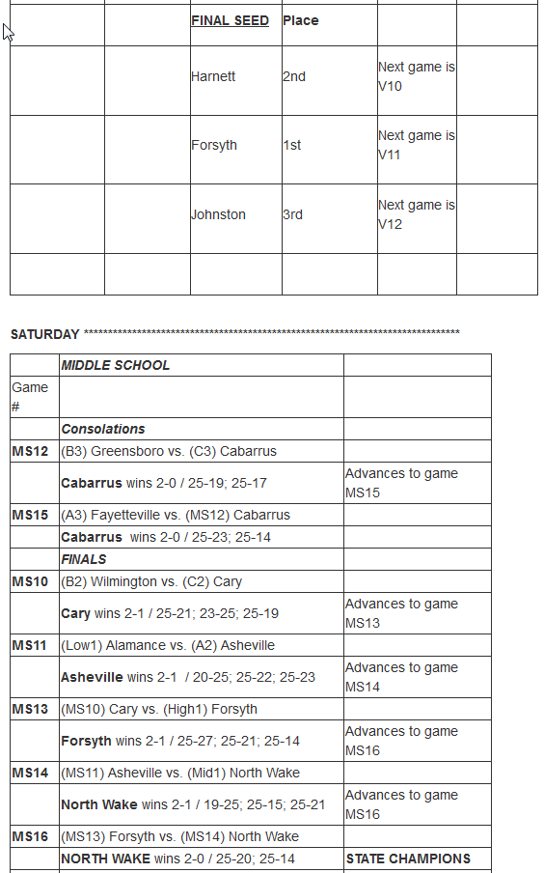
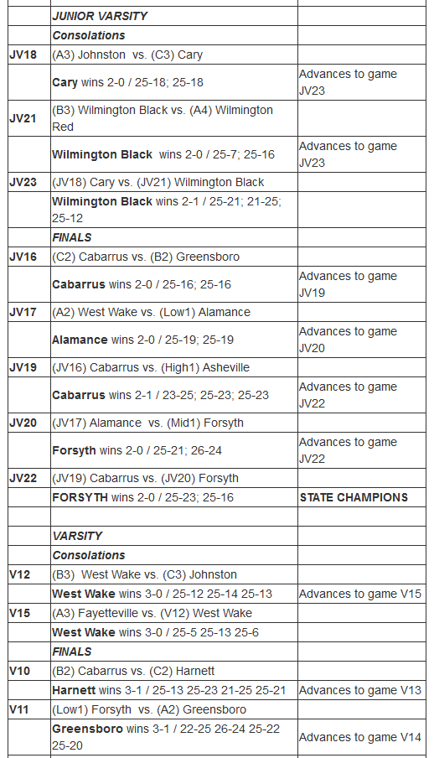
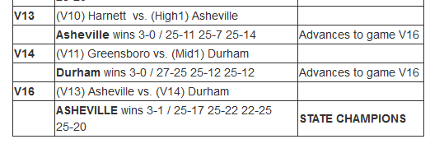

All-Tournament Selections:

Varsity
Asheville | Catherine Clark
 | Rebekah Downer
 | Katie Kania
Durham | Kailey Macy
 | Lindsey Stephens
Cabarrus | Karley Long
Fayetteville | Carolyn Furmage
Forsyth | Hope Arrowood
Greensboro | Maggie Richardson
Harnett | Ally Brown
Johnston | Leah Ferrell
West Wake | Rosie McMahan

Junior Varsity
Forsyth | Kaleigh Bethea
 | Jadyn Hooker
 | Olivia Ney
Cabarrus | Anna Gambrell
 | Jenna Rider
Alamance | Sydney Cole
Asheville | Shakinley Wilkie
Cary | Rachel Bramble
Greensboro | Samara Neighbors
Johnston | Emma Ferrell
West Wake | Aimee Torres
Wilmington Black | Sariah Blanton
Wilmington Red | Bailey Eby

Middle School
North Wake | Christa Burns
 | Ava Stoddard
 | Abby Stone
Forsyth | Bree Adamick
 | Ashlyn Brinkley
Alamance | Sophia Knudson
Asheville | Gracie Bayne
Cabarrus | Hannah Kayall
Cary | Emily Ruble
Fayetteville | Lauren Allen
Greensboro | Abby Conrad
Wilmington | Lydia Bradshaw

