Pitching drill #1:
Players are to focus on the Mechanics of throwing.
Drive off the mound drill:
Player sets up on the mound in the Release Point position and pauses.
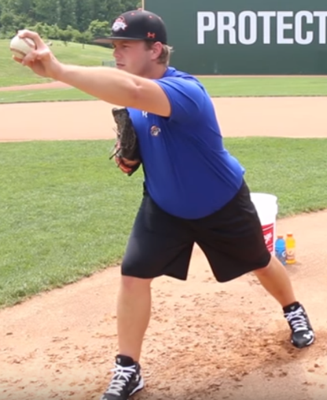
The player then works backwards to their power position and pauses.
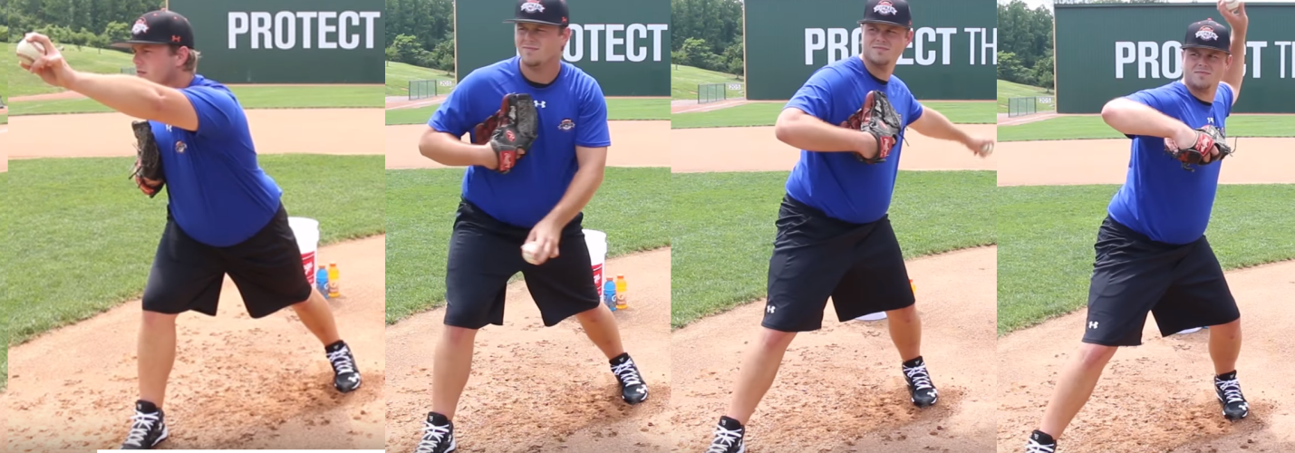
From here, player goes full speed and makes a good solid throw. Player should "FOLLOW THROUGH" on the pitch, with the throwing arm sweeping across the body and the player bending the upper half of the body on the delivery. The player should drive off the mound and have the back leg come up to allow for the body to naturally release the energy of throw into the ball. The pitcher should end in the fielding position and ready for the ball to be hit back at them.
This drill should be done 10 times to allow the player to concentrate on the proper mechanics of driving off the mound and following through after the pitch.
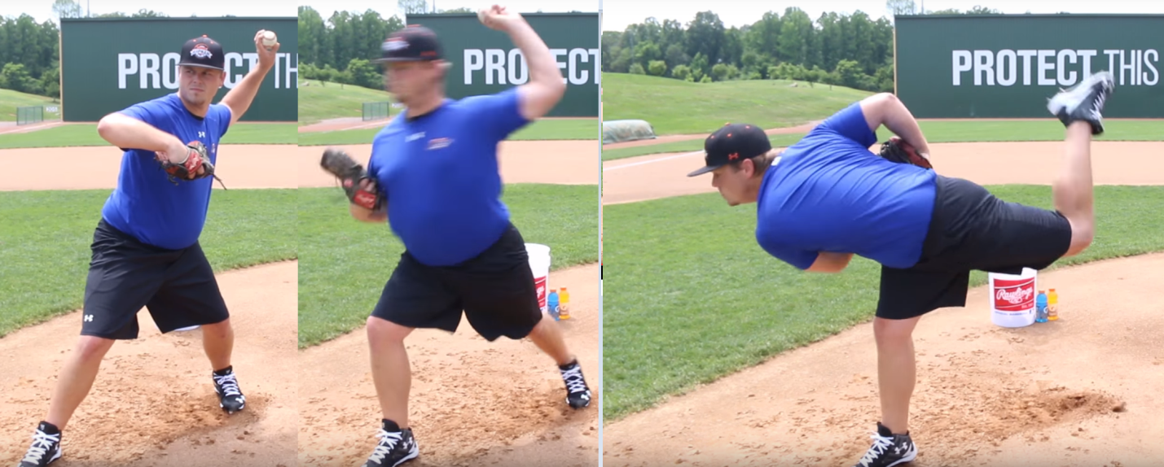
The player will now do 10 more pitches, but this time there is no pauses. Player should start at the release point, pull back in to power position and then deliver the position in a continuous motion, still maintaining the proper mechanics. It is important to discuss with the pitcher that they are to use their core and hips when they throw to get their whole body involved in their movement.

Rocker Drill 1:
This drill is to teach the player to get their weight involved in their throw. This drill works on getting the players weight shifting. This drill has the player shift their weight forward, then to the back, and then forward which the player will deliver the ball with a follow through. The player should start with a wide foot base and the ball in glove, then the player begins with shifting their weight forward, then shifting their weight back, then shifting weight forward as the player throws the ball with a follow through. When the player shifts their weight back to begin their throw forward, they should focus on bending the back leg, known as "Sitting into the throw". The player should lift the plant foot (front foot) and really drive the throw with the back leg remembering to throw their weight on the follow through.
Alternate to this drill is to utilizes a bucket and the player sits on the bucket, then goes through the rocker drill but when pitching the ball, the player comes off the bucket and drives the pitch to the catcher. This is help the pitcher understand the importance of using their power leg (back leg) and drive their body weight into the pitch.
This drill starts the first 10 throws with pausing at the first and second weight shift.
The next 10 throws should have the pitcher go full speed without pausing.
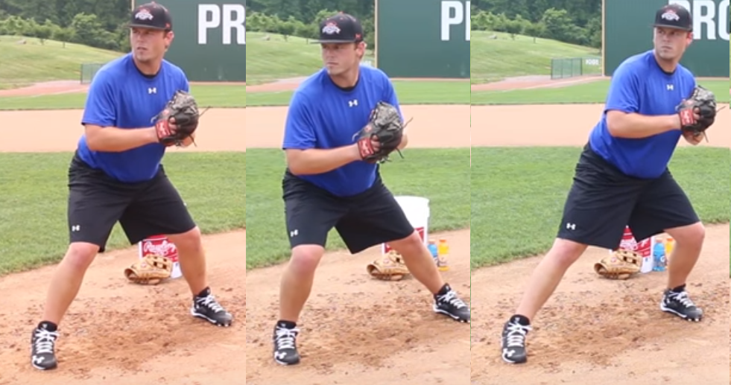
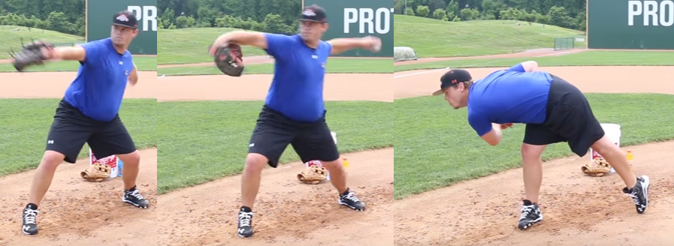
Alternate with bucket:
