Blocking drills:
When the catcher is going through these drills, they should always focus on the proper technique with falling (NOT hopping) to the knees, knees split around shoulder apart, glove down on the ground between the legs, the throwing hand down by the glove, shoulders facing the pitcher and catcher crunched down to take the ball bounce to the belly button area.

Blocking drill 1: Catcher setups in their ready catcher stance with glove and the catcher's hand in the catching position. The catcher goes through dry blocking left and right. The catcher should focus on each block to slight turn their body toward the pitcher to practice blocking the ball that will end going out in front of the plate after the block. The drill is the catcher sets up in front of the teammate and then blocks one direction, then returns to the original position and does the other side block. The teammate should put his hand on the catchers helmet to ensure the catcher head does not bobble on the block.
Reps: 5 sets of left and right blocks minimum
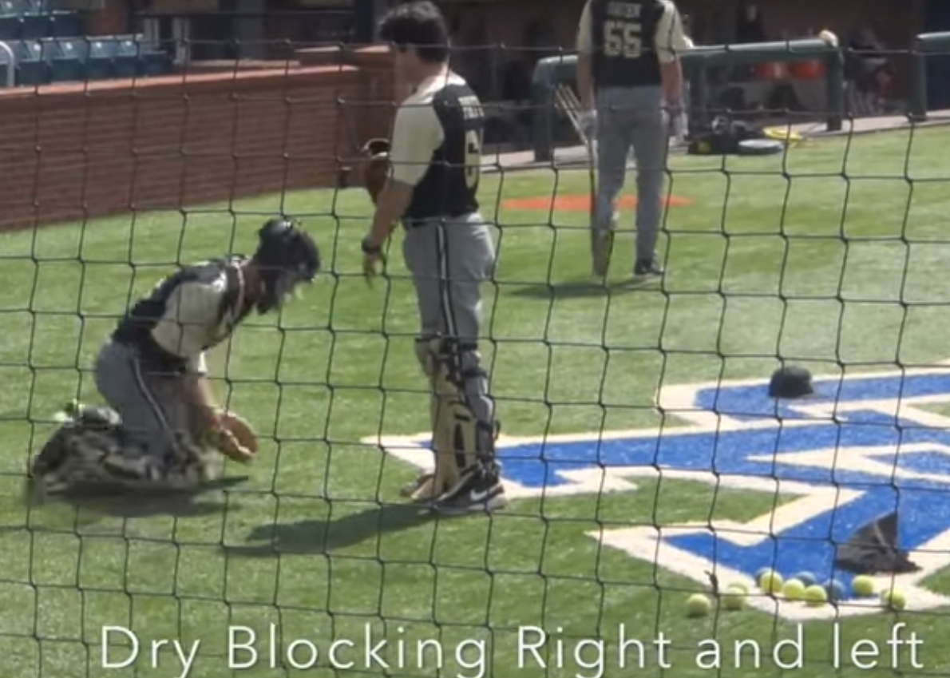

Blocking drill 2: Live throws: Catcher is to setup in their ready catcher stance with glove and the catcher's hand in the catching position. The catcher goes through catching or blocking, the thrower should mix the throws up to catcher.
Reps: 10 throws minimum
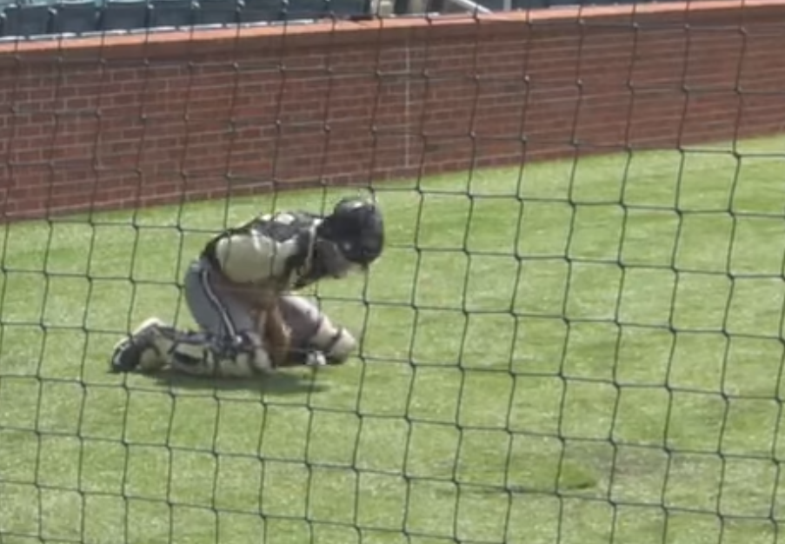

Blocking drill 3: Live throws (Block and recover): Catcher is to setup in their ready catcher stance with glove and the catcher's hand in the catching position. The catcher goes through catching or blocking again but this time the catcher is to work on popping up after the block and get the ball. The catcher is then recover the ball and mimic the throw to second but no throw is needed at this time.
Reps: 10 throws minimum
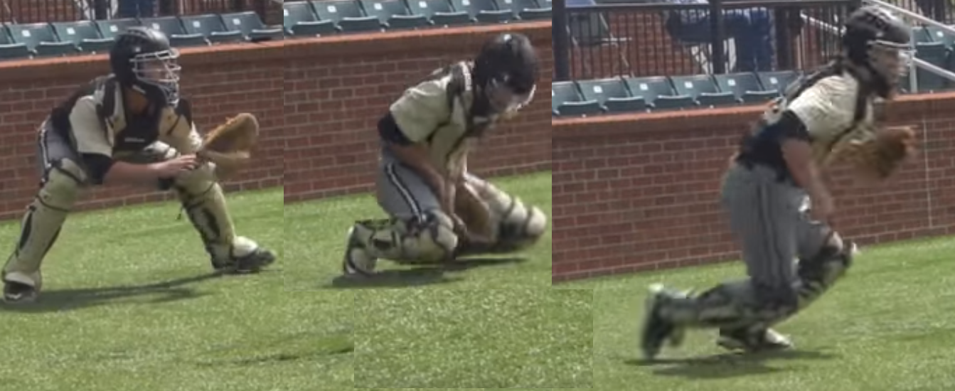
Blocking drill 4: Live throws (Tracking): Catcher is to setup in their blocked position. The catcher will stay in this position throughout this drill. The teammate will throw 10 tennis balls so that it bounces to the catcher. The catcher is to watch the ball all the way in.
Reps: 3 sets of 10 throws
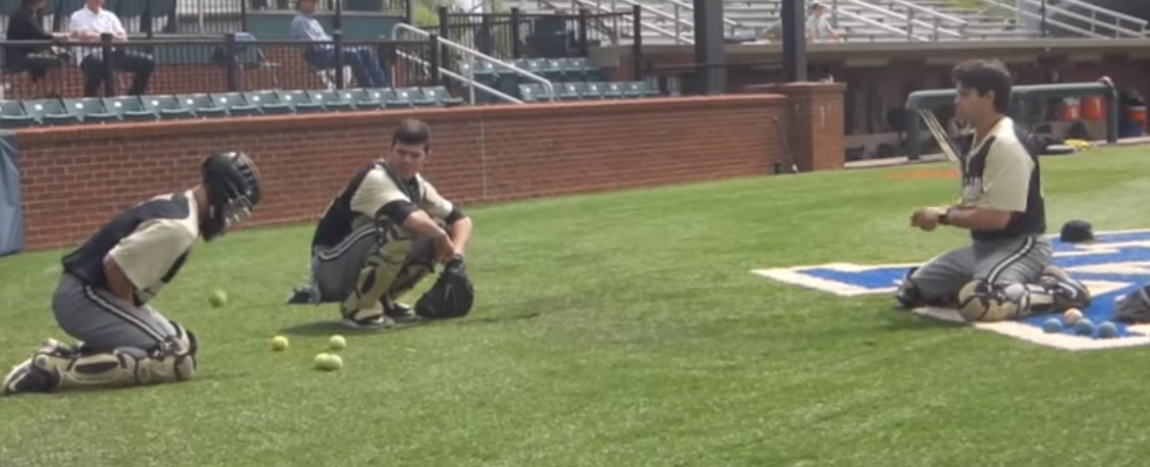
Blocking drill 5: Live throws (blocking and popping): Catcher is to setup in their ready catching position. The teammate will throw 10 tennis balls so that it bounces to the catcher. The catcher is to work on dropping to the block position and popping back up on their feet.
Reps: 2 sets of 10 throws

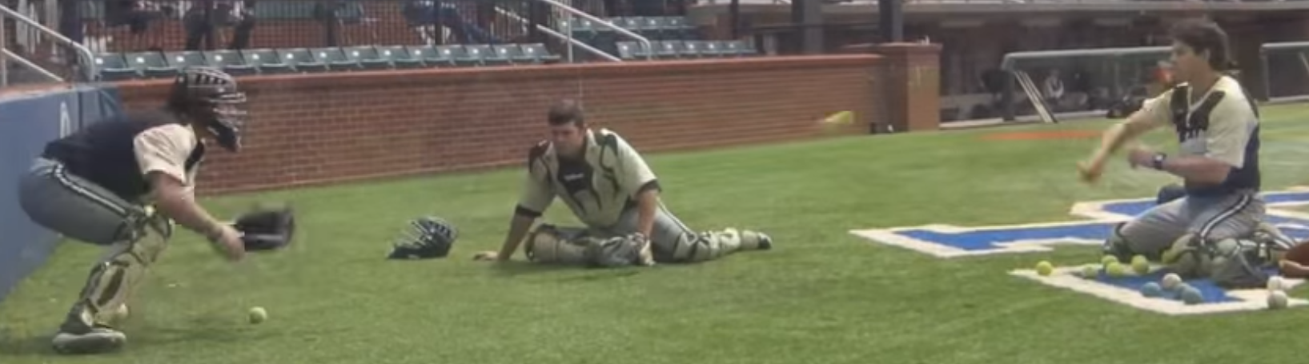

Blocking drill 6: Live throws (rapid throw blocks): Catcher is to setup in their ready catching position. The teammate will throw 10 tennis balls in a rapid fire fashion so that it bounces to the catcher. The catcher is to work on dropping to the block position and popping back up on their feet as fast as they can.
Reps: 2 sets of 10 throws

Blocking drill 7: Live throws (blocking to left and right): Catcher is to setup in their ready catching position. The teammate will throw 10 tennis balls so that it bounces to the catcher to his right and left. The catcher is to work on dropping to the side and turning their body in to block the ball.
Reps: 1 set of 10 throws

