Infield drill #1:
Players are to focus on good posture, footwork, and quickness.
Ground ball drill #1
Stationary drill (player sets and doesn't move), player sets up with the butt down, glove down (open toward coach), and throwing hand near glove. Coach sets up about 10 feet away. Coach rolls the ball to player fairly easy, the goal is player to work on form. The player receives the ball and underhand's back to the coach. This drill repeats 10 times each round, a recommended 5 rounds each player with players ready to rotate in with 3-4 players with one coach and the other players with another coach.
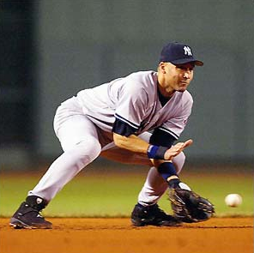
Ground Ball drill #2: This drill is the same setup as the previous drill. The difference is the player is backhand throwing back to the coach. Once fielded, the player throws the ball back to the coach by taking ball up to the chest and back hand throw back to coach.
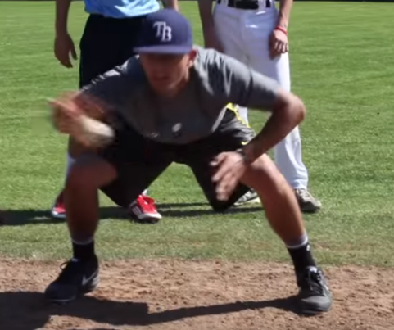

Groundball drill 3:
Players setup in same position, ball is then rolled to the players side. Player "shuffles" to get in front of the ball and throws back to coach with the back hand throw. Then ball is then rolled to the other side of the player. The player should work on being quick and have good ball transfer between hands. The drill happens quickly back and forth and should be able to roll through about 10 back and forth in about 10-15 secs each player. 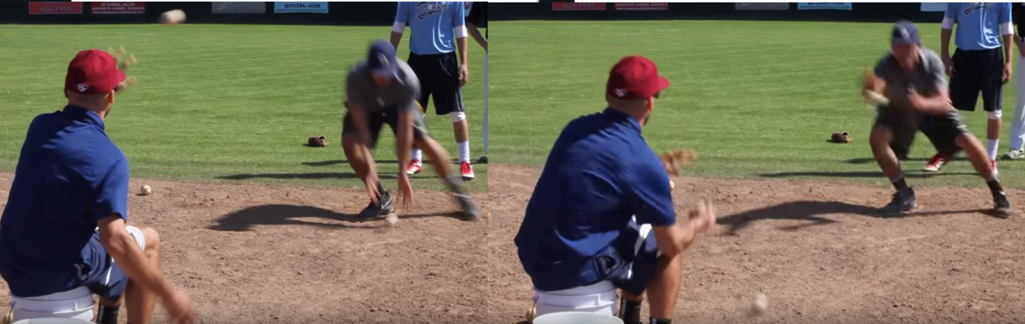
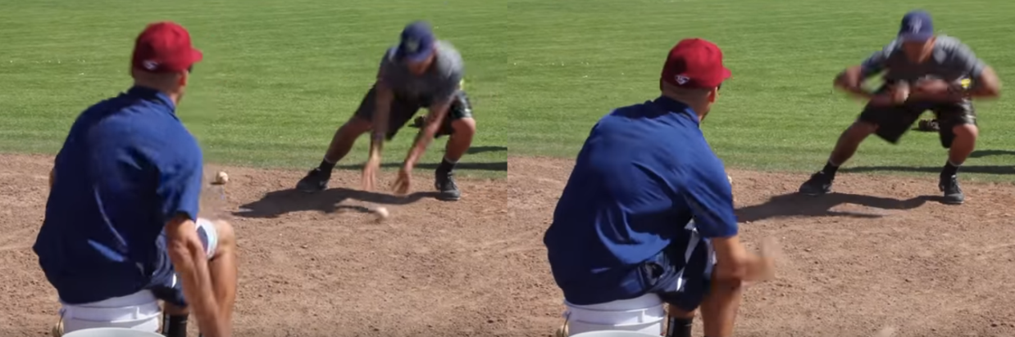

Links to show this in action:

Infielding Quick Tips - Glove Work I

