  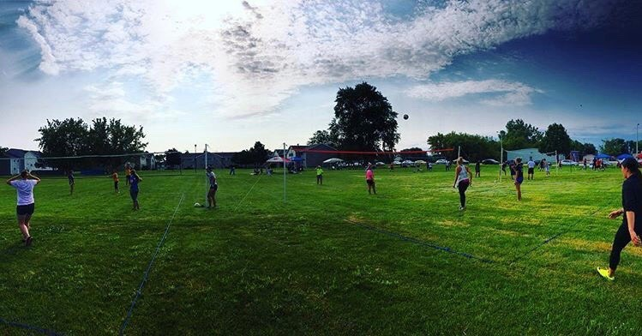
    - sunday, august 5th,2018
  2nd annual
  men’s & women’s Grass Triples
  Marian University made history in 2015 becoming only the 4th NCAA DIII school in Wisconsin to fully sponsor varsity men’s volleyball. Following our 3rd season we are hosting our 2nd annual men’s & women’s grass triples tournaments hosted by the men’s team! Every team is guaranteed pool play matches, top two teams from every pool move on to single elimination gold bracket, bottom teams play consolation!
  REGISTER ONLINE!
  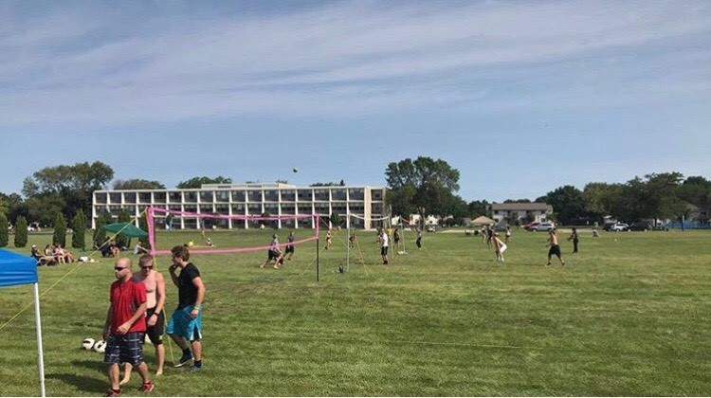
  MARIAN UNIVERSITY MEN’S VOLLEYBALL
  $25 per player 1st place cash prize!
  *Additional prizes for 2nd & 3rd
  Marian Men’s Volleyball Fundra
   Visit sabreathletics.com to register!
  Location:
  Marian University
  45 S National Ave Fond du Lac, WI
  Questions: Tyler Frings
  Tmfrings71@marianuniversity.edu
  Sharp 8 am Start

