CRANBROOK LACROSSE ASSOCIATION
PLAYER AND PARENT
HANDBOOK 2019

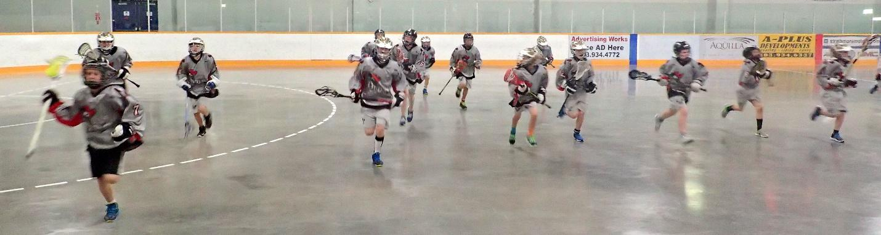

CONTENTS Page
Welcome letter 3
Code of Conduct 4
Media Release 5
Away Tournament - Hotel Bookings 6/7
Team clothing 8
Required equipment/gear exchange 9
Volunteer List/ Photography 10
Team builder 11
House League Promo 12

Cranbrook Lacrosse Association
Cranbrook, BC
17, January 2019

Dear Lacrosse Players and Parents,
On behalf of the Cranbrook Lacrosse Association, I would like to welcome you to the 2019 Lacrosse Season.
We are gearing up for an exciting season of practice and tournaments and look forward to a positive contribution from coaches, players and parents. Above all, we aim to provide a fantastic experience for everyone involved.
If you have any questions or concerns, please email us at cranbrooklacrosse@gmail.com
We are always looking for volunteers, so please say hello when you have the opportunity and thank you all in advance for your support.
Sincerely,
Karyn Yasinsky
Karyn Yasinsky
President,
Cranbrook Lacrosse Association

PARENT AND GUARDIAN CODE OF CONDUCT

Section 1: All individuals affiliated with the CMLA shall:
i) Attempt at all times to work toward the goals and objectives of the CMLA and the game of Lacrosse, and towards the betterment of its members.
ii) Strive to heighten the image and dignity of the Association and the sport of Lacrosse as a whole, and to refrain from behavior which may discredit or embarrass the Association or the game.
iii) Always be courteous and objective in dealings with other members.
iv) Except when made through proper channels, refrain from unfavorable criticism of other members or representatives of the CMLA.
v) Strive to achieve excellence in the sport while supporting the concepts of Fair Play and Drug-free sport.
vi) Show respect for the cultural, social and political values of all participants in the sport.
vii)As a guest in another province or foreign country, abide by the laws of the host jurisdiction and adhere to any social customs concerning conduct.

Section 2: Social media
The CMLA recognizes the vital importance of participating in online conversations and are
committed to ensuring that we participate in online social media in an appropriate, positive, respectful manner.
i] The CMLA expects that all members are aware of and respect these Social Media Guidelines.
ii] If anyone is found to be in violation of the guidelines to the extent that it is damaging to the CMLA, it will be handled using the provisions of the CMLA CODE OF CONDUCT.
Iii] Non-compliance with this policy may be considered as misconduct, harassment, discrimination, or in certain circumstances contravention of the law. Those who fail to comply with the guidelines may be disciplined.

NOTE: We are bound by BCLA Code of conduct. As a member of CMLA, you must abide by this code in full. To access the BCLA Code of Conduct in full, please refer to the BCLA website.

Agreed to upon online registration

MEDIA CONSENT FORM AND RELEASE FOR MINOR CHILDREN

I am the parent/guardian of_________________________________ (print full name of child)(“My Child”).
I hereby grant Badgers Sports Inc and Cranbrook Lacrosse Association the absolute right and permission to use photographic portraits, pictures, digital images or videotapes of My Child, or in which My Child may be included in whole or part, or reproductions thereof in color or otherwise for any lawful purpose whatsoever, including but not limited to use in any publication or on websites, without payment or any other consideration. I hereby waive any right that I may have to inspect and/or approve the finished product or the copy that may be used in connection therewith, wherein My Child’s likeness appears, or the use to which it may be applied. I hereby release, discharge, and agree to indemnify and hold harmless Badgers Sports Inc and Cranbrook Lacrosse Association from all claims, demands, and causes of action that I or My Child have or may have by reason of this authorization or use of My Child’s photographic portraits, pictures, digital images or videotapes, including any liability by virtue of any blurring, distortion, alteration, optical illusion, or use in composite form, whether intentional or otherwise, that may occur or be produced in the taking of said images or videotapes, or in processing tending towards the completion of the finished product, including publication on the internet, in brochures, or any other advertisements or promotional materials.

I represent that I am at least eighteen (18) years of age and am fully competent to sign this Release.

THIS IS A RELEASE OF LEGAL RIGHTS. READ IT CAREFULLY AND BE CERTAIN YOU UNDERSTAND IT BEFORE SIGNING (Both parents, if possible) PLEASE CHECK ONE OF THE BOXES BELOW THEN SIGN YOUR NAME(S)

☐ CONSENT: We/I hereby certify that We/I are/am the parent(s) or guardian(s) of the above named child and do hereby give our/my consent without reservation to the foregoing on behalf of My Child.

☐ NON-CONSENT: We/I hereby certify that We/I are/am the parent(s) or guardian(s) of the above named child and do not hereby give our/my consent without reservation to the foregoing on behalf of My Child.

AGREED TO UPON ONLINE REGISTRATION
2019 AWAY TOURNAMENT - HOTEL BOOKINGS

Northwest Shootout, Kalispell, MT. April 20-21 - FIELD ONLY

Hotel: Holiday Inn Express
Booking: Cranbrook Badgers
Rooms: $75.00 per room/per night/+tax
Inclusions: Breakfast
Note: 20 rooms with 2 beds reserved until March 19
Phone: 406-755-7405

Barn Burner Tournament, High River, AB. April 26 - 28 2019

Hotel: Super 8 **Primary**
Booking: Cranbrook Lacrosse
Rooms: $125.00 per room/per night/+ tax
Inclusions: Breakfast
Note: 30 rooms with 2 beds reserved until April 5
Phone: 403 652 4448
Hotel: Ramada Inn**Overflow**
Booking: Cranbrook Lacrosse
Rooms: $143.10 per room/per night/+tax
Inclusions: Breakfast
Note: 24 rooms with 2 beds reserved until March 20
Phone: 403 603 3183

Floorbusters Tournament, Lethbridge, AB. May 24 - 26 2019

Hotel: Sandman Signature Lethbridge Lodge
Booking: Cranbrook Lacrosse
Rooms: $139.00 per room/per night/+tax
Inclusions: Full Breakfast (4 per room)
Note: 80 rooms reserved until April 19
Phone: 403-328-1123

Girls Rock Tournament, Calgary, AB. May 24 - 26 2019 FEMALE ONLY

Hotel: Deerfoot Inn & Casino
Booking: Girls Rock Tournament or use Code: TTGRLRCK
Rooms: $139.00 per room/per night/+tax
Inclusions: Breakfast
Note: 40 rooms with reserved until April 24
Phone: 403-236-7529

Cranbrook Lacrosse Clothing

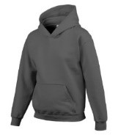
Men/Women $20 Men $20 Kids $35
black / S-XL black,red & charcoal/XS-XXL black & charcoal/S-L
Kids black/S-L $20 Kids $20
black,red & charcoal/XS-XL

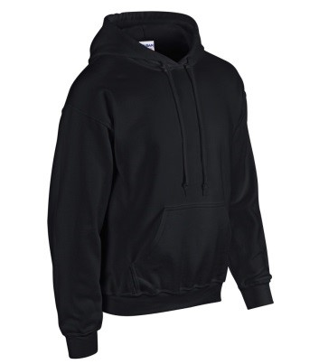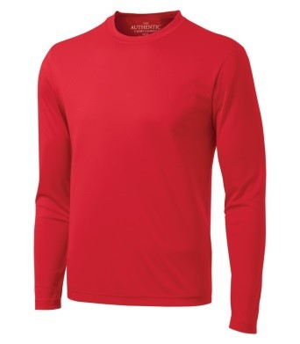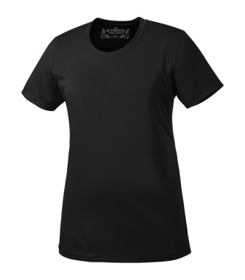
Men / Women $45 Men / Kids $25 Women $20
black/ S-L,XXL black,red & charcoal/XS-XXL black,red & charcoal/XS-XXL
charcoal/S-XXL Kids: blk,red&charcoal/XS-XL $25

Clothing will be available for sale during the first 2 weeks of practice (March 25 – April 4). Please look for our booth at the Kinsmen Arena. All clothing will be sold on a first-come basis as sizes are limited.
For further information, please contact: cranbrooklacrosse@gmail.com

2019 REQUIRED EQUIPMENT
All players are required to wear helmet and facemask, protective gloves, shoulder and arm pads, and a back/kidney pad, all which must be approved for lacrosse as specified in the CLA Safety and Equipment Policy. Goalkeepers are required to wear CLA approved helmet and facemask and throat guard, chest, shoulder and arm pads, gloves, pants, leg guards and shoes.
Stick – A player’s stick shall measure not more than 46”, nor less than 40” in overall length, and not more than 8”, nor less than 4 1⁄2” in width. The measurement for width is to be inside frame measurement. Note: In Pee Wee and all lower divisions, the minimum length of the stick shall be 34”. The goalkeeper’s stick may be of any desired length, but shall not be over 15” in width.
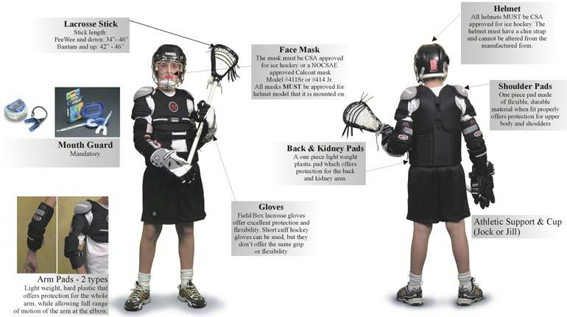

VOLUNTEER DUTIES

Everyone in this club is a volunteer, so please get involved. Please support your team manager with the following volunteer activities….

- Slice oranges
- Fill out game sheet
- Work 30-second shot clock
- Timekeep the games
- Wash jerseys
- Volunteer backyard for team social event/BBQ
- Keep game stats
- Act as team treasurer
- Secure $100 sponsor for food at tournaments
- Volunteer to carpool
- Purchase first aid supplies
- Fill water for games
- Fax tournament results to local newspaper
- Take action shots of players during season
- Create year-end Photobook of season
- Capture all news articles about team
- Call local newspaper to promote media coverage
- Donate tape for players to use
- Act as team manager
- Create team email communication list
- Create hardcopy team contact list
- Create Emergency action plan for tournaments
- Coordinate purchase of laminated player action shots
- Secure free slurpies for prizes
- Donate purchase of product for after practice trip to Dairy Queen
- Sign up and coordinate entire team for 3 hours volunteer service at food bank or similar
- Pay for team trip to public swimming pool

2019 PHOTOGRAPHY

Team and individual photographs will be taken during the season. Your team manager will advise exact dates when available.

2019 CRANBROOK LACROSSE CLUB BUILDER
BOTTLE DRIVE

Saturday, 13 April, 2019
9:30am start (Curling Club parking lot)

Each team will be given an area to canvas for bottles, cans,
and juice jugs… This is a club/team builder. This is a mandatory event.
Coaches and managers will provide more information

Any questions, email Cranbrook Lacrosse Association at cranbrooklacrosse@gmail.com

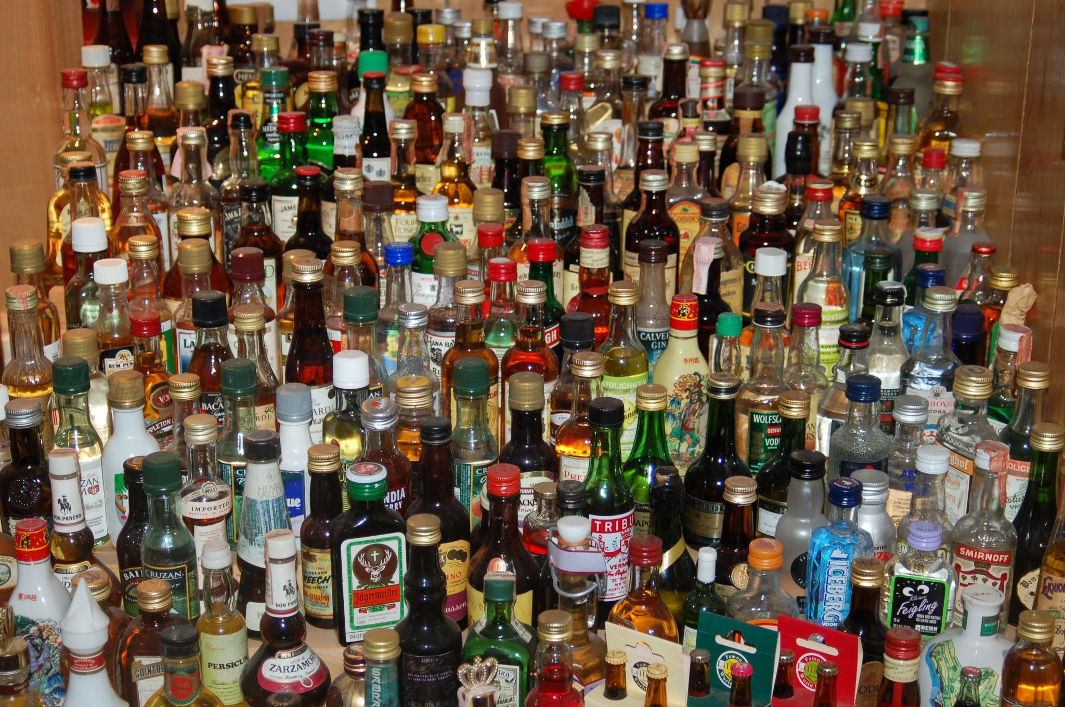
House League
May 25 - June 8 , 2019
Details coming soon !

