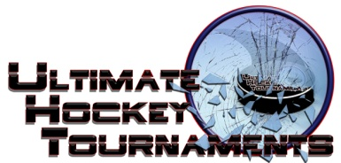
Ice Blast Tournament, St. Louis, May 4- 6, 2018
Midget A White Division

Tournament Format

Four teams, with each team playing three preliminary round games. At the conclusion of preliminary round, 1st plays 2nd for Championship. 3rd plays 4th for the consolation.

Standings
Team | Points Gm1 | Points Gm2 | Points Gm3 | Total Points | Tiebreakers
Chicago 88’s | 0 | 2 | 0 | 2
Ice Force 2 Hockey | 2 | 0 | 2 | 4
Twin Bridges Hockey | 0 | 0 | 0 | 0
Vianney Griffins | 2 | 2 | 2 | 6
Game Results
Fri | 5:20 |  | Pm |  | Affton Rink |  |  | Vianney |  | 8 |  | vs. |  | Twin Bridges |  | 5
Fri | 7:15 |  | Pm |  | Rec Plex- Rink A |  |  | Ice Force |  | 5 |  | vs. |  | Chicago |  |  | 0
Sat | 2:15 |  | Pm |  | Rec Plex- Rink A |  |  | Vianney |  | 7 |  | vs. |  | Ice Force |  |  | 2
Sat | 3:15 |  | Pm |  | Rec Plex- Rink B |  |  | Chicago |  | 9 |  | vs. |  | Twin Bridges |  |  | 4
Sat | 7:00 |  | Pm |  | All American Rink |  |  | Vianney |  | 5 |  | vs. |  | Chicago |  |  | 0
Sat | 8:15 |  | Pm |  | Rec Plex- Rink B |  |  | Ice Force |  | 7 |  | vs. |  | Twin Bridges |  |  | 5
 |  |  |  |  |  |  |  |  | HOME |  |  |  |  |  | AWAY
Sunday |  | 11:40 |  | Am |  | Affton Rink | 3rd |  | Chicago |  | 3 |  | 4th |  | Twin Bridges 3 Consolation
Sunday |  | 10:45 |  | Am |  | Rec Plex- Rink B | 1st |  | Vianney |  | 5 |  | 2nd |  | Ice Force 1 Championship

