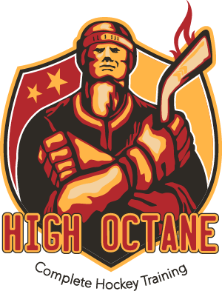  
**HIGH OCTANE SUMMER TRAINING CAMP 2018**

**U12 / U14 / MIDGET / HIGH SCHOOL**

High Octane Complete Hockey Training aspires to be the leader in the development of youth hockey players not only in the greater Indianapolis metro area but the state of Indiana. Our main objective is assuring that all players enjoy the great game of hockey while maximizing their overall potential. We do this by offering a first class on and off ice training facility unmatched in the Indianapolis area. We believe that you must have top of the line training tools available to our players in order to develop at a greater rate over the summer. Fuel Fitness has again been contracted to handle the off-ice workouts for the summer of 2018 and will maximize the usage of our state of the art training center located on premises at the Fuel Tank. High Octane will also utilize the High-Octane Training Room which has the Rapid Shot, Rapid Hands and Batak machines which are cutting edge technology for hockey training purposes. All players will receive a camp jersey, hockey socks and camp t-shirt.

COST: **$575**PER PLAYER

**$575** PER GOALIE (MAX 4)

**(GOALIES ARE FREE IF SIGNED UP IN HIGH OCTANE GOALIE SUMMER CAMP)**

**JULY 9TH TO AUGUST 9TH**

JULY CAMP DAYS: 9TH, 11TH, 12TH, 16TH, 18TH,19TH, 23RD, 25TH, 26TH, 30TH

AUGUST CAMP DAYS: 1ST, 2ND, 6TH, 8TH, 9TH

**U12 TRAINING TIMES U14 TRAINING TIMES**

**10:15AM – 11:15AM: ON ICE TRAINING 11:30AM – 12:30PM: ON ICE TRAINING**

**11:30AM – 12:30PM: OFF ICE TRAINING 12:45PM – 1:45PM: OFF ICE TRAINING**

**MIDGET/HIGH SCHOOL TRAINING TIMES**

**7:15 – 8:15PM: ON ICE TRAINING**

**6:00 – 7:00PM: OFF ICE TRAINING**

***ON ICE SESSIONS* INCLUDES** **OFF ICE SESSIONS INCLUDE**

ON ICE CONDITIONING PLYOMETRIC TRAINING

SMALL AREA GAMES QUICK FEET AND AGILITY TRAINING

BATTLE DRILLS CORE STRENGTH TRAINING

POSITION SPECIFIC GROUP TRAINING BATAK REACTION TRAINING

SITUATIONAL DRILLS RAPID SHOT SHOOTING CAGE

POWER SKATING RAPID HANDS STICKHANDLING

PUCK CONTROL

SHOOTING

PASSING

FLOW DRILLS

All High-Octane camps are open to all players from **ALL ORGANIZATIONS**. With our facilities and lineup of on and off ice instructors we will continue to lead the hockey industry in off season player development.

ONLINE REISTRATION AVAILABLE AT [WWW.INDYFUELTANK.COM](http://WWW.INDYFUELTANK.COM)

** **CREDIT CARD** PAYMENTS ONLY ACCEPTED FOR ONLINE REGISTRATION

** **CHECK OR CASH** PAYMENTS ARE ACCEPTED IN THE PRO SHOP LOCATED IN THE MAIN LOBBY OF THE FUEL TANK

IF YOU HAVE ADDITIONAL QUESTIONS PLEASE CONTACT JUDI KREMER AT **JKREMER@JUNIORFUELHOCKEY.COM**