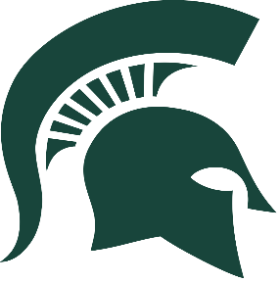 Sun Valley Soccer
Important Dates and Information

December 12 & 14 – Fitness Test Orientation and Training
January 2 – February 13 (Tuesdays & Thursdays) – Fitness/Training @3:15-4:45 *Exception of exam week.
February 14-16, 3:15-4:45, Mandatory Training/Tryouts
February 19 – End of season (all weekdays), 3:15-4:45 – Mandatory Training *Exception of match days.

Players cannot participate in any type of training without a valid physical.
Be on time…Early is on time!
Numbers will dictate JV and Varsity teams.
No practice/No play!
In addition to our conditioning/training, you should also participate in fitness training on your own.
Fitness testing will take place the first week of mandatory training. Those who do not pass, will not be eligible for varsity playing time.
Players should have cleats and flats for each training session.
Make me aware of any conflicts with training in advance.

Lee Ennis 704-576-2235 (C) lee.ennis@ucps.k12.nc.us

