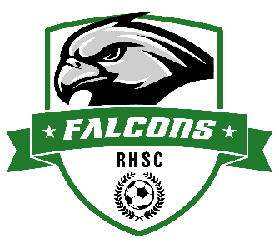
Rush-Henrietta Falcons Soccer Club
Fall Saturday Morning Clinics
Players born in 2013-2019 come join us for FREE Saturday Morning Soccer Clinics!
This program is open to all players!
If your child has played for our Travel or Recreation programs, or has not played before, these sessions are tailored to a variety of ages and skillsets.

WHO: Players born in 2013-2019
WHEN: 8/9, 8/16, 8/23, 9/6, 9/13, 9/20, 9/27, 10/4, 10/11, 10/18 (10 weeks total)
- Session 1: 9am - 10am for players born in 2016-2019 (U8-U10)
- Session 2: 10:30am - 11:45am for players born in 2013-2015 (U11-U13)
WHERE: Martin Road Park Field #7 (Parking available in the front parking lot)
HOW: Come ready to play with cleats, ball (size 4), shinguards, and water bottle

Please register by going to rhsoccer.org, select the Registration tab, and choose the Saturday Morning Clinics registration.
https://registration.teamsnap.com/form/33514

For any questions or concerns, please contact the RHSC Directors of Coaching at DOC@rhsoccer.org

