Scarborough Stingers XXU
Emergency Action Plan
This EAP should be printed double-sided on a single piece of paper.

Call 9-1-1 for all emergencies

Emergency Phone Numbers
Phone Number – Head Coach: | Name, Phone #
Phone Number – Assistant Coach: | Name, Phone #
Phone Number – Team Manager: | Name, Phone #
Address of Home Facility | Neilson Park, 1555 Neilson Road, Scarborough, ON, M1B 5Z7
Address of Nearest Hospital | Scarborough Health Network - Centenary Hospital, 2867 Ellesmere Rd, Scarborough, ON M1E 4B9
Charge Person (1st option): | Name (Position), Phone #
Charge Person (2nd option): | Name (Position), Phone #
Charge Person (3rd option): | Name (Position), Phone #
Call Person (1st option): | Name (Position), Phone #
Call Person (2nd option): | Name (Position), Phone #
Call Person (3rd option): | Name (Position), Phone #

Concussion Recorder: | Name (Position), Phone #

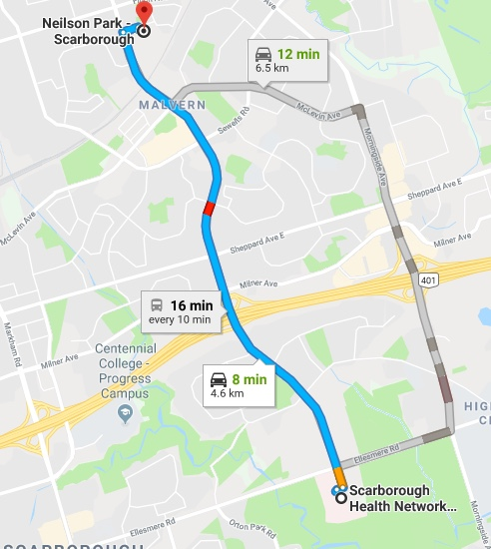
Directions to Centenary Hospital:

-Head west on Neilson Park Drive
-Turn left onto Neilson Road (south) for 4.4km
-Turn right at Mourning Dove Crescent
-Hospital will be on the right

Scarborough Stingers
Emergency Action Plan (page 2 of 2)

Roles and Responsibilities

Charge person
- Clear the risk of further harm to the injured person by securing the area and shelter the injured person from the elements
- Designate who is in charge of the other participants
- Protect yourself (wears gloves if in contact with bodily fluids)
- Assess ABCs (checks that airway is clear, breathing is present, a pulse is present, and there is no major bleeding)
- Wait by the injured person until EMS arrives and the injured person is transported
- Fill in an accident report form
Call person
- Call for emergency help (9-1-1)
- Provide all necessary information to dispatch (e.g. facility location, nature of injury, what, if any, first aid has been done)
- Clear any traffic from the entrance/access road before ambulance arrives
- Wait by the driveway entrance to the facility to direct the ambulance when it arrives
- Call the emergency contact person listed on the injured person’s medical profile
Concussion Recorder
- As per Rowan’s Law, each team must have a designated person to record, track and manage (compliance only, no medical intervention) any concussion or suspected concussions
- Record any incidents of suspected head or neck injury, or concussion
- Ensure each participant is following all policies and protocols
- Report to the Club* all incidents
- Ensure all return to sport protocols are followed, including written medical clearance
- Share medical clearance with the Club

It is recommended that emergency contact information should be included for each participant, with any relevant medical information (i.e. allergies or medication).

*Scarborough Stingers Baseball Club

