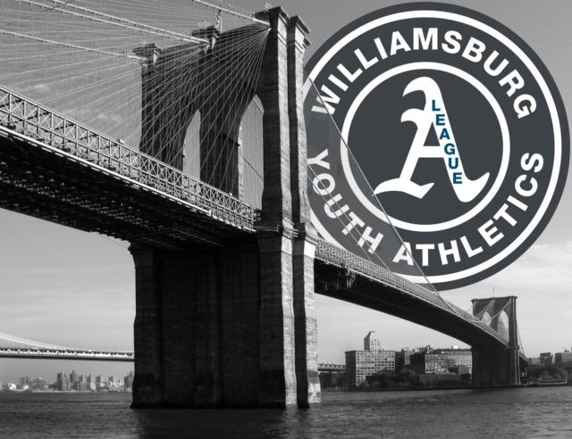W.Y.A.L. Flag Football 2020 Registration Form

First _________________________ Last_____________________________

Street Address ________________________________________________________

Primary Phone #: ( )__________________Secondary Contact #: ( ) __________________

How old will your child be on 9/1/21 ? _____________ DOB ___________________

Birth certificate is (circle one): on file enclosed must accompany this form if not already on file.

Name of School Child Attends:___________________________________ Grade:_______
(If your child attends Private School or is being Homeschooled, list the County school your child would attend)

Medical conditions, injuries, or allergies _________________________________________________________

Shirt Size (circle): Youth SM (6-8) Youth Med (10-12) Youth LG (14-16) Adult SM (34-36) Adult Med (38-40) Adult LG (42-44) Adult XLG (46-48)

Does a child have a brother/sister playing in the same age group? Yes _____ No ______ If yes, name of child ___________________________

Parental Consent: (Please read and sign below)
I hereby give my consent and approval for my child named above to participate in the WYAL Youth Flag Football Program, and I, the undersigned, do agree to indemnify and hold harmless employees, volunteer coaches and agents, from any and all claims or liability, including attorney's fees and costs for any injury or other damage suffered as a result of his/her participation. I understand that WYAL does not provide individual medical insurance for participants in the Youth Flag Football Program and that I am responsible for providing such insurance protection. Please refer to our website www.wyalbaseball.com for updated COVID-19 guidelines.

Signature ______________________________________________Date ___________

Print Name ______________________________________ The registration fee is $100.

